Elaboration Spec

The Glen Group: William Brown, Chris Isherwood, Ken Ballard, Brendon McNamara, Patrick Baker

**Table of Contents**

System Requirements pg. 2

Use Case Diagrams pg. 4

Trace Matrix pg. 22

Use Cases/Sequence Diagrams pg. 34

Class Diagram pg. 195

Database Design and Data Definitions pg.196

Navigation Diagram pg. 218

Physical Architecture Design pg. 220

Design Procedures for Security Concerns pg. 221

Gantt Chart pg. 222

Prototypes pg. 223

**System Requirements**

The known requirements for the planned system have been listed into two groups, Webpage and Database, then separated further into *functional* and *nonfunctional* types. The requirements are also sorted in a hierarchal list, with the most significant being at the top. Our team based these requirements off the information provided to us by the School of Nursing and through discussions with the School of Nursing staff.

**Webpage**

* Functional:

1. The system will be responsible for the creation, deletion, modification, and viewing of admin users.
2. The system will be responsible for the creation, deletion, modification, and viewing of staff users.
3. The system will be responsible for the creation, deletion, modification, and viewing of perspective, lower division, upper division, graduate, and alumni students.
4. The system will be responsible for the creation, deletion, modification, and viewing of donors.
5. The system will be responsible for processing donations.
6. The system will be responsible for the creation, deletion, modification, posting, and viewing of calendar events.
7. The system will be responsible for the creation, deletion, modification, posting, and viewing of news.
8. The system will be responsible for the creation, deletion, modification, posting, and viewing of schedule items (such as, but not limited to, classes, workshops, etc.)
9. The system will be responsible for the creation and submission of student questions to staff users.
10. The system will be responsible for the creation, deletion, modification, and viewing of reports.
11. The system will be responsible for the creation, deletion, modification, and viewing of mail directories.
12. The system will be responsible for sending messages between users.
13. The system will be responsible for the creation, deletion, modification, viewing, and uploading of clinical compliance records.
14. The system will be responsible for the creation, deletion, modification, and viewing of online applications for admittance, upper division, and graduate levels.

* Non-Functional:

1. The system will be responsible for having a secured link with the database.
2. The webpage system will be responsible for using an SSL certificate to securely connect users.
3. The webpage system will be responsible for displaying unique pages based on the user type.

**Database**

* Functional:

1. The database will be responsible for the consolidation of current student data.
2. The database will be responsible for the recording new user data.
3. The database will be responsible for reporting aspects of student progression.
4. The database will be responsible for recording donor data.
5. The database will be responsible for reporting aspects of donor progression.
6. The database will be responsible for exporting desired data for further reporting.

* Nonfunctional:

1. The database will be backed up.
2. The database will be secure and only accessible by approved users.
3. The database will be accessible through a webpage/user interface.

**Use Case Diagrams**

These Use Case Diagrams are used to determine what rights a specific user has within the system. Each diagram shows the specific rights within the system of each associated user. Each user represents a different member or group within the School of Nursing, and shows which type of staff or administration will be able to access certain materials and can perform certain actions that are only allowed with user permissions.

**Admin Users**

This diagram depicts the admin user’s ability to create users and entities that only Admin users can create. Admin users have complete access to the proposed system and can create, delete, update, and read information for any entity.

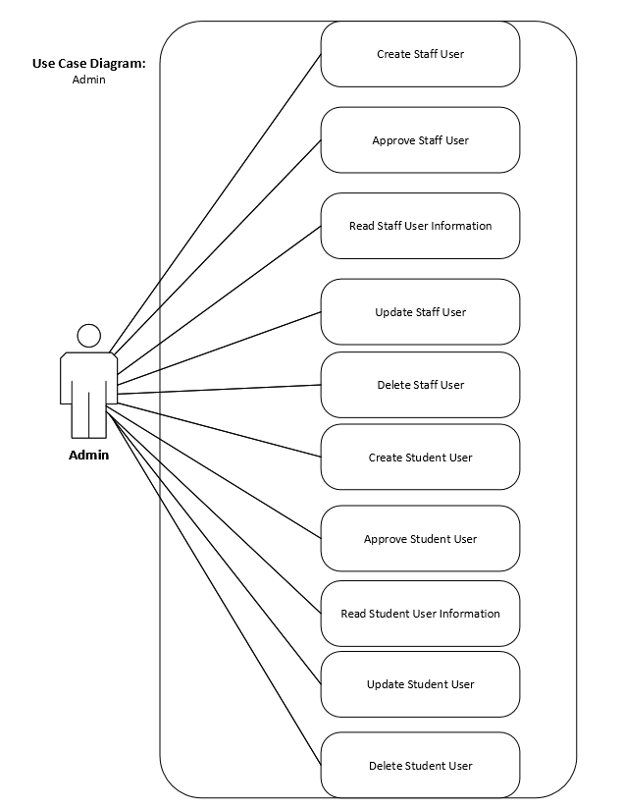

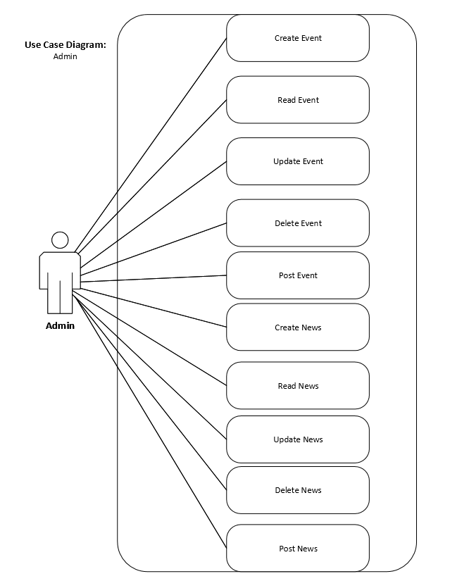

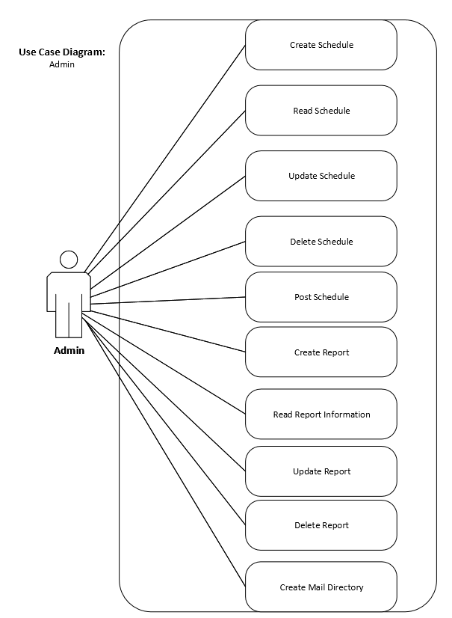

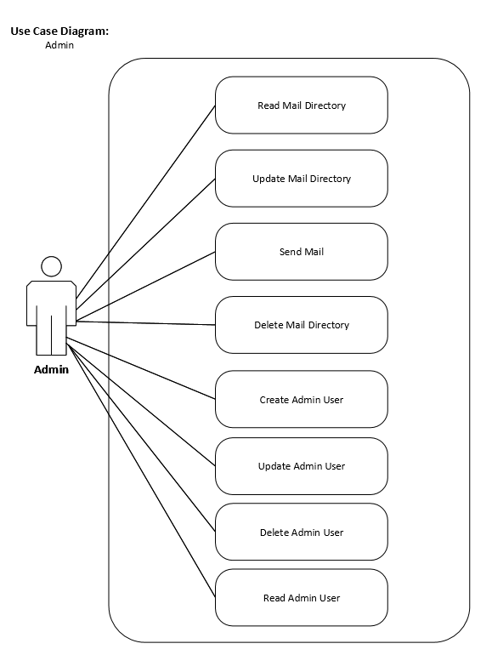



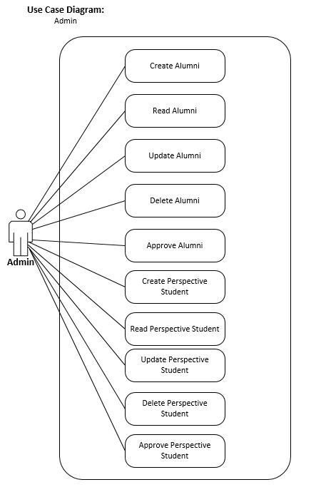

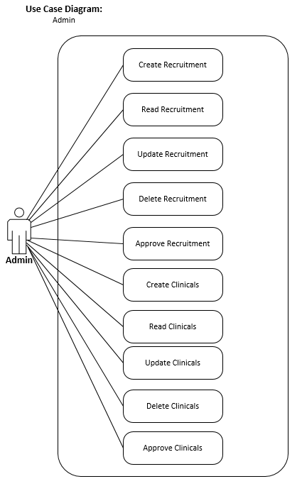

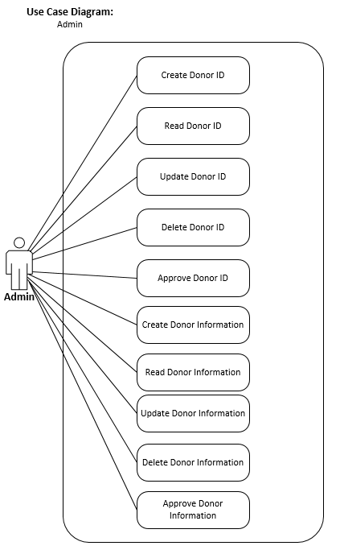

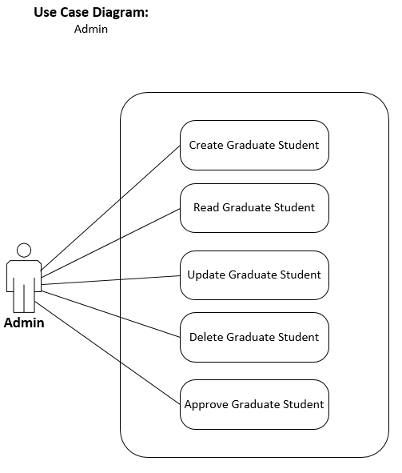

**Staff User**

These diagrams depict the staff user’s ability to manage the system and use functions within their rights. Staff users don’t have as many permissions as administration and cannot use certain functions within the system.

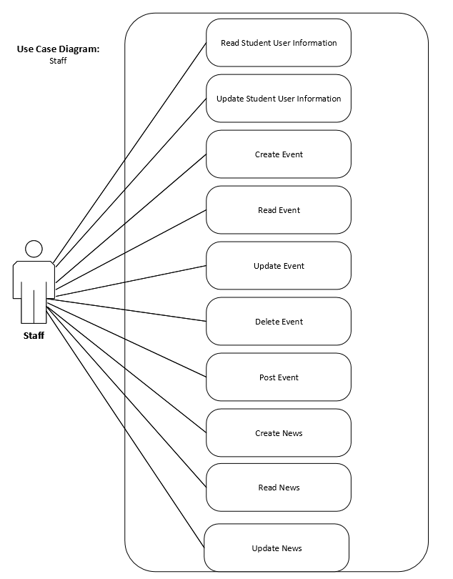

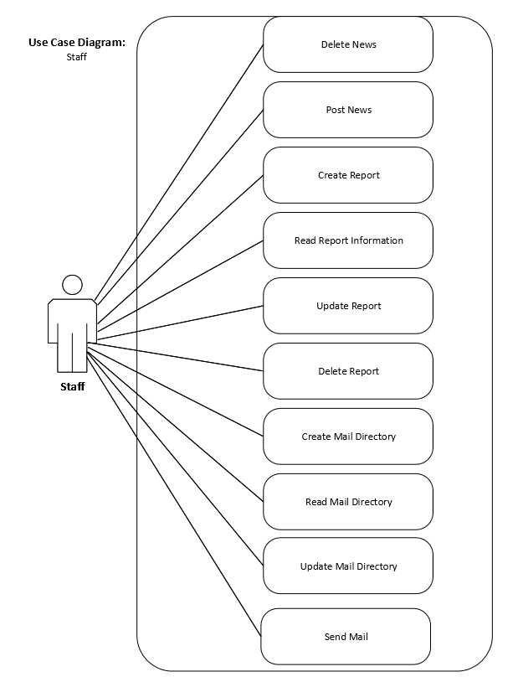

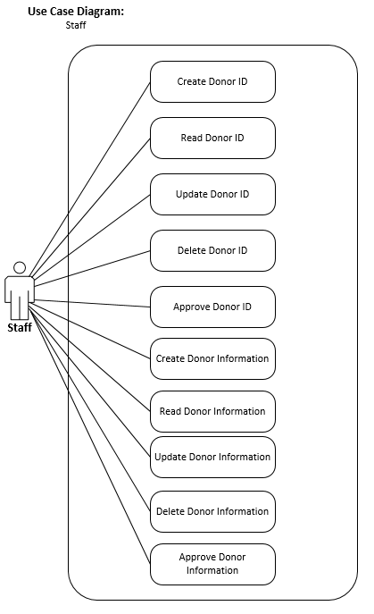

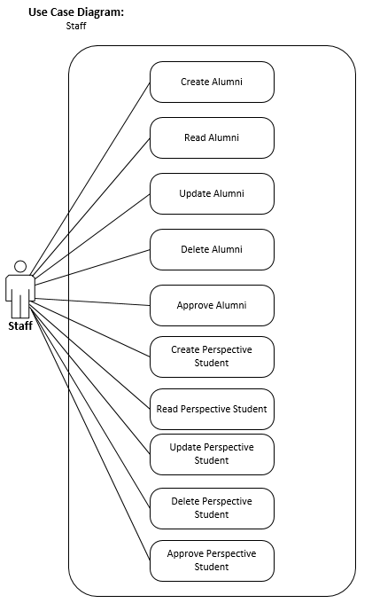

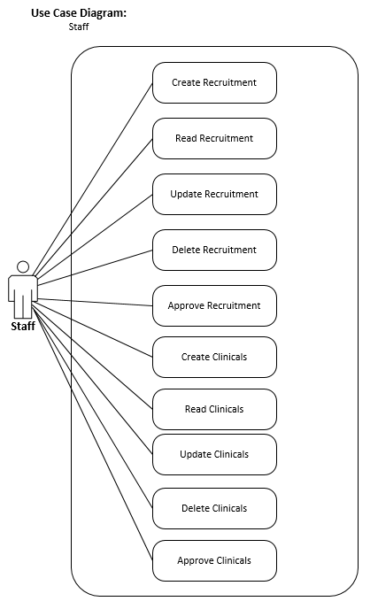

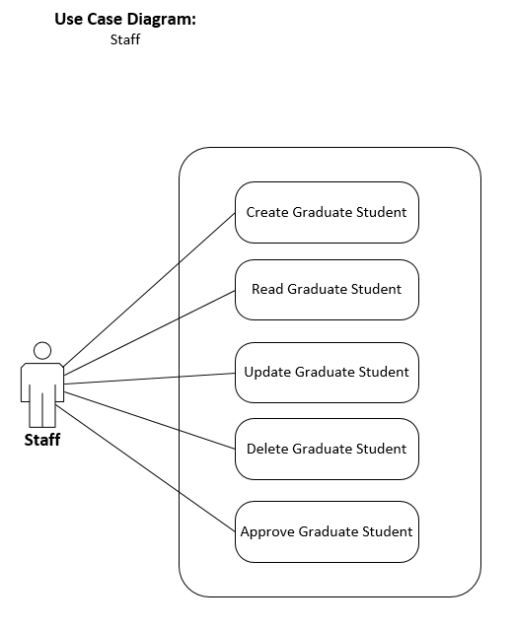

**Student User**

These diagrams depict the student user’s ability to navigate the system. The student user has the least amount of rights to the system and cannot use certain functions within the system.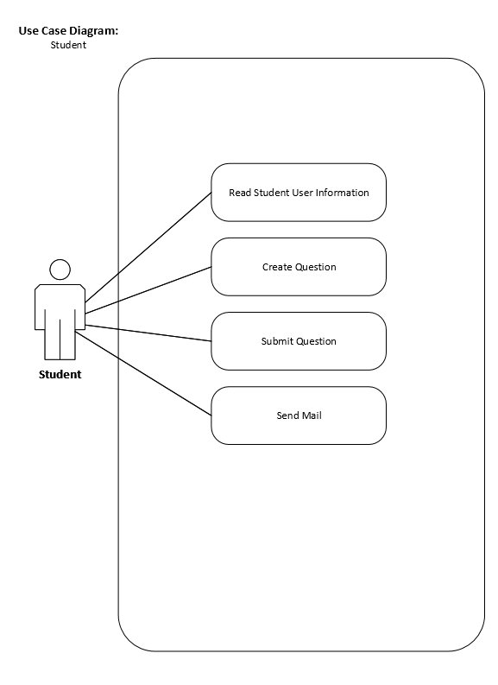

**Trace Matrix**

By comparing the developed Use Cases with the known System Requirements, we’re able to view how the system’s needs are met with our hand-designed, state-of-the-art processes. The identified requirements are listed vertically to the left-most of the matrix and the Use Cases, which are identified by their affiliated case number, are listed horizontally along the top of the matrix from left to right. A dot signifies which requirement is affiliated with which use case.

|  |  |  |  |  |  |  |  |  |
| --- | --- | --- | --- | --- | --- | --- | --- | --- |
|  | **Use Case ID#** | 001 | 002 | 003 | 004 | 005 | 006 | 007 |
| **Requirements** | | Create Staff User | Approve Staff User | Read Staff Information | Update Staff User | Delete Staff User | Create Student User | Approve Student User |
| User Account Management | | • | • | • | • | • | • | • |
| Donation Management | |  |  |  |  |  |  |  |
| News Management |  |  |  |  |  |  |  |  |
| Event Management |  |  |  |  |  |  |  |  |
| Schedule Management | |  |  |  |  |  |  |  |
| Report Management |  |  |  |  |  |  |  |  |
| Mail Directory Management | |  |  |  |  |  |  |  |
| Clinical Compliance Management | |  |  |  |  |  |  |  |
| Application Management | |  |  |  |  |  |  |  |
| User Message Management | |  |  |  |  |  |  |  |
| Record New User Data | | • | • | • | • | • | • | • |
| Consolidate Data |  | • |  | • | • | • | • |  |
| Export Data |  |  |  |  |  |  |  |  |
| Database Backed Up |  | • | • | • | • | • | • | • |
| Database Security |  | • | • | • | • | • | • | • |
| Unique User-Type Experience | | • |  | • | • |  | • |  |
| File Sharing | |  |  | • | • | • | • |  |
| Webpage Linked w/Database | | • | • | • | • | • | • | • |
| SSL Certificate |  | • | • | • | • | • | • | • |

|  |  |  |  |  |  |  |  |  |
| --- | --- | --- | --- | --- | --- | --- | --- | --- |
|  | **Use Case ID#** | 008 | 009 | 010 | 011 | 012 | 013 | 014 |
| **Requirements** | | Read Student Information | Update Student User | Delete Student User | Create Admin User | Read Admin User | Update Admin User | Delete Admin User |
| User Account Management | | • | • | • | • | • | • | • |
| Donation Management | |  |  |  |  |  |  |  |
| News Management |  |  |  |  |  |  |  |  |
| Event Management |  |  |  |  |  |  |  |  |
| Schedule Management | |  |  |  |  |  |  |  |
| Report Management |  |  |  |  |  |  |  |  |
| Mail Directory Management | |  |  |  |  |  |  |  |
| Clinical Compliance Management | |  |  |  |  |  |  |  |
| Application Management | |  |  |  |  |  |  |  |
| User Message Management | |  |  |  |  |  |  |  |
| Record New User Data | | • | • | • | • | • | • | • |
| Consolidate Data |  | • | • | • | • | • | • | • |
| Export Data |  |  |  |  |  |  |  |  |
| Database Backed Up |  | • | • | • | • | • | • | • |
| Database Security |  | • | • | • | • | • | • | • |
| Unique User-Type Experience | | • | • |  |  |  |  |  |
| File Sharing | | • | • | • | • | • | • | • |
| Webpage Linked w/Database | | • | • | • | • | • | • | • |
| SSL Certificate |  | • | • | • | • | • | • | • |

|  |  |  |  |  |  |  |  |  |
| --- | --- | --- | --- | --- | --- | --- | --- | --- |
|  | **Use Case ID#** | 015 | 016 | 017 | 018 | 019 | 020 | 021 |
| **Requirements** | | Create Clinicals | Read Clinicals | Update Clinicals | Delete Clinicals | Create Compliance | Read Compliance | Update Compliance |
| User Account Management | |  |  |  |  |  |  |  |
| Donation Management | |  |  |  |  |  |  |  |
| News Management |  |  |  |  |  |  |  |  |
| Event Management |  |  |  |  |  |  |  |  |
| Schedule Management | |  |  |  |  |  |  |  |
| Report Management |  |  |  |  |  |  |  |  |
| Mail Directory Management | |  |  |  |  |  |  |  |
| Clinical Compliance Management | | • | • | • | • | • | • | • |
| Application Management | |  |  |  |  |  |  |  |
| User Message Management | |  |  |  |  |  |  |  |
| Record New User Data | |  |  |  |  |  |  |  |
| Consolidate Data |  | • | • | • | • | • | • | • |
| Export Data |  |  | • |  |  |  | • |  |
| Database Backed Up |  | • | • | • | • | • | • | • |
| Database Security |  |  |  |  |  |  |  |  |
| Unique User-Type Experience | | • | • | • | • | • | • | • |
| File Sharing | | • | • | • | • | • | • | • |
| Webpage Linked w/Database | | • | • | • | • | • | • | • |
| SSL Certificate |  |  |  |  |  |  |  |  |

|  |  |  |  |  |  |  |  |  |
| --- | --- | --- | --- | --- | --- | --- | --- | --- |
|  | **Use Case ID#** | 022 | 023 | 024 | 025 | 026 | 027 | 028 |
| **Requirements** | | Delete Compliance | Approve Compliance | Create Event | Read Event Information | Update Event | Delete Event | Post Event |
| User Account Management | |  |  |  |  |  |  |  |
| Donation Management | |  |  |  |  |  |  |  |
| News Management |  |  |  |  |  |  |  |  |
| Event Management |  |  |  | • | • | • | • | • |
| Schedule Management | |  |  |  |  |  |  |  |
| Report Management |  |  |  |  |  |  |  |  |
| Mail Directory Management | |  |  |  |  |  |  |  |
| Clinical Compliance Management | | • | • |  |  |  |  |  |
| Application Management | |  |  |  |  |  |  |  |
| User Message Management | |  |  |  |  |  |  |  |
| Record New User Data | |  |  |  |  |  |  |  |
| Consolidate Data |  | • |  | • | • | • | • | • |
| Export Data |  |  |  |  |  |  |  |  |
| Database Backed Up |  | • | • |  |  |  |  |  |
| Database Security |  |  |  |  |  |  |  |  |
| Unique User-Type Experience | | • | • | • | • | • | • | • |
| File Sharing | | • | • | • | • | • | • | • |
| Webpage Linked w/Database | | • | • | • | • | • | • | • |
| SSL Certificate |  |  |  |  |  |  |  |  |

|  |  |  |  |  |  |  |  |  |
| --- | --- | --- | --- | --- | --- | --- | --- | --- |
|  | **Use Case ID#** | 029 | 030 | 031 | 032 | 033 | 034 | 035 |
| **Requirements** | | Create News | Read News Information | Update News | Delete News | Post News | Create Schedule | Read Schedule Information |
| User Account Management | |  |  |  |  |  |  |  |
| Donation Management | |  |  |  |  |  |  |  |
| News Management |  | • | • | • | • | • |  |  |
| Event Management |  |  |  |  |  |  |  |  |
| Schedule Management | |  |  |  |  |  | • | • |
| Report Management |  |  |  |  |  |  |  |  |
| Mail Directory Management | |  |  |  |  |  |  |  |
| Clinical Compliance Management | |  |  |  |  |  |  |  |
| Application Management | |  |  |  |  |  |  |  |
| User Message Management | |  |  |  |  |  |  |  |
| Record New User Data | |  |  |  |  |  |  |  |
| Consolidate Data |  | • | • | • | • | • | • | • |
| Export Data |  |  |  |  |  |  |  |  |
| Database Backed Up |  |  |  |  |  |  |  |  |
| Database Security |  |  |  |  |  |  |  |  |
| Unique User-Type Experience | | • | • | • | • | • | • | • |
| File Sharing | | • | • | • | • | • | • | • |
| Webpage Linked w/Database | | • | • | • | • | • | • | • |
| SSL Certificate |  |  |  |  |  |  |  |  |

|  |  |  |  |  |  |  |  |  |
| --- | --- | --- | --- | --- | --- | --- | --- | --- |
|  | **Use Case ID#** | 036 | 037 | 038 | 039 | 040 | 041 | 042 |
| **Requirements** | | Update Schedule | Delete Schedule | Post Schedule | Create Question | Submit Question | Create Report | Read Report Information |
| User Account Management | |  |  |  |  |  |  |  |
| Donation Management | |  |  |  |  |  |  |  |
| News Management |  |  |  |  |  |  |  |  |
| Event Management |  |  |  |  |  |  |  |  |
| Schedule Management | | • | • | • |  |  |  |  |
| Report Management |  |  |  |  |  |  | • | • |
| Mail Directory Management | |  |  |  |  |  |  |  |
| Clinical Compliance Management | |  |  |  |  |  |  |  |
| Application Management | |  |  |  |  |  |  |  |
| User Message Management | |  |  |  | • | • |  |  |
| Record New User Data | |  |  |  |  |  |  |  |
| Consolidate Data |  | • | • | • | • | • | • | • |
| Export Data |  |  |  |  |  |  | • | • |
| Database Backed Up |  |  |  |  |  |  | • | • |
| Database Security |  |  |  |  |  |  | • | • |
| Unique User-Type Experience | | • | • | • | • | • | • | • |
| File Sharing | | • | • | • | • | • | • | • |
| Webpage Linked w/Database | | • | • | • | • | • | • | • |
| SSL Certificate |  |  |  |  |  |  | • | • |

|  |  |  |  |  |  |  |  |  |
| --- | --- | --- | --- | --- | --- | --- | --- | --- |
|  | **Use Case ID#** | 043 | 044 | 045 | 046 | 047 | 048 | 049 |
| **Requirements** | | Update Report | Delete Report | Create Mail Directory | Read Mail Directory | Update Mail Directory | Send Mail Directory | Delete Mail Directory |
| User Account Management | |  |  |  |  |  |  |  |
| Donation Management | |  |  |  |  |  |  |  |
| News Management |  |  |  |  |  |  |  |  |
| Event Management |  |  |  |  |  |  |  |  |
| Schedule Management | |  |  |  |  |  |  |  |
| Report Management |  | • | • |  |  |  |  |  |
| Mail Directory Management | |  |  | • | • | • | • | • |
| Clinical Compliance Management | |  |  |  |  |  |  |  |
| Application Management | |  |  |  |  |  |  |  |
| User Message Management | |  |  |  |  |  |  |  |
| Record New User Data | |  |  |  |  |  |  |  |
| Consolidate Data |  | • | • | • | • | • | • | • |
| Export Data |  | • | • |  |  |  | • |  |
| Database Backed Up |  | • | • |  |  |  |  |  |
| Database Security |  | • | • |  |  |  |  |  |
| Unique User-Type Experience | | • | • | • | • | • | • | • |
| File Sharing | | • | • | • | • | • | • | • |
| Webpage Linked w/Database | | • | • | • | • | • | • | • |
| SSL Certificate |  | • | • |  |  |  |  |  |

|  |  |  |  |  |  |  |  |  |
| --- | --- | --- | --- | --- | --- | --- | --- | --- |
|  | **Use Case ID#** | 050 | 051 | 052 | 053 | 054 | 055 | 056 |
| **Requirements** | | Create Donor ID | Read Donor ID | Update Donor ID | Delete Donor ID | Approve Donor ID | Create Alumni | Read Alumni |
| User Account Management | | • | • | • | • | • | • | • |
| Donation Management | | • | • | • | • | • |  |  |
| News Management |  |  |  |  |  |  |  |  |
| Event Management |  |  |  |  |  |  |  |  |
| Schedule Management | |  |  |  |  |  |  |  |
| Report Management |  |  |  |  |  |  |  |  |
| Mail Directory Management | |  |  |  |  |  |  |  |
| Clinical Compliance Management | |  |  |  |  |  |  |  |
| Application Management | |  |  |  |  |  |  |  |
| User Message Management | |  |  |  |  |  |  |  |
| Record New User Data | | • | • | • | • | • | • | • |
| Consolidate Data |  | • | • | • | • |  | • | • |
| Export Data |  |  | • |  |  |  |  |  |
| Database Backed Up |  | • | • | • | • | • | • | • |
| Database Security |  | • | • | • | • | • | • | • |
| Unique User-Type Experience | | • | • | • | • |  | • | • |
| File Sharing | | • | • | • | • |  | • | • |
| Webpage Linked w/Database | | • | • | • | • | • | • | • |
| SSL Certificate |  | • | • | • | • | • | • | • |

|  |  |  |  |  |  |  |  |  |
| --- | --- | --- | --- | --- | --- | --- | --- | --- |
|  | **Use Case ID#** | 057 | 058 | 059 | 060 | 061 | 062 | 063 |
| **Requirements** | | Update Alumni | Delete Alumni | Approve Alumni | Create Prospective Student | Read Prospective Student | Update Prospective Student | Delete Prospective Student |
| User Account Management | | • | • | • | • | • | • | • |
| Donation Management | |  |  |  |  |  |  |  |
| News Management |  |  |  |  |  |  |  |  |
| Event Management |  |  |  |  |  |  |  |  |
| Schedule Management | |  |  |  |  |  |  |  |
| Report Management |  |  |  |  |  |  |  |  |
| Mail Directory Management | |  |  |  |  |  |  |  |
| Clinical Compliance Management | |  |  |  |  |  |  |  |
| Application Management | |  |  |  |  |  |  |  |
| User Message Management | |  |  |  |  |  |  |  |
| Record New User Data | | • | • | • | • | • | • | • |
| Consolidate Data |  | • | • |  | • | • | • | • |
| Export Data |  |  |  |  |  |  |  |  |
| Database Backed Up |  | • | • | • | • | • | • | • |
| Database Security |  | • | • | • | • | • | • | • |
| Unique User-Type Experience | | • | • |  | • | • | • | • |
| File Sharing | | • | • |  | • | • | • | • |
| Webpage Linked w/Database | | • | • | • | • | • | • | • |
| SSL Certificate |  | • | • | • | • | • | • | • |

|  |  |  |  |  |  |  |  |  |
| --- | --- | --- | --- | --- | --- | --- | --- | --- |
|  | **Use Case ID#** | 064 | 065 | 066 | 067 | 068 | 069 | 070 |
| **Requirements** | | Approve Prospective Student | Create Recruitment | Read Recruitment | Update Recruitment | Delete Recruitment | Approve Recruitment | Approve Compliance |
| User Account Management | | • |  |  |  |  |  |  |
| Donation Management | |  |  |  |  |  |  |  |
| News Management |  |  |  |  |  |  |  |  |
| Event Management |  |  | • | • | • | • | • |  |
| Schedule Management | |  |  | • |  |  |  |  |
| Report Management |  |  |  |  |  |  |  |  |
| Mail Directory Management | |  |  |  |  |  |  |  |
| Clinical Compliance Management | |  |  |  |  |  |  | • |
| Application Management | |  |  |  |  |  |  |  |
| User Message Management | |  |  |  |  |  |  |  |
| Record New User Data | | • |  |  |  |  |  |  |
| Consolidate Data |  |  | • | • | • | • | • | • |
| Export Data |  |  |  |  |  |  |  |  |
| Database Backed Up |  | • |  |  |  |  |  |  |
| Database Security |  | • |  |  |  |  |  |  |
| Unique User-Type Experience | |  | • | • | • | • | • | • |
| File Sharing | |  | • | • | • | • | • | • |
| Webpage Linked w/Database | | • | • | • | • | • | • | • |
| SSL Certificate |  | • |  |  |  |  |  |  |

|  |  |  |  |  |  |  |
| --- | --- | --- | --- | --- | --- | --- |
|  | **Use Case ID#** | 071 | 072 | 073 | 074 | 075 |
| **Requirements** | | Create Graduate Student | Read Graduate Student | Update Graduate Student | Delete Graduate Student | Approve Graduate Student |
| User Account Management | | • | • | • | • | • |
| Donation Management | |  |  |  |  |  |
| News Management |  |  |  |  |  |  |
| Event Management |  |  |  |  |  |  |
| Schedule Management | |  |  |  |  |  |
| Report Management |  |  |  |  |  |  |
| Mail Directory Management | |  |  |  |  |  |
| Clinical Compliance Management | |  |  |  |  |  |
| Application Management | |  |  |  |  |  |
| User Message Management | |  |  |  |  |  |
| Record New User Data | | • | • | • | • | • |
| Consolidate Data |  | • | • | • | • |  |
| Export Data |  |  |  |  |  |  |
| Database Backed Up |  | • | • | • | • | • |
| Database Security |  | • | • | • | • | • |
| Unique User-Type Experience | | • | • | • | • |  |
| File Sharing | | • | • | • | • |  |
| Webpage Linked w/Database | | • | • | • | • | • |
| SSL Certificate |  | • | • | • | • | • |

|  |  |  |  |  |  |  |
| --- | --- | --- | --- | --- | --- | --- |
|  | **Use Case ID#** | 076 | 077 | 078 | 079 | 080 |
| **Requirements** | | Create Donation Information | Read Donation Information | Update Donation Information | Delete Donation Information | Approve Donation Information |
| User Account Management | |  |  |  |  |  |
| Donation Management | | • | • | • | • | • |
| News Management |  |  |  |  |  |  |
| Event Management |  |  |  |  |  |  |
| Schedule Management | |  |  |  |  |  |
| Report Management |  |  |  |  |  |  |
| Mail Directory Management | |  |  |  |  |  |
| Clinical Compliance Management | |  |  |  |  |  |
| Application Management | |  |  |  |  |  |
| User Message Management | |  |  |  |  |  |
| Record New User Data | | • | • | • | • | • |
| Consolidate Data |  | • | • | • | • |  |
| Export Data |  |  | • |  |  |  |
| Database Backed Up |  | • | • | • | • | • |
| Database Security |  | • | • | • | • | • |
| Unique User-Type Experience | | • | • | • | • |  |
| File Sharing | | • | • | • | • |  |
| Webpage Linked w/Database | | • | • | • | • | • |
| SSL Certificate |  | • | • | • | • | • |

**Use Cases:**

Following are a list of use cases with the actors on the proposed system for each use case as well as the main flow. These use cases describe the back-end functionality of the proposed system including user system privileges. Each use case describes a unique process that is needed for each of the different processes. Immediately following each use case is a sequence diagram. The sequence diagram shows the necessary flow of interactions between the primary actor and the system. Based on interactions with the system, different steps can be taken to achieve the creation, deletion, reading, and modification of different aspects of the system.

|  |
| --- |
| **Use Case: Create Staff User – Admin User** |
| **ID: UCID001** |
| **Brief Description:**  This use case describes how staff create user accounts, inputting contact information, birth date, name, and this form would require administrator approval. |
| **Primary Actors:** Administration |
| **Secondary Actors:** None |
| **Preconditions: <**The system must be operational. User clicks create staff> |
| **Main Flow:**   * Admin clicks staff enrollment link * System shows staff enrollment page * Admin enters name of staff to be created * Admin specifies if new staff member has ever worked for the School of Nursing * Admin specifies languages spoken by new staff member * Admin specifies primary language of new staff member * Admin enters age of new staff member * Admin enters birthdate of new staff member * Admin enters start date of new staff member * Admin enters address of new staff member * Admin enters zip of new staff member * Admin enters phone of new staff member * Admin enters cell of new staff member * Admin enters email of new staff member * Admin enters experience that staff member possesses * Admin uploads resume of new staff member * Admin uploads form to system * System uploads information to database * Admin approves new staff member enrollment on the backend * New staff member is notified of approval |
| **Postconditions:**  <After enrollment form is submitted, new staff user needs to be approved and will be notified of approval> |
| **Alternative flows:**  None |

The sequence diagram shows the necessary flow of interactions between the primary actor and the system. Based on interactions with the system, different steps can be taken to achieve the creation, deletion, reading, and modification of different aspects of the system. This shows the “happy day” scenario of how the system would run.

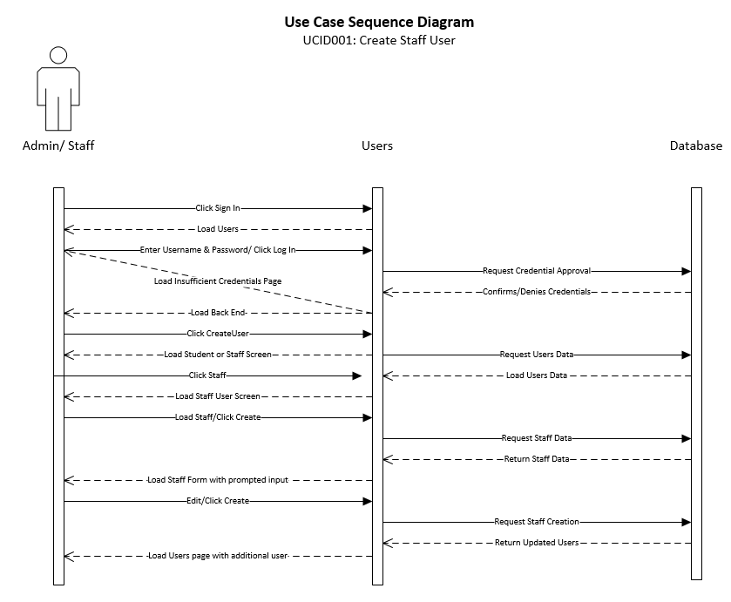

|  |
| --- |
| **Use Case: Approve Staff User** |
| **ID: UCID002** |
| **Brief Description:**  Describes the approval of a newly created staff account as a user. If approved, staff becomes a staff user. If denied, administrator prompted to send a rejection response. |
| **Primary Actors:** Administration |
| **Secondary Actors:** None |
| **Preconditions: <**System must be operational>  <There must a request for approval waiting> |
| **Main Flow:**   * Admin clicks sign in on webpage * Admin enters credentials to log in to website * Admin clicks ‘Manage Staff’ * Admin clicks staff member needing approval * Admin clicks approve or disapprove * System sends email to notify staff member of approval or disapproval |
| **Postconditions:**  <After staff user is approved or disapproved the system will be updated>  <System will send email to notify staff user of approval or disapproval> |
| **Alternative flows:**  None |

The sequence diagram shows the necessary flow of interactions between the primary actor and the system. Based on interactions with the system, different steps can be taken to achieve the creation, deletion, reading, and modification of different aspects of the system. This shows the “happy day” scenario of how the system would run.

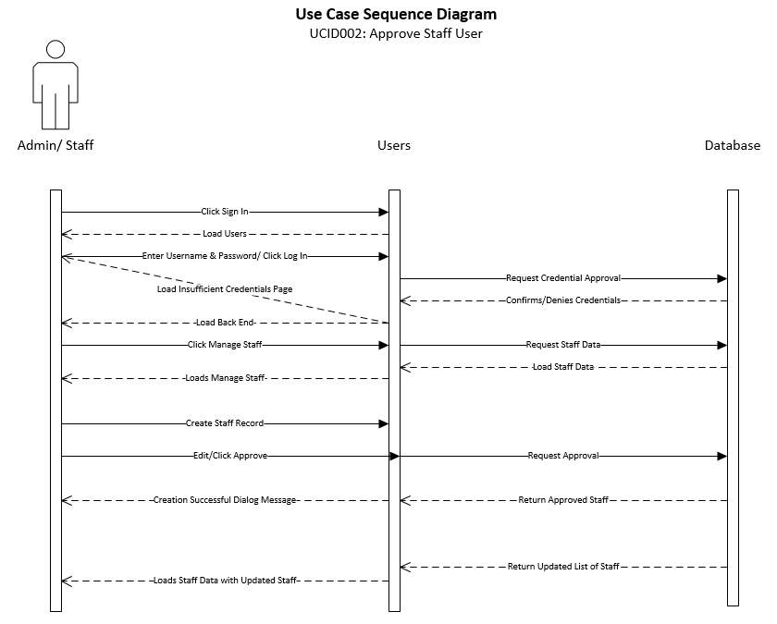

|  |
| --- |
| **Use Case: Read Staff User Information** |
| **ID: UCID003** |
| **Brief Description:**  The new system shall allow certain staff data/information to be viewed by approved users. Staff users with approved permissions will be able to view other staff member information. |
| **Primary Actors:** Administration |
| **Secondary Actors:** None |
| Preconditions: <System must be operational> <Admin user must have permissions to view other staff profile> |
| **Main Flow:**   * Admin user will click login on website * Admin user enters credentials * Admin user clicks load staff profile |
| **Postconditions:**<Staff user profile information is viewed> |
| **Alternative flows:**  None |

The sequence diagram shows the necessary flow of interactions between the primary actor and the system. Based on interactions with the system, different steps can be taken to achieve the creation, deletion, reading, and modification of different aspects of the system. This shows the “happy day” scenario of how the system would run.

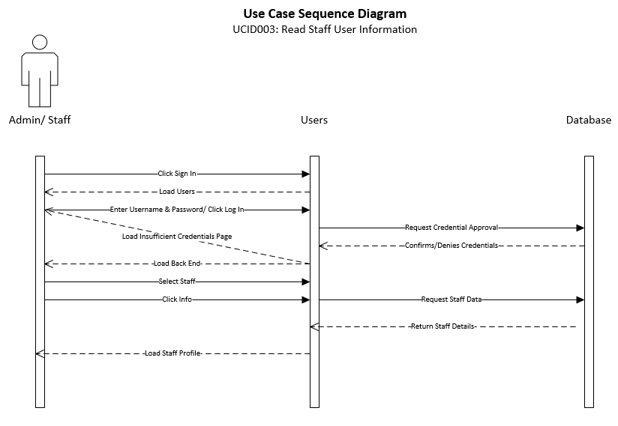

|  |
| --- |
| **Use Case: Read Staff User Information** |
| **ID: UCID004** |
| **Brief Description:**  This use case will allow staff users to update staff user information. Staff users must have the proper permissions to edit staff information. |
| **Primary Actors:** Administration |
| **Secondary Actors:** None |
| Preconditions: <System must be operational> <Admin user must have permissions to edit other staff profiles> |
| **Main Flow:**   * Admin user will click login on website * Admin user enters credentials * Admin user clicks load staff profile * Admin user clicks edit profile * Admin user edits profile * Admin user clicks complete |
| **Postconditions:** <Admin user profile information is viewed> |
| **Alternative flows:**  None |

The sequence diagram shows the necessary flow of interactions between the primary actor and the system. Based on interactions with the system, different steps can be taken to achieve the creation, deletion, reading, and modification of different aspects of the system. This shows the “happy day” scenario of how the system would run.

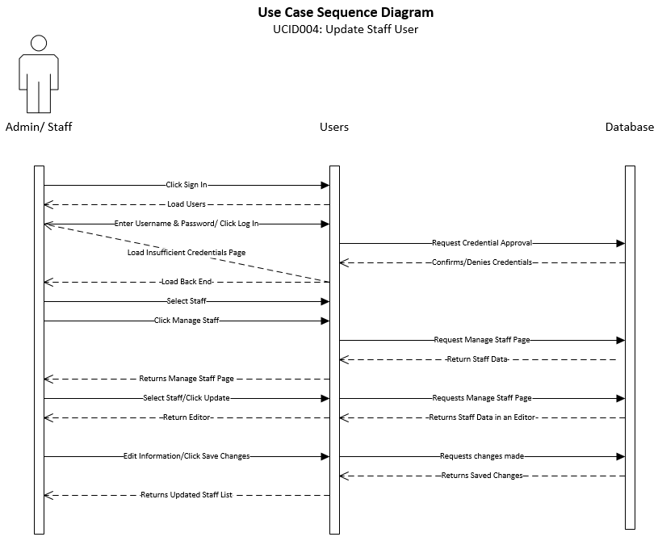

|  |
| --- |
| **Use Case: Delete Staff User Information** |
| **ID: UCID005** |
| **Brief Description:**  This use case will allow staff users to update staff user information. Staff users must have the proper permissions to edit staff information. |
| **Primary Actors:** Administration |
| **Secondary Actors:** None |
| Preconditions: <System must be operational> <Admin user must have permissions to delete staff profiles> |
| **Main Flow:**   * Admin user will click login on website * Admin user enters credentials * Admin user clicks load staff profile * Admin user clicks delete profile * Admin user clicks complete |
| **Postconditions:** <Staff user profile is deleted> |
| **Alternative flows:**  None |

The sequence diagram shows the necessary flow of interactions between the primary actor and the system. Based on interactions with the system, different steps can be taken to achieve the creation, deletion, reading, and modification of different aspects of the system. This shows the “happy day” scenario of how the system would run.

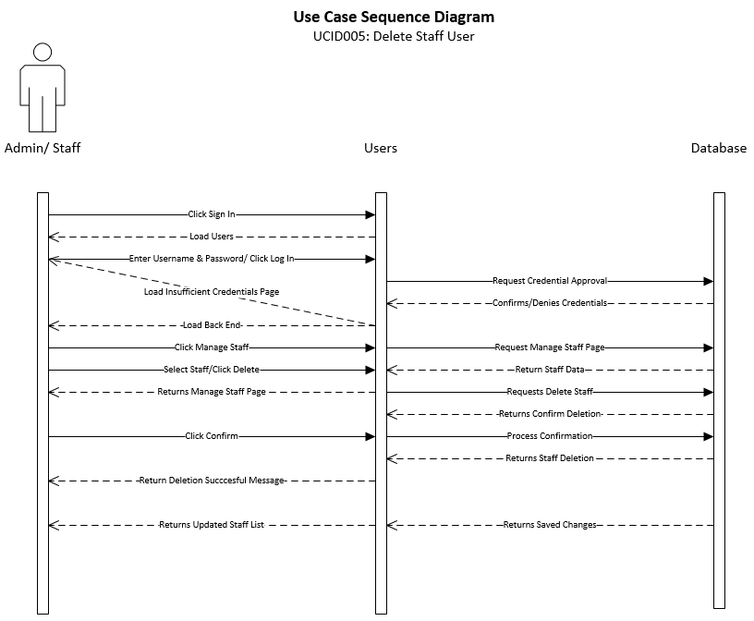

|  |
| --- |
| **Use Case: Create Student User** |
| **ID: UCID006** |
| **Brief Description:**  This use case describes how a student creates an account to be student user. They would have to input contact information, personal information, etc. This form would require staff approval. |
| **Primary Actors:** Administration |
| **Secondary Actors:** None |
| Preconditions: <System must be operational> <Admin user must have permissions to create student profiles> |
| **Main Flow:**   * Selects the Sign In/Sign Up button * Student enters personal information and requests enrollment into the School of Nursing program. Information to include: * First Name * Last Name * MI * DoB * Gender * Address * Zip * City * State * Phone * E-mail * School * Parent(s) First Name * Parent(s) Last Name * School of Nursing Admin verifies the information and approve the new student account. |
| **Postconditions:** <Student user profile is created> |
| **Alternative flows:**  None |

The sequence diagram shows the necessary flow of interactions between the primary actor and the system. Based on interactions with the system, different steps can be taken to achieve the creation, deletion, reading, and modification of different aspects of the system. This shows the “happy day” scenario of how the system would run.

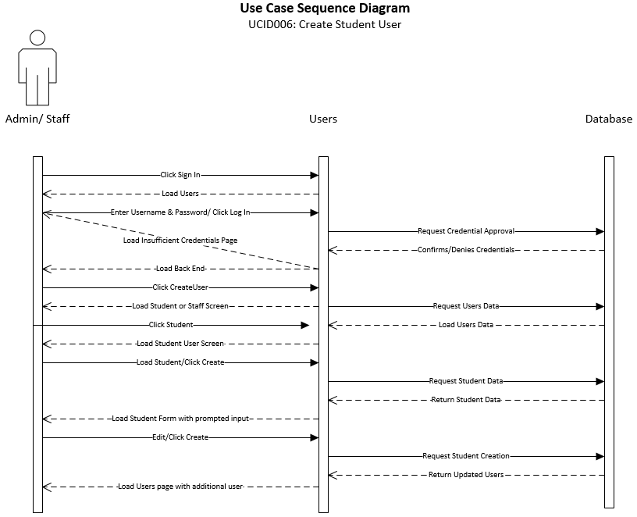

|  |
| --- |
| **Use Case: Approve Student User** |
| **ID: UCID007** |
| **Brief Description:**  This use case describes the approval of a newly created student account as a user/member. If approved, student becomes a student user. If denied, staff prompted to send a rejection response. |
| **Primary Actors:** Administration |
| **Secondary Actors:** |
| Preconditions: <System must be operational> <Admin user must have permissions to view student profiles> |
| **Main Flow:**   * Application is submitted by student * Staff member imports student information from an excel file to database including information like:   + First Name   + Last Name   + MI   + DoB   + Gender   + Address   + Zip   + City   + State   + Phone   + E-mail   + School   + Parent(s) First Name   + Parent(s) Last Name * Admin member clicks approve |
| **Postconditions:** <Student user profile is created> |
| **Alternative flows:**  None |

The sequence diagram shows the necessary flow of interactions between the primary actor and the system. Based on interactions with the system, different steps can be taken to achieve the creation, deletion, reading, and modification of different aspects of the system. This shows the “happy day” scenario of how the system would run.

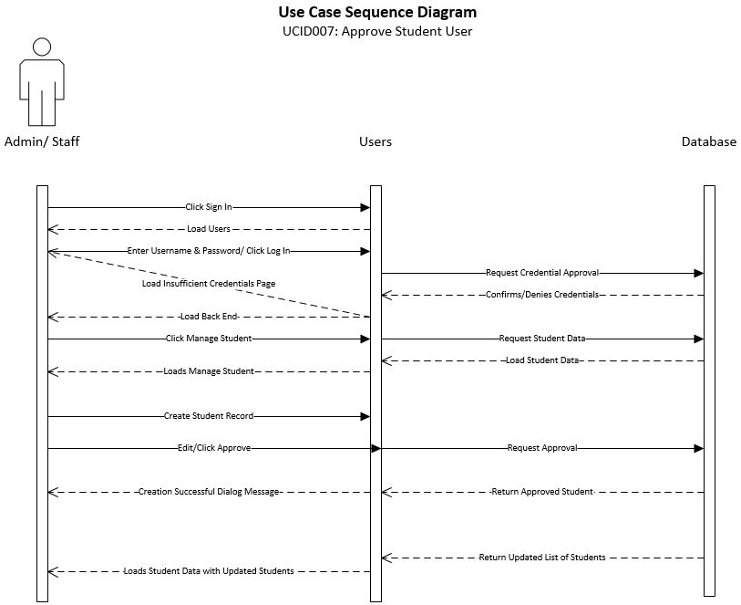

|  |
| --- |
| **Use Case: Read Student User Information** |
| **ID: UCID008** |
| **Brief Description:**  The new system should allow certain student information to be viewed by approved users. |
| **Primary Actors:** Administration |
| **Secondary Actors:** Staff/Student |
| Preconditions: <System must be operational> <Admin/Staff/Student user must have permissions to view student profiles> |
| **Main Flow:**   * Student clicks Sign in/Sign up * Student enters in credentials * Student clicks submit * Student views profile |
| **Postconditions:** <Student user profile is viewed> |
| **Alternative flows:**   * Admin/Staff staff logs in * Admin/Staff accesses the back end * Admin/Staff selects Manage Students under the Manage Users tab * Admin/Staff highlights student in the Enrolled student box * Admin/Staff selects details |

The sequence diagram shows the necessary flow of interactions between the primary actor and the system. Based on interactions with the system, different steps can be taken to achieve the creation, deletion, reading, and modification of different aspects of the system. This shows the “happy day” scenario of how the system would run.

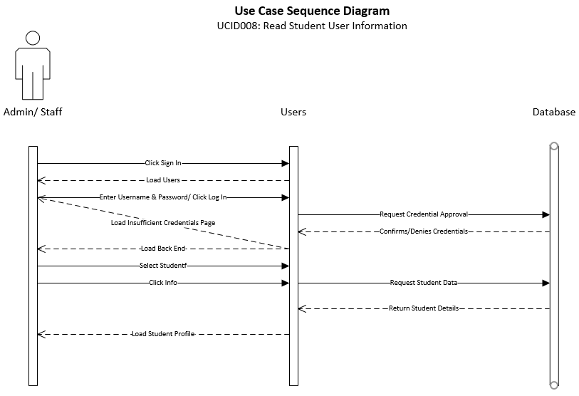

|  |
| --- |
| **Use Case: Update Student User Information** |
| **ID: UCID009** |
| **Brief Description:**  Describes how to update student data |
| **Primary Actors:** Administration |
| **Secondary Actors:** |
| Preconditions: <System must be operational> <Admin user must have permissions to view student profiles> |
| **Main Flow:**   * School of Nursing Admin logs in * School of Nursing Admin accesses the back end * School of Nursing Admin selects Manage Students under the Manage Users tab * School of Nursing Admin highlights student in the Enrolled student box * School of Nursing Admin selects edit underneath the student details box * School of Nursing Admin updates/changes student information. * School of Nursing Admin selects update to save student information |
| **Postconditions:** <Student information can be updated> |
| **Alternative flows:** <None> |

The sequence diagram shows the necessary flow of interactions between the primary actor and the system. Based on interactions with the system, different steps can be taken to achieve the creation, deletion, reading, and modification of different aspects of the system. This shows the “happy day” scenario of how the system would run.

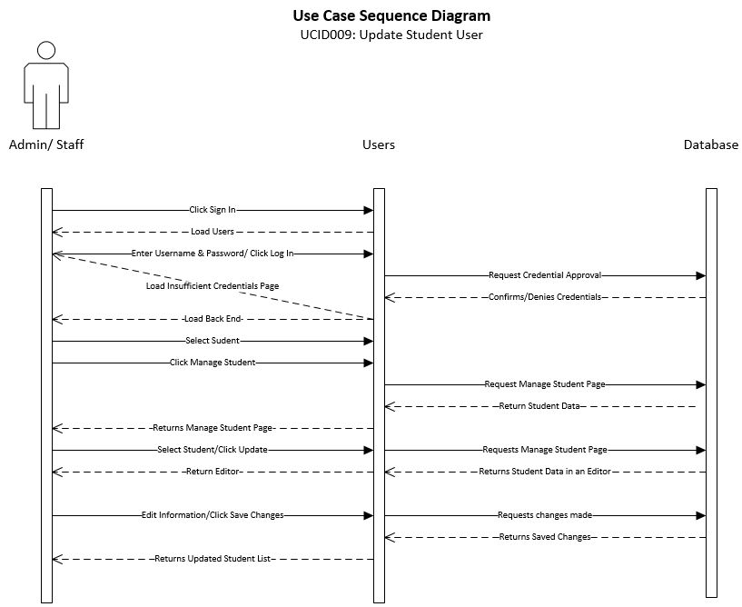

|  |
| --- |
| **Use Case: Delete Student User** |
| **ID: UCID010** |
| **Brief Description:**  Describes student removal. Removal would require staff approval. |
| **Primary Actors:** Administration |
| **Secondary Actors:** |
| Preconditions: <System must be operational> <Admin user must have permissions to delete student profiles> |
| **Main Flow:**   * Admin logs in * Admin accesses the back end * Admin selects Manage Students under the Manage Users tab * Admin highlights student in the Enrolled student box * Admin selects Delete |
| **Postconditions:** <Student user has been deleted> |
| **Alternative flows:** <None> |

The sequence diagram shows the necessary flow of interactions between the primary actor and the system. Based on interactions with the system, different steps can be taken to achieve the creation, deletion, reading, and modification of different aspects of the system. This shows the “happy day” scenario of how the system would run.

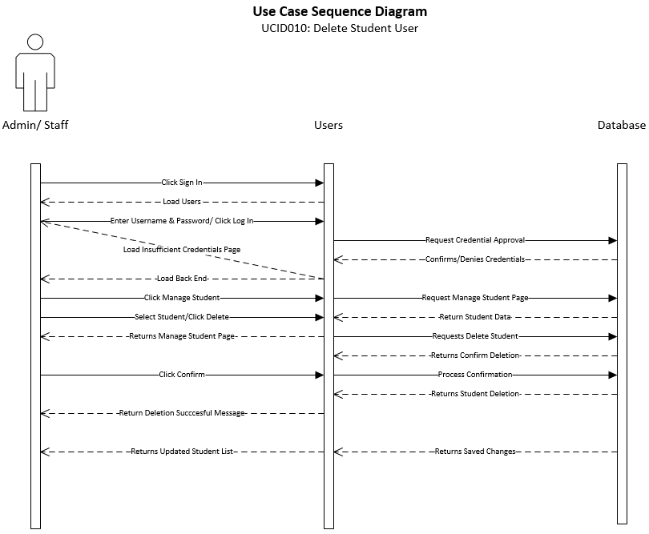

|  |
| --- |
| **Use Case: Create Admin User** |
| **ID: UCID011** |
| **Brief Description:** This use case describes the process of creating an admin user. |
| **Primary Actors:** Admin |
| **Secondary Actors:** None. |
| **Preconditions:**  1. User is signed in with an admin account. |
| **Main Flow:**   1. User navigates to the admin section. 2. User clicks the “Admin User” link in the admin section. 3. User clicks “Create New” Admin User. 4. User enters admin credentials and saves. |
| **Postconditions:**   1. Admin user values are validated. |
| **Alternative flows:** None. |

The sequence diagram shows the necessary flow of interactions between the primary actor and the system. Based on interactions with the system, different steps can be taken to achieve the creation, deletion, reading, and modification of different aspects of the system. This shows the “happy day” scenario of how the system would run.

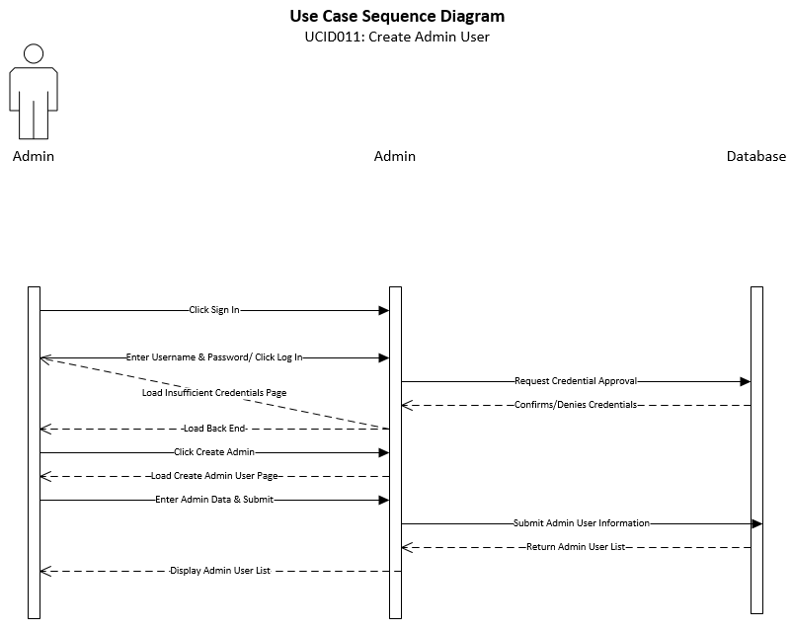

|  |
| --- |
| **Use Case: Read Admin User** |
| **ID: UCID012** |
| **Brief Description:** This use case describes the process viewing admin users. |
| **Primary Actors:** Admin |
| **Secondary Actors:** None. |
| **Preconditions:**   1. User is signed in with an admin account. |
| **Main Flow:**   1. User navigates to the admin section. 2. User clicks the “Admin User” link in the admin section. 3. Website lists admin users to the current user. |
| **Postconditions:** None. |
| **Alternative flows:** None. |

The sequence diagram shows the necessary flow of interactions between the primary actor and the system. Based on interactions with the system, different steps can be taken to achieve the creation, deletion, reading, and modification of different aspects of the system. This shows the “happy day” scenario of how the system would run.

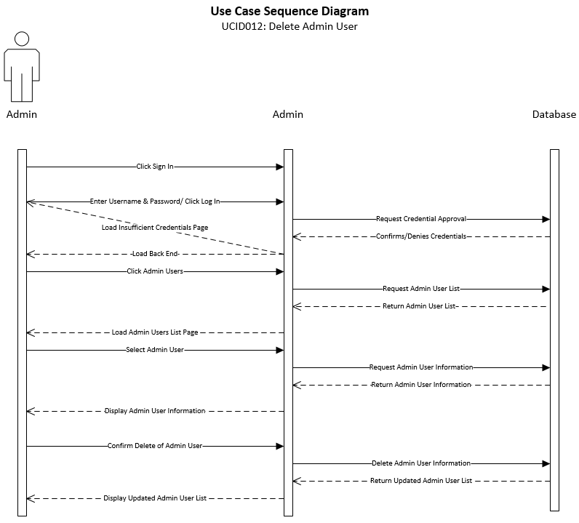

|  |
| --- |
| **Use Case: Update Admin User** |
| **ID: UCID013** |
| **Brief Description:** This use case describes the process of updating an admin user. |
| **Primary Actors:** Admin |
| **Secondary Actors:** None. |
| **Preconditions:**  1. User is signed in with an admin account. |
| **Main Flow:**   1. User navigates to the admin section. 2. User clicks the “Admin User” link in the admin section. 3. User clicks on an existing admin user. 4. User clicks “Edit User” to load the Edit page. 5. User makes changes to admin information and saves. |
| **Postconditions:**   1. New admin user values are validated. |
| **Alternative flows:** None. |

The sequence diagram shows the necessary flow of interactions between the primary actor and the system. Based on interactions with the system, different steps can be taken to achieve the creation, deletion, reading, and modification of different aspects of the system. This shows the “happy day” scenario of how the system would run.

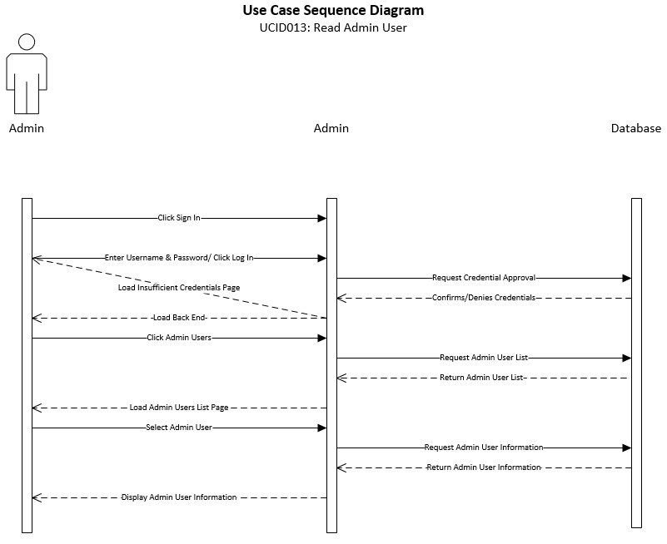

|  |
| --- |
| **Use Case: Delete Admin User** |
| **ID: UCID014** |
| **Brief Description:**  Describes how to remove an admin user |
| **Primary Actors:** Administration |
| **Secondary Actors:** |
| Preconditions: <System must be operational> <Admin user must have permissions to delete student profiles> |
| **Main Flow:**   * Admin logs in * Admin accesses the back end * Admin selects Manage Admins under the Manage Users tab * Admin slects admin to delete * Admin selects Delete |
| **Postconditions:** <Admin user has been deleted> |
| **Alternative flows:** <None> |

The sequence diagram shows the necessary flow of interactions between the primary actor and the system. Based on interactions with the system, different steps can be taken to achieve the creation, deletion, reading, and modification of different aspects of the system. This shows the “happy day” scenario of how the system would run.

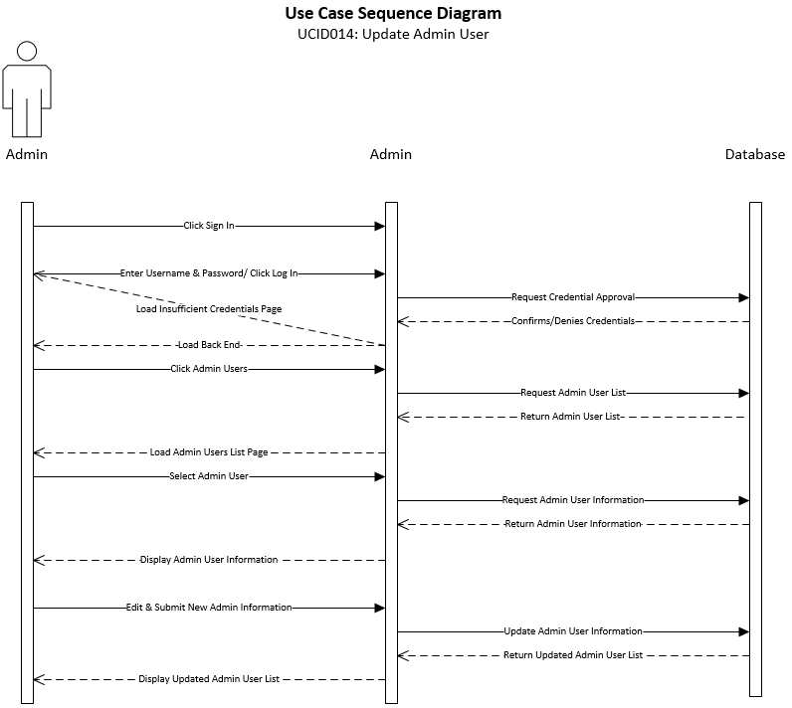

|  |
| --- |
| **Use Case:** Create Clinicals – Admin/Staff View |
| **ID:** UCID015 |
| **Brief Description:**  Describes how the system will create a clinical |
| **Primary Actors:** Admin |
| **Secondary Actors:** Admin/Staff |
| **Preconditions:**  System operational  Admin/Staff user must have rights to create clinicals |
| **Main Flow:**   1. Admin/Staff user will click login on website 2. Admin/Staff user enters credentials 3. Admin/Staff user clicks clinicals 4. Admin/Staff user creates clinicals 5. Admin/Staff user clicks submit |
| **Postconditions:** Clinical is created |
| **Alternative flows:**  None |

The sequence diagram shows the necessary flow of interactions between the primary actor and the system. Based on interactions with the system, different steps can be taken to achieve the creation, deletion, reading, and modification of different aspects of the system. This shows the “happy day” scenario of how the system would run.

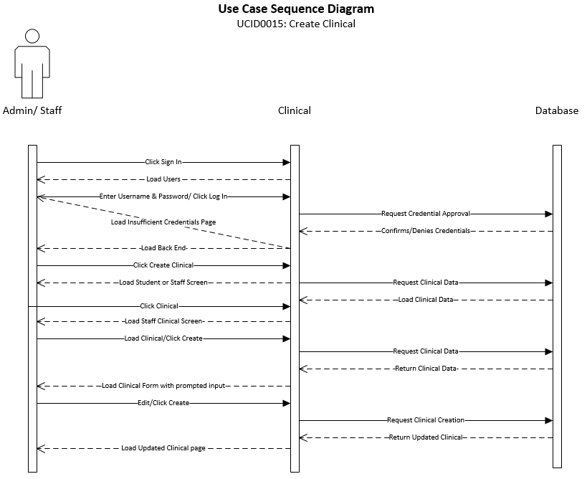

|  |
| --- |
| **Use Case:** Read Clinicals – Admin/Staff View |
| **ID:** UCID016 |
| **Brief Description:**  Describes how the system will view Clinicals data |
| **Primary Actors:** Admin |
| **Secondary Actors:** Admin/Staff |
| **Preconditions:**  System operational  Admin/Staff user must have rights to view clinicals |
| **Main Flow:**   1. Admin/Staff user will click login on website 2. Admin/Staff user enters credentials 3. Admin/Staff user clicks clinicals 4. Admin/Staff user views Clinicals |
| **Postconditions:** Mail Directory is read |
| **Alternative flows:**  None |

The sequence diagram shows the necessary flow of interactions between the primary actor and the system. Based on interactions with the system, different steps can be taken to achieve the creation, deletion, reading, and modification of different aspects of the system. This shows the “happy day” scenario of how the system would run.

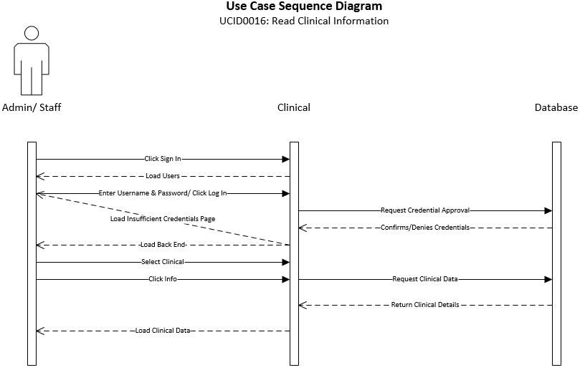

|  |
| --- |
| **Use Case:** Update Clinicals – Admin/Staff View |
| **ID:** UCID017 |
| **Brief Description:**  Describes how the system will update a Clinical |
| **Primary Actors:** Admin |
| **Secondary Actors:** Admin/Staff |
| **Preconditions:**  System operational  Admin/Staff user must have rights to update clinicals |
| **Main Flow:**   1. Admin/Staff user will click login on website 2. Admin/Staff user enters credentials 3. Admin/Staff user clicks Clinicals 4. Admin/Staff user views Clinicals 5. Admin/Staff user clicks Update Clinicals |
| **Postconditions:** Clinical is updated |
| **Alternative flows:**  None |

The sequence diagram shows the necessary flow of interactions between the primary actor and the system. Based on interactions with the system, different steps can be taken to achieve the creation, deletion, reading, and modification of different aspects of the system. This shows the “happy day” scenario of how the system would run.

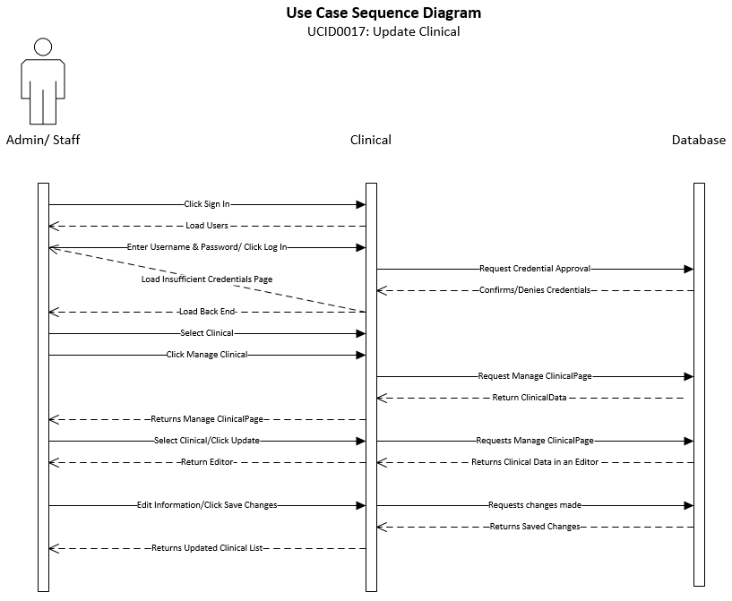

|  |
| --- |
| **Use Case:** Delete Clinicals – Admin/Staff View |
| **ID:** UCID018 |
| **Brief Description:**  Describes how the system will delete a Clinical |
| **Primary Actors:** Admin |
| **Secondary Actors:** Admin/Staff |
| **Preconditions:**  System operational  Admin/Staff user must have rights to delete clinicals |
| **Main Flow:**   1. Admin/Staff user will click login on website 2. Admin/Staff user enters credentials 3. Admin/Staff user clicks Clinicals 4. Admin/Staff user views Clinicals 5. Admin/Staff user clicks Delete Clinical |
| **Postconditions:** Clinical is deleted |
| **Alternative flows:**  None |

The sequence diagram shows the necessary flow of interactions between the primary actor and the system. Based on interactions with the system, different steps can be taken to achieve the creation, deletion, reading, and modification of different aspects of the system. This shows the “happy day” scenario of how the system would run.

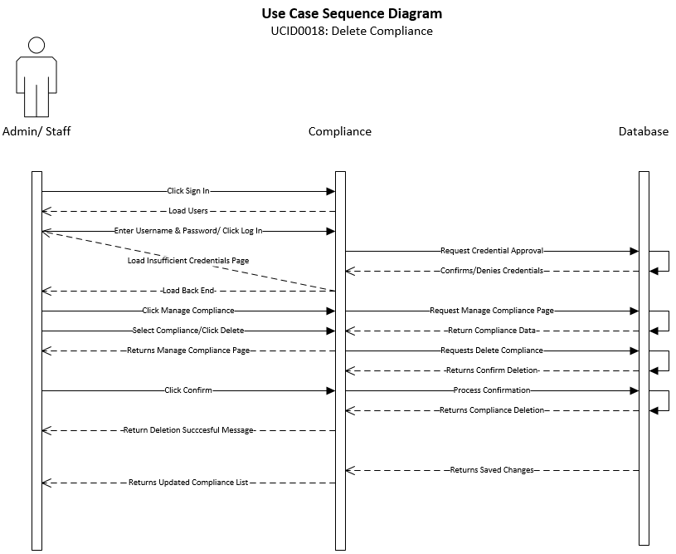

|  |
| --- |
| **Use Case:** Create Compliance – Admin/Staff View |
| **ID:** UCID019 |
| **Brief Description:**  Describes how the system will create a Compliance |
| **Primary Actors:** Admin |
| **Secondary Actors:** Admin/Staff |
| **Preconditions:**  System operational  Admin/Staff user must have rights to create Compliance |
| **Main Flow:**   1. Admin/Staff user will click login on website 2. Admin/Staff user enters credentials 3. Admin/Staff user clicks Compliance 4. Admin/Staff user creates Compliance 5. Admin/Staff user clicks Submit |
| **Postconditions:** Compliance is created |
| **Alternative flows:**  None |

The sequence diagram shows the necessary flow of interactions between the primary actor and the system. Based on interactions with the system, different steps can be taken to achieve the creation, deletion, reading, and modification of different aspects of the system. This shows the “happy day” scenario of how the system would run.

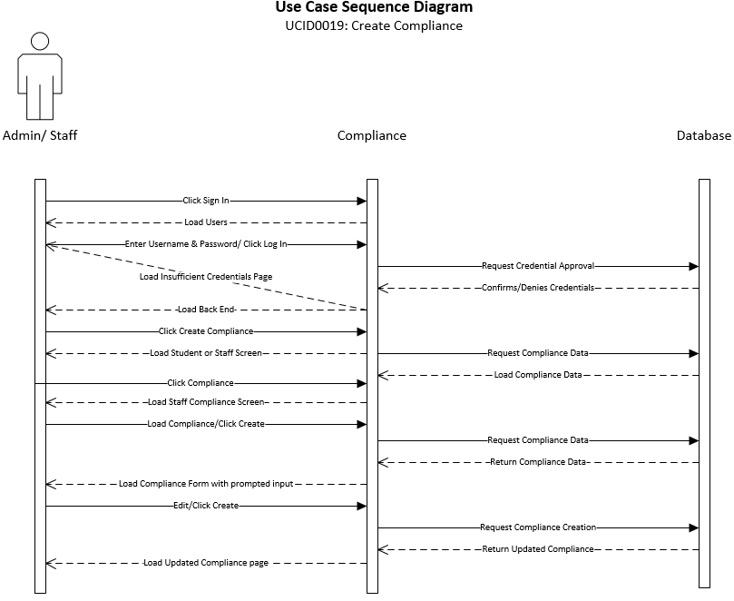

|  |
| --- |
| **Use Case:** Read Compliance – Admin/Staff View |
| **ID:** UCID020 |
| **Brief Description:**  Describes how the system will view a Compliance |
| **Primary Actors:** Admin |
| **Secondary Actors:** Admin/Staff |
| **Preconditions:**  System operational  Admin/Staff user must have rights to view a Compliance |
| **Main Flow:**   1. Admin/Staff user will click login on website 2. Admin/Staff user enters credentials 3. Admin/Staff user clicks Compliance 4. Admin/Staff user views Compliance |
| **Postconditions:** Compliance is read |
| **Alternative flows:**  None |

The sequence diagram shows the necessary flow of interactions between the primary actor and the system. Based on interactions with the system, different steps can be taken to achieve the creation, deletion, reading, and modification of different aspects of the system. This shows the “happy day” scenario of how the system would run.

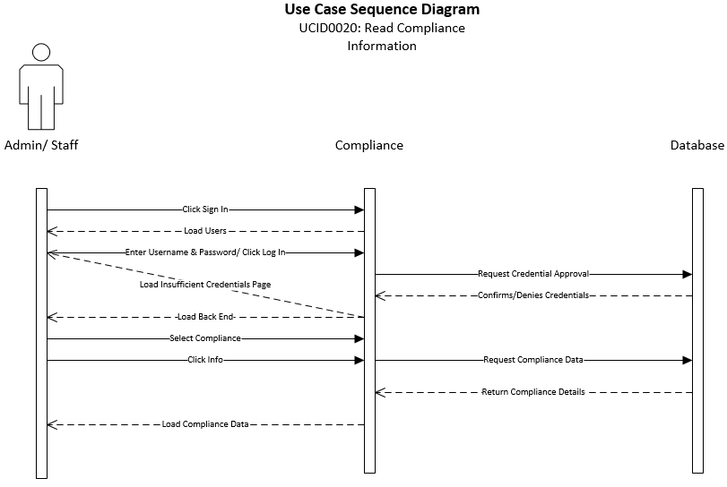

|  |
| --- |
| **Use Case:** Update Compliance – Admin/Staff View |
| **ID:** UCID021 |
| **Brief Description:**  Describes how the system will update a Compliance |
| **Primary Actors:** Admin |
| **Secondary Actors:** Admin/Staff |
| **Preconditions:**  System operational  Admin/Staff user must have rights to update a Compliance |
| **Main Flow:**   1. Admin/Staff user will click login on website 2. Admin/Staff user enters credentials 3. Admin/Staff user clicks Compliance 4. Admin/Staff user views Compliance 5. Admin/Staff user clicks Update Compliance |
| **Postconditions:** Compliance is updated |
| **Alternative flows:**  None |

The sequence diagram shows the necessary flow of interactions between the primary actor and the system. Based on interactions with the system, different steps can be taken to achieve the creation, deletion, reading, and modification of different aspects of the system. This shows the “happy day” scenario of how the system would run.

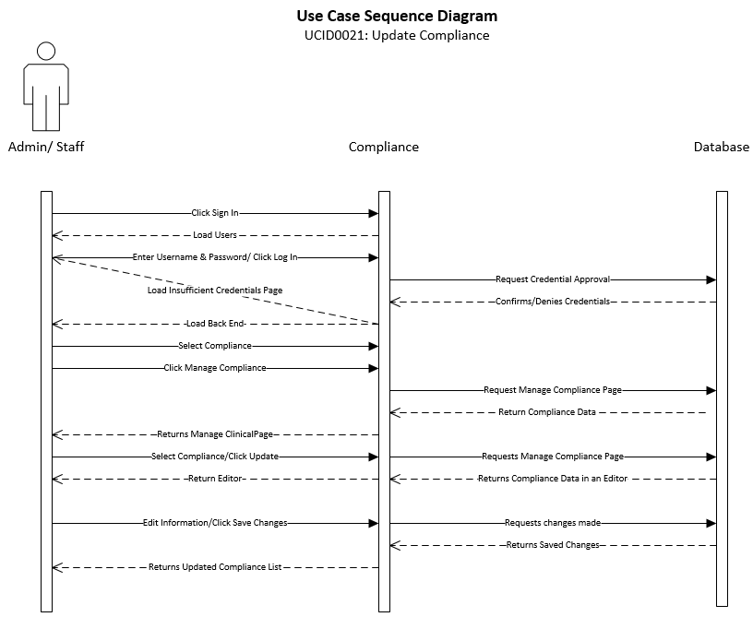

|  |
| --- |
| **Use Case:** Delete Compliance – Admin/Staff View |
| **ID:** UCID022 |
| **Brief Description:**  Describes how the system will delete a Compliance |
| **Primary Actors:** Admin |
| **Secondary Actors:** Admin/Staff |
| **Preconditions:**  System operational  Admin/Staff user must have rights to delete a Compliance |
| **Main Flow:**   1. Admin/Staff user will click login on website 2. Admin/Staff user enters credentials 3. Admin/Staff user clicks Compliance 4. Admin/Staff user views Compliance 5. Admin/Staff user clicks Delete Compliance |
| **Postconditions:** Compliance is deleted |
| **Alternative flows:**  None |

The sequence diagram shows the necessary flow of interactions between the primary actor and the system. Based on interactions with the system, different steps can be taken to achieve the creation, deletion, reading, and modification of different aspects of the system. This shows the “happy day” scenario of how the system would run.

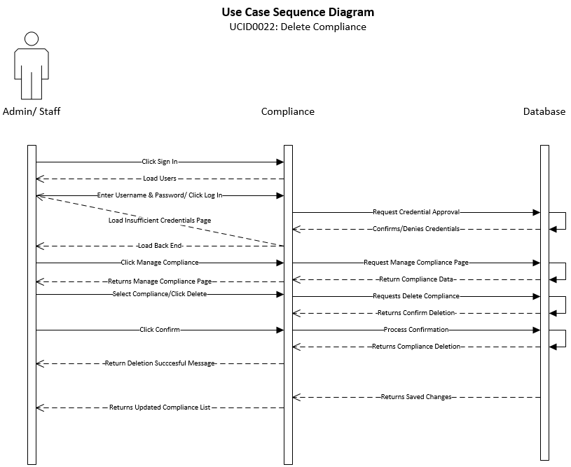

|  |
| --- |
| **Use Case:** Approve Compliance – Admin/Staff View |
| **ID:** UCID023 |
| **Brief Description:**  Describes how the system will approve a Compliance |
| **Primary Actors:** Admin |
| **Secondary Actors:** Admin/Staff |
| **Preconditions:**  System operational  Admin/Staff user must have rights to approve Compliance  Compliance must be created |
| **Main Flow:**   1. Admin/Staff user will click login on website 2. Admin/Staff user enters credentials 3. Admin/Staff user clicks Compliance 4. Admin/Staff user views Compliance 5. Admin/Staff user clicks Approve Compliance |
| **Postconditions:** Compliance is approved |
| **Alternative flows:**  None |

The sequence diagram shows the necessary flow of interactions between the primary actor and the system. Based on interactions with the system, different steps can be taken to achieve the creation, deletion, reading, and modification of different aspects of the system. This shows the “happy day” scenario of how the system would run.

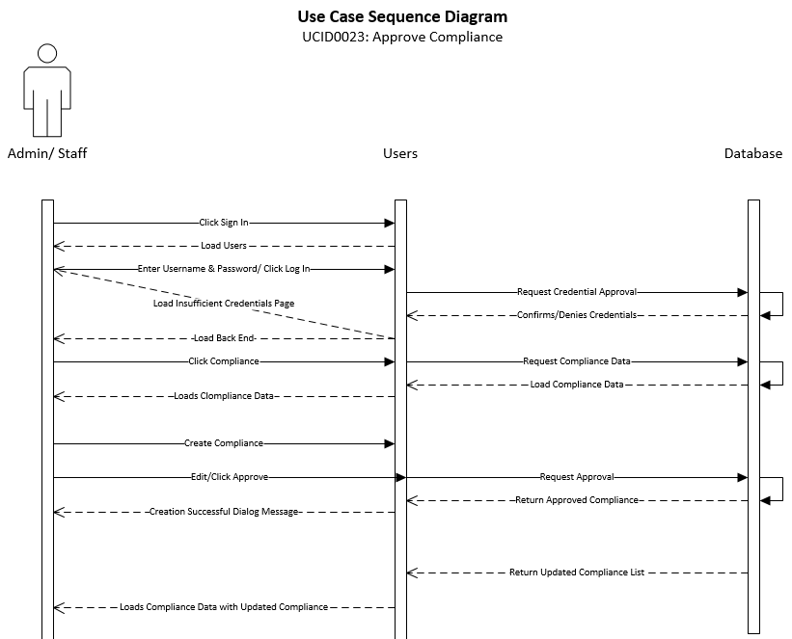

|  |
| --- |
| **Use Case: Create Event** |
| **ID: UCID024** |
| **Brief Description:**  This use case describes how a Staff or Admin user creates Events. |
| **Primary Actors:**  Staff/Administrator |
| **Secondary Actors:**  None |
| **Preconditions:**   1. User account has been approved 2. User is logged in |
| **Main Flow:**   1. User clicks News & Events 2. User selects Date on Calendar 3. User inputs Event Name 4. User inputs Event Location 5. User inputs Event Date 6. User inputs Event Description 7. User clicks Create Event |
| **Postconditions:**   1. The Event is created and ready to be posted to the News & Events page. |
| **Alternative flows:**  None |

The sequence diagram shows the necessary flow of interactions between the primary actor and the system. Based on interactions with the system, different steps can be taken to achieve the creation, deletion, reading, and modification of different aspects of the system. This shows the “happy day” scenario of how the system would run.

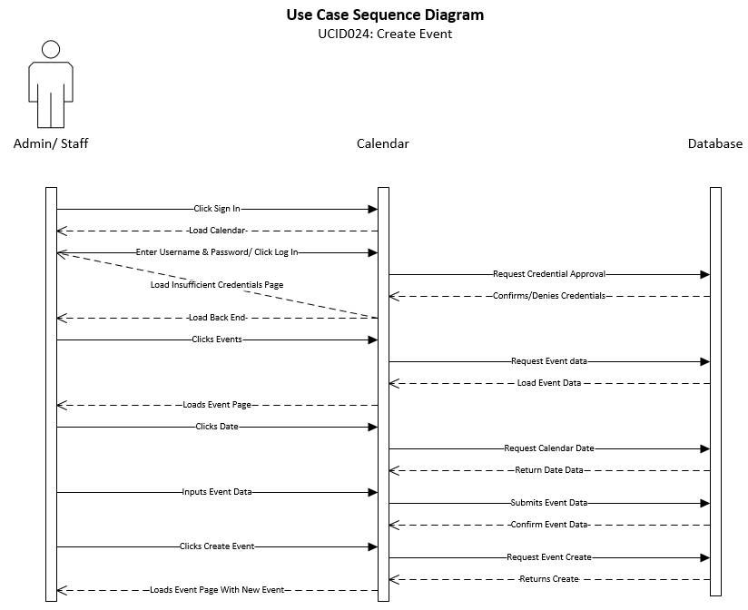

|  |
| --- |
| **Use Case: Read Event** |
| **ID: UCID025** |
| **Brief Description:**  This use case describes how a Staff or Admin user reads an Event. |
| **Primary Actors:**  Staff/Administrator |
| **Secondary Actors:**  None |
| **Preconditions:**   1. User account has been approved 2. User is logged in 3. Event created and posted to News & Events |
| **Main Flow:**   1. User clicks News & Events 2. User selects Date on Calendar |
| **Postconditions:**   1. Selected Event details are viewable. |
| **Alternative flows:**  None |

The sequence diagram shows the necessary flow of interactions between the primary actor and the system. Based on interactions with the system, different steps can be taken to achieve the creation, deletion, reading, and modification of different aspects of the system. This shows the “happy day” scenario of how the system would run.

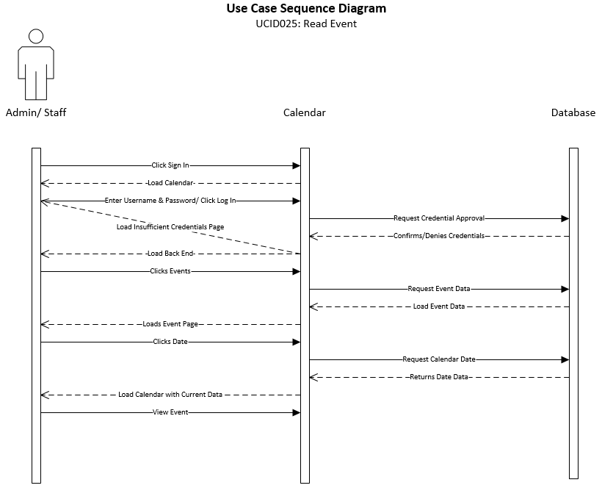

|  |
| --- |
| **Use Case: Update Event** |
| **ID: UCID026** |
| **Brief Description:**  This use case describes how a Staff or Admin user updates an Event. |
| **Primary Actors:**  Staff/Administrator |
| **Secondary Actors:**  None |
| **Preconditions:**   1. User account has been approved 2. User is logged in 3. Event has been created |
| **Main Flow:**   1. User clicks News & Events 2. User selects Date on Calendar 3. User clicks Edit 4. User alters Event data as desired 5. User clicks Submit |
| **Postconditions:**   1. Selected Event is updated. |
| **Alternative flows:**  None |

The sequence diagram shows the necessary flow of interactions between the primary actor and the system. Based on interactions with the system, different steps can be taken to achieve the creation, deletion, reading, and modification of different aspects of the system. This shows the “happy day” scenario of how the system would run.

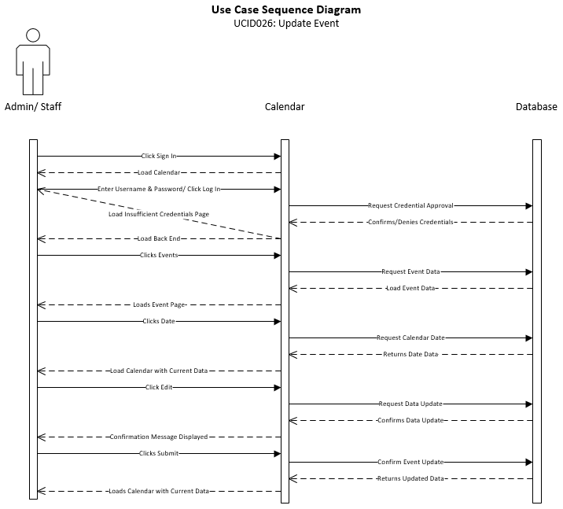

|  |
| --- |
| **Use Case: Delete Event** |
| **ID: UCID027** |
| **Brief Description:**  This use case describes how a Staff or Admin user deletes an Event. |
| **Primary Actors:**  Staff/Administrator |
| **Secondary Actors:**  None |
| **Preconditions:**   1. User account has been approved 2. User is logged in 3. Event has been created |
| **Main Flow:**   1. User clicks News & Events 2. User selects Date on Calendar 3. User clicks Delete 4. User confirms Delete |
| **Postconditions:**   1. The Event is deleted and no longer displayed on the News & Events page. |
| **Alternative flows:**  None |

The sequence diagram shows the necessary flow of interactions between the primary actor and the system. Based on interactions with the system, different steps can be taken to achieve the creation, deletion, reading, and modification of different aspects of the system. This shows the “happy day” scenario of how the system would run.

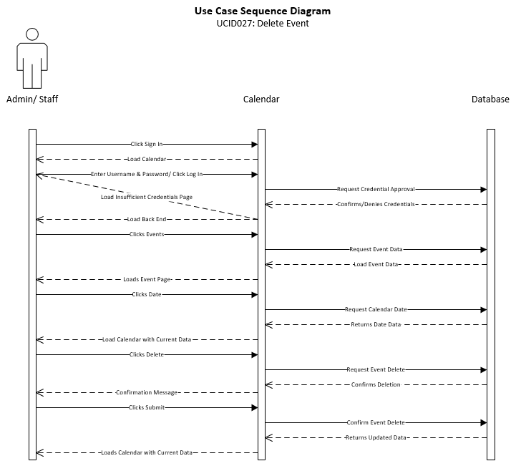

|  |
| --- |
| **Use Case: Post Event** |
| **ID: UCID028** |
| **Brief Description:**  This use case describes how a Staff or Admin user Posts an Event. |
| **Primary Actors:**  Staff/Administrator |
| **Secondary Actors:**  None |
| **Preconditions:**   1. User account has been approved 2. User is logged in 3. Event has been created |
| **Main Flow:**   1. User clicks News & Events 2. User selects Date on Calendar 3. User clicks Post |
| **Postconditions:**   1. The Event is posted to the News & Events page and viewable by all approved Users. |
| **Alternative flows:**  None |

The sequence diagram shows the necessary flow of interactions between the primary actor and the system. Based on interactions with the system, different steps can be taken to achieve the creation, deletion, reading, and modification of different aspects of the system. This shows the “happy day” scenario of how the system would run.

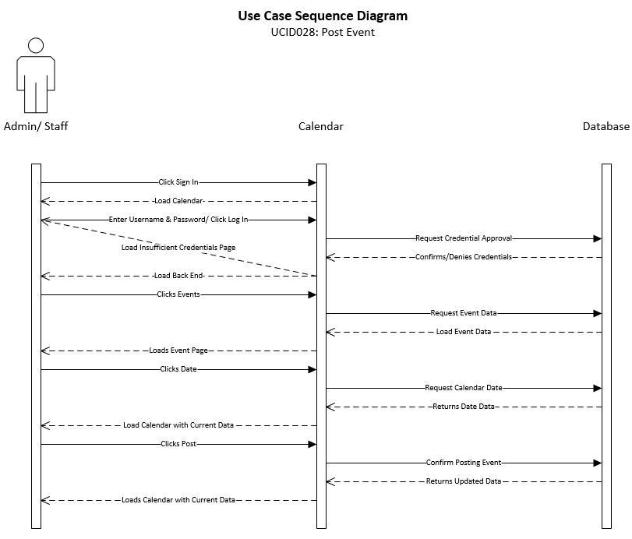

|  |
| --- |
| **Use Case: Create News** |
| **ID: UCID029** |
| **Brief Description:**  This use case describes how a Staff or Admin user creates a News item. |
| **Primary Actors:**  Staff/Administrator |
| **Secondary Actors:**  None |
| **Preconditions:**   1. User account has been approved 2. User is logged in |
| **Main Flow:**   1. User clicks News & Events 2. User clicks Create News 3. User inputs News ID 4. User inputs News Title 5. User inputs News Description 6. User inputs News Body 7. User inputs News Author 8. User inputs News Time Stamp (date & time) 9. User clicks Submit |
| **Postconditions:**   1. The User is returned to the News & Events page with the News item created and ready to be posted. |
| **Alternative flows:**  None |

The sequence diagram shows the necessary flow of interactions between the primary actor and the system. Based on interactions with the system, different steps can be taken to achieve the creation, deletion, reading, and modification of different aspects of the system. This shows the “happy day” scenario of how the system would run.

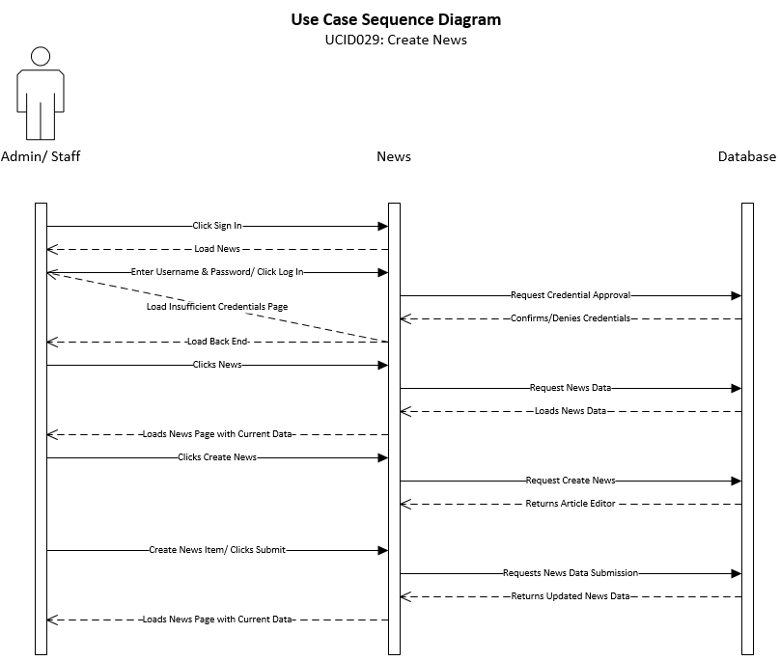

|  |
| --- |
| **Use Case: Read News** |
| **ID: UCID030** |
| **Brief Description:**  This use case describes how a Staff or Admin user reads a News item. |
| **Primary Actors:**  Staff/Administrator |
| **Secondary Actors:**  None |
| **Preconditions:**   1. User account has been approved 2. User is logged in 3. News item exists |
| **Main Flow:**   1. User clicks News & Events 2. User selects desired News item |
| **Postconditions:**   1. Selected News item is displayed |
| **Alternative flows:**  None |

The sequence diagram shows the necessary flow of interactions between the primary actor and the system. Based on interactions with the system, different steps can be taken to achieve the creation, deletion, reading, and modification of different aspects of the system. This shows the “happy day” scenario of how the system would run.

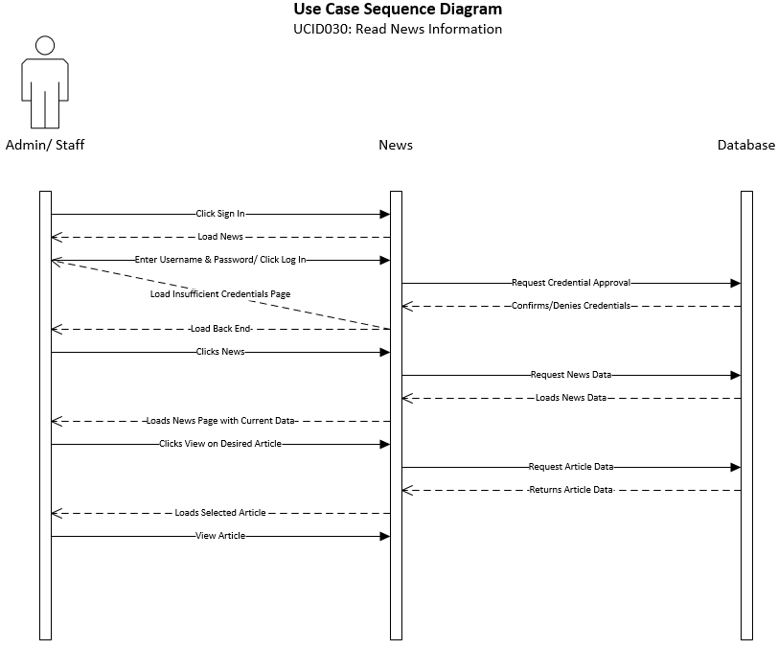

|  |
| --- |
| **Use Case: Update News** |
| **ID: UCID031** |
| **Brief Description:**  This use case describes how a user would update news articles. |
| **Primary Actors:**  Admin |
| **Secondary Actors:**  Staff |
| **Preconditions:** The Web System must be active.The user must be logged in and have the appropriate permissions.An article must have been created/imported previously.An article must be selected. |
| **Main Flow:**   * The user will click the ‘Sign In’ link anywhere in the Front-End of the website. * Once clicked they do so, they will be redirected to the Login section of the website. They then will enter their credentials and click login. * When the user is validated they will be redirected to the Back-End where they will click “News”. * This will redirect the user to the Manage News section of the Back-End. Here the user will select a previously created/imported article from the “Current News” section. * Once selected the data will populate and the user will click edit. * Once clicked the news article editor will appear and the user will make their desired changes. * Once the edits are complete, the user clicks the update button. When the update button has been selected, the user will have the option to save to the original version, or create a copy with the new changes. |
| **Postconditions:** The article will be updated. |
| **Alternative flows:**  None |

The sequence diagram shows the necessary flow of interactions between the primary actor and the system. Based on interactions with the system, different steps can be taken to achieve the creation, deletion, reading, and modification of different aspects of the system. This shows the “happy day” scenario of how the system would run.

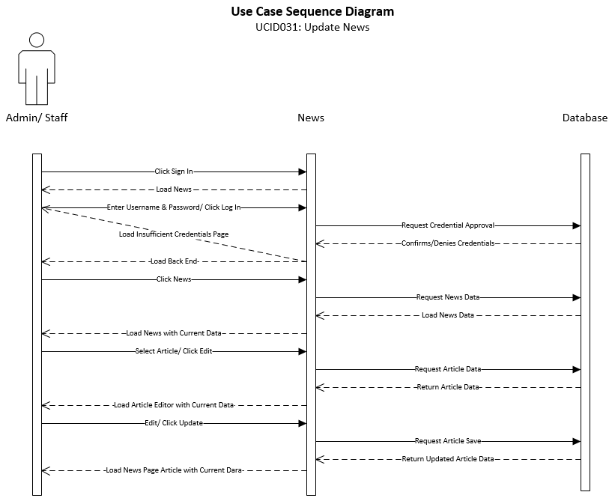

|  |
| --- |
| **Use Case: Delete News** |
| **ID: UCID032** |
| **Brief Description:**  This use case describes how a user will delete news articles. |
| **Primary Actors:**  Admin |
| **Secondary Actors:**  Staff |
| Preconditions: The Web System must be Active.The Staff user must be logged in and have the correct permissions.An article must be selected.The staff user must accept all warnings before deletion. |
| **Main Flow:**   * The staff user will click the “Sign In” link anywhere in the Front-End of the website. * Once clicked they will be redirected to the Login section of the website. They then will enter their credentials and click login. * When the user is validated they will be redirected to the Back-End where they will click “News”. This will redirect the user to the Manage News section of the Back-End. * Here the user will filter/select a created/imported article by highlighting a specific article in the “Current News” section. * Once highlighted the user clicks the delete button. * The user will then have to accept multiple deletion confirmations stating that once deleted, the article will be permanently deleted. After the user accepts the criteria, the article will be removed from the database. |
| **Postconditions:** The news article will be deleted. |
| **Alternative flows:**  None |

The sequence diagram shows the necessary flow of interactions between the primary actor and the system. Based on interactions with the system, different steps can be taken to achieve the creation, deletion, reading, and modification of different aspects of the system. This shows the “happy day” scenario of how the system would run.

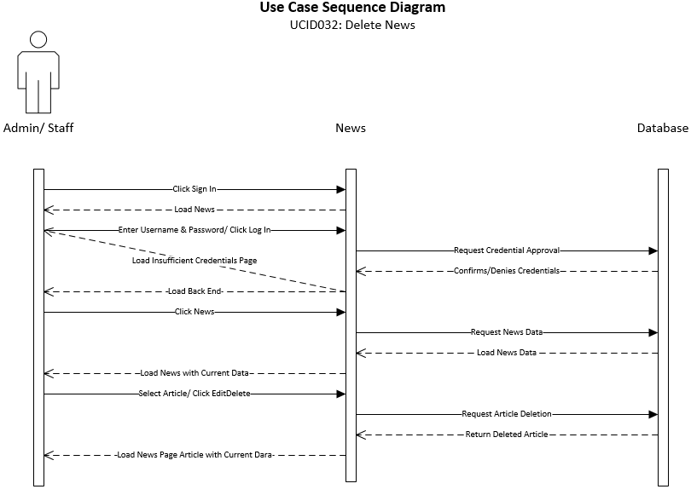

|  |
| --- |
| **Use Case: Post News** |
| **ID:** **UCID033** |
| **Brief Description:**  Describes how a news article can be posted to the system. |
| **Primary Actors:**  Admin |
| **Secondary Actors:**  Staff |
| **Preconditions:** The Web System must be Active.The Staff user must be logged in and have the correct permissions. |
| **Main Flow:**   * The staff user will click the “Sign In” link anywhere in the Front-End of the website. * Once clicked they will be redirected to the Login section of the website. They then will enter their credentials and click login. * When the user is validated they will be redirected to the Back-End where they will click “News”. * This will redirect the user to the Manage News section of the Back-End. Here the user will click Create News. * The Create News form will be loaded for the user. * The user will input/ import the news article, and click Post Article. |
| **Postconditions:**  The news article will be posted. |
| **Alternative flows:**  None |

The sequence diagram shows the necessary flow of interactions between the primary actor and the system. Based on interactions with the system, different steps can be taken to achieve the creation, deletion, reading, and modification of different aspects of the system. This shows the “happy day” scenario of how the system would run.

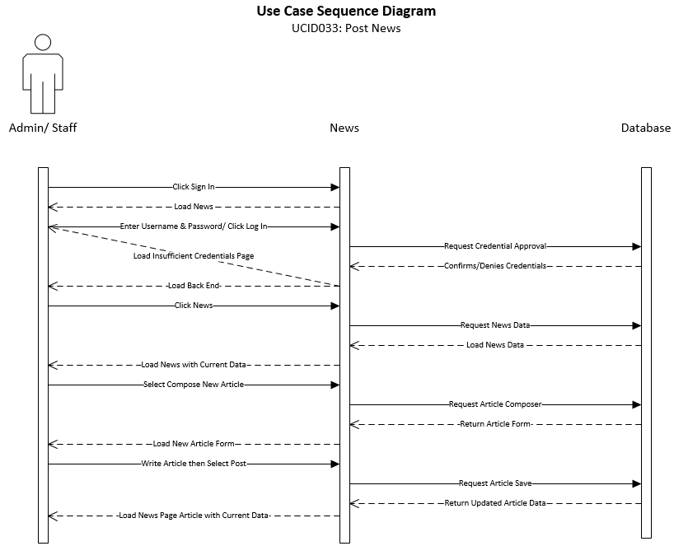

|  |
| --- |
| **Use Case: Create Schedule Item** |
| **ID:** **UCID034** |
| **Brief Description:**  Describes how the Admin can create schedule items like courses or classes. |
| **Primary Actors:**  Admin |
| **Secondary Actors:**  None |
| **Preconditions:** The Web System must be Active.The Staff user must be logged in and have the correct permissions. |
| **Main Flow:**   * The user will click the “Sign In” link anywhere in the Front-End of the website. * Once clicked they will be redirected to the Login section of the website. They then will enter their credentials and click login. * When the user is validated they will be redirected to the Back-End where they will click “Schedule”. * This will redirect the user to the Manage Schedule section of the Back-End. Here the user will select “Create Schedule Item”. * Once clicked the Schedule Class editor will appear and the user will input their desired class data. * Once the data has been inputted, the user will click “Create Schedule Item”. |
| **Postconditions:** The class will be created. |
| **Alternative flows:**  None |

The sequence diagram shows the necessary flow of interactions between the primary actor and the system. Based on interactions with the system, different steps can be taken to achieve the creation, deletion, reading, and modification of different aspects of the system. This shows the “happy day” scenario of how the system would run.

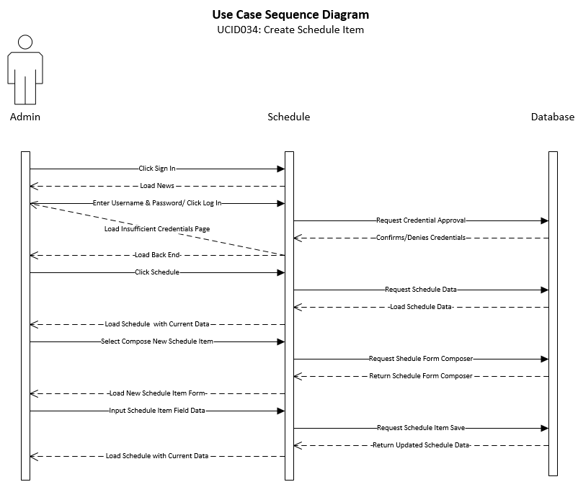

|  |
| --- |
| **Use Case: Read Schedule Item Information** |
| **ID:** **UCID035** |
| **Brief Description:**  This describes how a user will view/ review scheduled classes. |
| **Primary Actors:**  Admin/ Staff |
| **Secondary Actors:**  Student |
| **Preconditions:** The Web System must be active.The user must be logged in and have the appropriate permissions.A schedule must have been created/imported previously.A schedule item must be selected. |
| **Main Flow:**   * The user will click the “Sign In” link anywhere in the Front-End of the website. * Once clicked they will be redirected to the Login section of the website. They then will enter their credentials and click login. * When the user is validated they will be redirected to Back-End where they will click “Schedule”. * The user will select a class stored in the system by selecting any item in the “Scheduled Items” section, and clicking “View Schedule”. |
| **Postconditions:**  The current schedule of classes will be displayed. |
| **Alternative flows:**  None |

The sequence diagram shows the necessary flow of interactions between the primary actor and the system. Based on interactions with the system, different steps can be taken to achieve the creation, deletion, reading, and modification of different aspects of the system. This shows the “happy day” scenario of how the system would run.

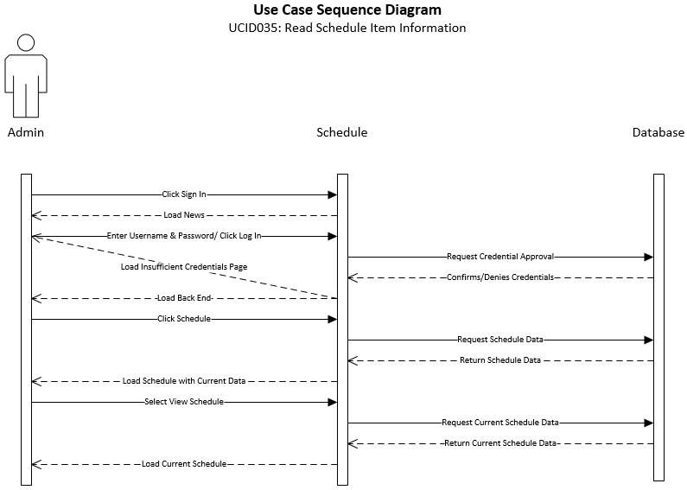

|  |
| --- |
| **Use Case: Update Schedule Item** |
| **ID:** **UCID036** |
| **Brief Description:**  This use case describes how to update scheduled items, like classes. |
| **Primary Actors:**  Admin |
| **Secondary Actors:**  None |
| **Preconditions:** The Web System must be active.The user must be logged in and have the appropriate permissions.A class must have been created/imported previously.A class must be selected. |
| **Main Flow:**   * The user will click the “Sign In” link anywhere in the Front-End of the website. * Once clicked they will be redirected to the Login section of the website. They then will enter their credentials and click login. * When the user is validated they will be redirected to the Back-End where they will click “Schedule”. * This will redirect the user to the Manage Schedule section of the Back-End. Here the user will select a previously created/imported class from the “Scheduled Items” page. * Once selected the data will populate and the user will click edit. * Once clicked the schedule item editor will appear and the user will make their desired changes. * Once the edits are complete, the user clicks the update button. |
| **Postconditions:**  The schedule of classes will be updated. |
| **Alternative flows:**  None |

The sequence diagram shows the necessary flow of interactions between the primary actor and the system. Based on interactions with the system, different steps can be taken to achieve the creation, deletion, reading, and modification of different aspects of the system. This shows the “happy day” scenario of how the system would run.

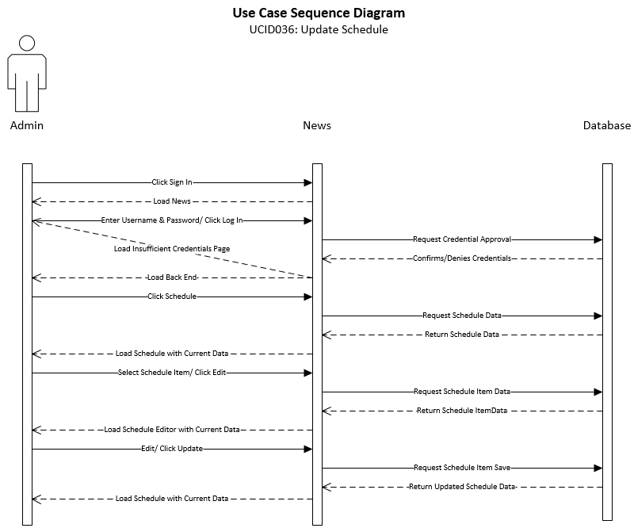

|  |
| --- |
| **Use Case: Delete Schedule Item** |
| **ID:** **UCID037** |
| **Brief Description:**  This Use Case describes how to delete schedule item. |
| **Primary Actors:**  Admin |
| **Secondary Actors:**  None |
| **Preconditions:** The Web System must be Active.The Staff user must be logged in and have the correct permissions.A class must be selected.The user must accept all warning before deletion. |
| **Main Flow:**   * The staff user will click the “Sign Up/Sign In” link anywhere in the Front-End of the website. * Once clicked they will be redirected to the Login section of the website. They then will enter their credentials and click login. * When the user is validated they will be redirected to the Back-End where they will click “Schedule”. This will redirect the Staff user to the Manage Schedule section of the Back-End. * Here the user will filter/select a created/imported class by highlighting a specific class in the “Scheduled Classes” section. * Once highlighted the user clicks the delete button. * The user will then have to accept multiple deletion confirmations stating that once deleted, the article will be permanently deleted. After the user accepts the criteria, the article will be removed from the database. |
| **Postconditions:**  The scheduled class will be deleted. |
| **Alternative flows:**  None |

The sequence diagram shows the necessary flow of interactions between the primary actor and the system. Based on interactions with the system, different steps can be taken to achieve the creation, deletion, reading, and modification of different aspects of the system. This shows the “happy day” scenario of how the system would run.

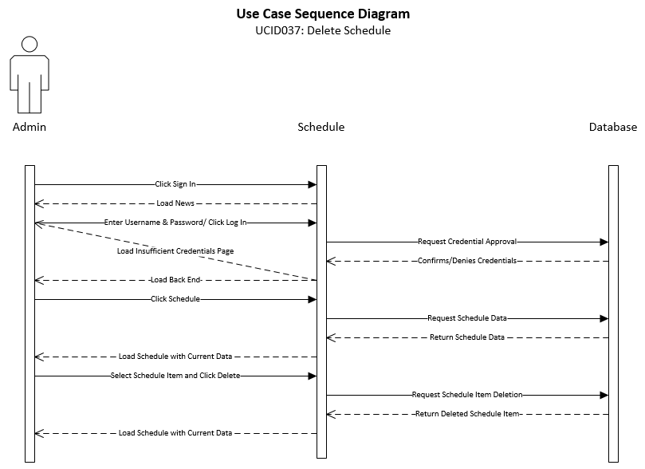

|  |
| --- |
| **Use Case: Post Schedule** |
| **ID: UCID038** |
| **Brief Description:**  This use case describes how to post a schedule of items. |
| **Primary Actors:**  Admin |
| **Secondary Actors:**  Staff |
| **Preconditions:** The Web System must be Active.The user must be logged in and have the correct permissions. |
| **Main Flow:**   * The staff user will click the “Sign Up/Sign In” link anywhere in the Front-End of the website. * Once clicked they will be redirected to the Login section of the website. They then will enter their credentials and click login. * When the user is validated they will be redirected to the Back-End where they will click “Schedule”. * This will redirect the user to the Manage Schedule section of the Back-End. Here the user will input the class and click post. |
| **Postconditions:**  **The new class will be posted.** |
| **Alternative flows:**  None |

The sequence diagram shows the necessary flow of interactions between the primary actor and the system. Based on interactions with the system, different steps can be taken to achieve the creation, deletion, reading, and modification of different aspects of the system. This shows the “happy day” scenario of how the system would run.

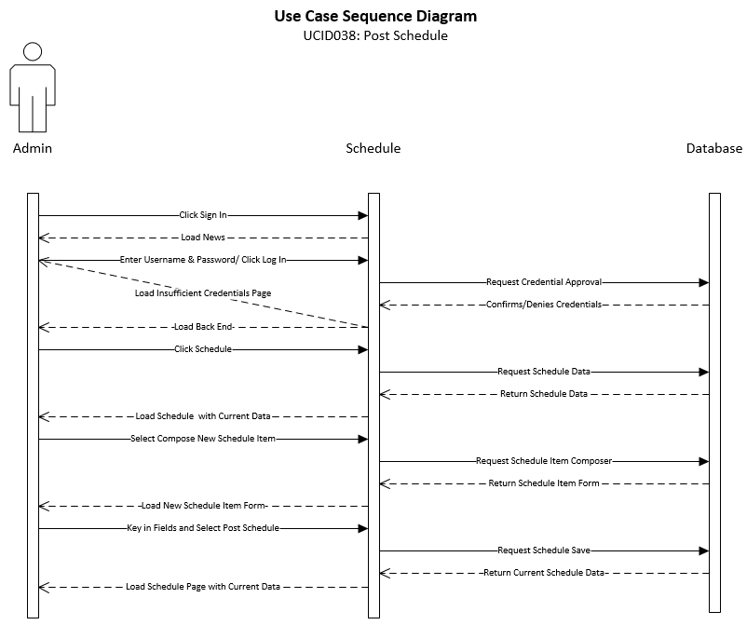

|  |
| --- |
| **Use Case: Create Question** |
| **ID: UCID039** |
| **Brief Description:**  This use case describes how a student user would create a question for staff users. |
| **Primary Actors:**  Student |
| **Secondary Actors:**  None |
| **Preconditions:**  The Web System must be active.  The user must have the appropriate permissions. |
| **Main Flow:**   * The staff user will click the “Sign Up/Sign In” link anywhere in the Front-End of the website. * Once clicked they will be redirected to the Login section of the website. They then will enter their credentials and click login. * When the user is validated they will be redirected to the Back-End where they will click “Question”. * This will redirect the user to the “Questions” section of the Back-End. Here the user will select “Ask a Question”. |
| **Postconditions:**  The Ask a Question form will be presented to the student. |
| **Alternative flows:**  None |

The sequence diagram shows the necessary flow of interactions between the primary actor and the system. Based on interactions with the system, different steps can be taken to achieve the creation, deletion, reading, and modification of different aspects of the system. This shows the “happy day” scenario of how the system would run.

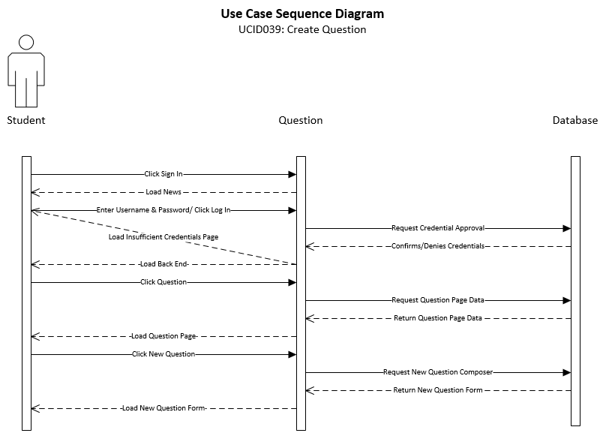

|  |
| --- |
| **Use Case: Submit Question** |
| **ID: UCID040** |
| **Brief Description:**  This use case describes how a student user would submit a question for staff users. |
| **Primary Actors:**  Student |
| **Secondary Actors:**  None |
| **Preconditions:**  The Web System must be active.  The user must have the appropriate permissions. |
| **Main Flow:**   * The staff user will click the “Sign Up/Sign In” link anywhere in the Front-End of the website. * Once clicked they will be redirected to the Login section of the website. They then will enter their credentials and click login. * When the user is validated they will be redirected to the Back-End where they will click “Question”. * This will redirect the user to the “Questions” section of the Back-End. Here the user will select “Ask a Question”. * The “Ask a Question” form will be generated. * The user will input question and click “Submit Question”. |
| **Postconditions:**  The Ask a Question form will be presented to the student. |
| **Alternative flows:**  None |

The sequence diagram shows the necessary flow of interactions between the primary actor and the system. Based on interactions with the system, different steps can be taken to achieve the creation, deletion, reading, and modification of different aspects of the system. This shows the “happy day” scenario of how the system would run.

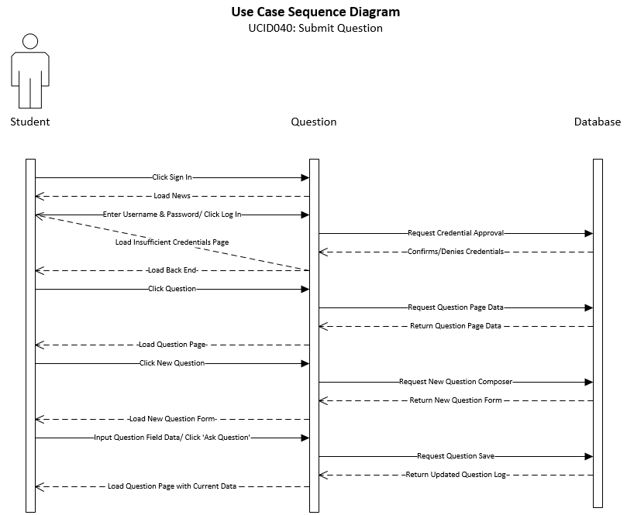

|  |
| --- |
| **Use Case:** Create Report – Admin/Staff View |
| **ID:** UCID041 |
| **Brief Description:** Describes the steps for creating a report. |
| **Primary Actors:** Admin |
| **Secondary Actors:** Staff |
| **Preconditions:** Admin/Staff user must be logged in  Admin/Staff must have rights to create a report |
| **Main Flow:**   1. Staff user clicks Reports 2. Staff user selects type of Report 3. Staff user clicks Filter By to specify report data 4. Staff user clicks Save to create report |
| **Postconditions:** Report is created |
| **Alternative flows:**  None |

The sequence diagram shows the necessary flow of interactions between the primary actor and the system. Based on interactions with the system, different steps can be taken to achieve the creation, deletion, reading, and modification of different aspects of the system. This shows the “happy day” scenario of how the system would run.

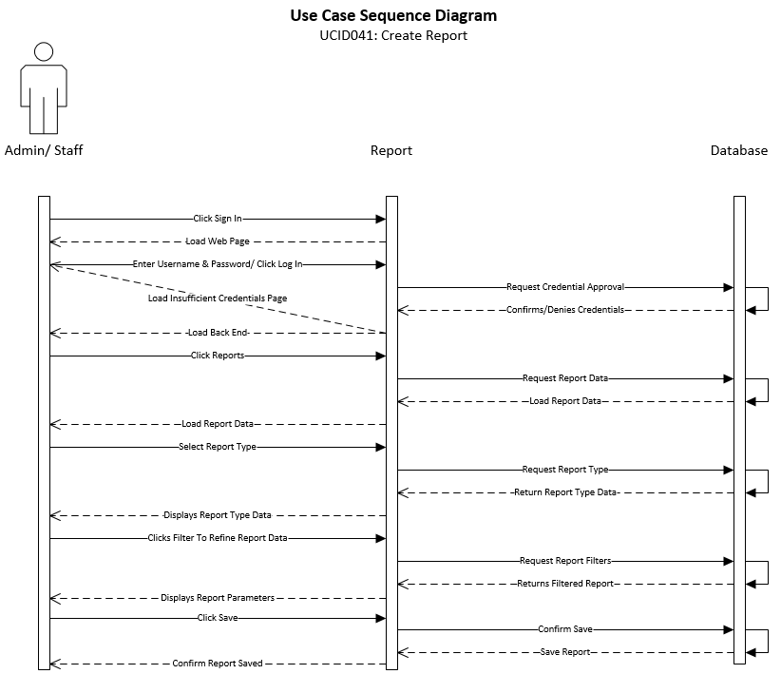

|  |
| --- |
| **Use Case:** Read Report Information – Admin/Staff View |
| **ID:** UCID042 |
| **Brief Description:**  Describes viewing/reviewing generated reports and their affiliated information. |
| **Primary Actors:** Admin |
| **Secondary Actors:** Staff |
| **Preconditions:** Admin/Staff must login  Admin/Staff user must have rights to read report  Report must first be created |
| **Main Flow:**   1. Admin/Staff user clicks Reports 2. Admin/Staff user selects name of report under Saved Report 3. Admin/Staff user clicks Load 4. Admin/Staff user reads report |
| **Postconditions:** Report is read |
| **Alternative flows:**  None |

The sequence diagram shows the necessary flow of interactions between the primary actor and the system. Based on interactions with the system, different steps can be taken to achieve the creation, deletion, reading, and modification of different aspects of the system. This shows the “happy day” scenario of how the system would run.

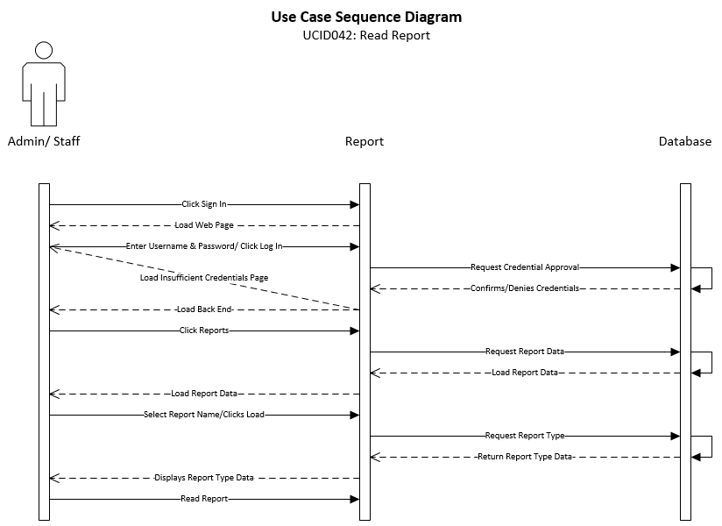

|  |
| --- |
| **Use Case:** Update Report – Admin/Staff View |
| **ID:** UCID043 |
| **Brief Description:**  Describes the steps for updating/altering a generated report. |
| **Primary Actors:** Admin |
| **Secondary Actors:** Staff |
| **Preconditions:** Admin/Staff must login  Admin/Staff must have rights to update report  Report must first be created |
| **Main Flow:**   1. Admin/Staff user clicks Reports 2. Admin/Staff user selects name of Report under Saved Reports 3. Admin/Staff user clicks Load 4. Admin/Staff user clicks Edit under Create/Edit Report |
| **Postconditions:** Report is updated |
| **Alternative flows:**  None |

The sequence diagram shows the necessary flow of interactions between the primary actor and the system. Based on interactions with the system, different steps can be taken to achieve the creation, deletion, reading, and modification of different aspects of the system. This shows the “happy day” scenario of how the system would run.

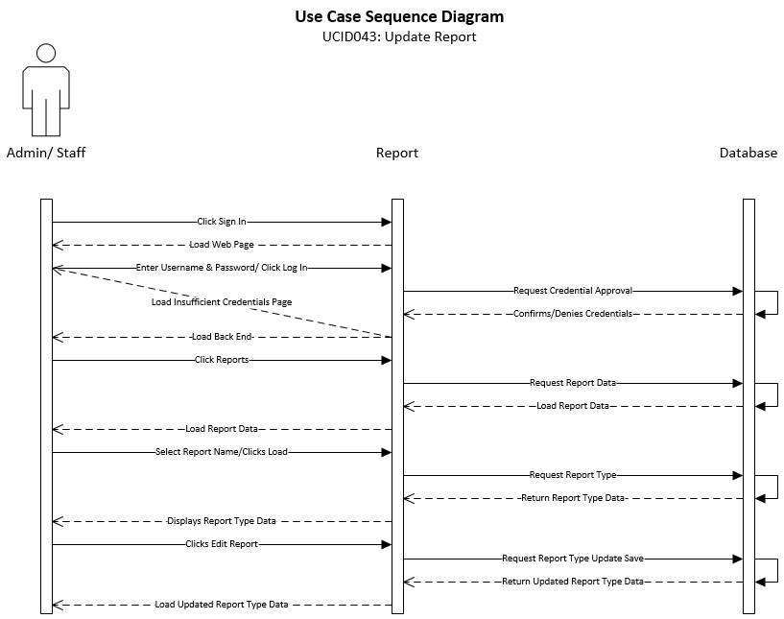

|  |
| --- |
| **Use Case:** Delete Report – Admin/Staff View |
| **ID:** UCID044 |
| **Brief Description:**  Describes the steps for removing a report. |
| **Primary Actors:** Admin |
| **Secondary Actors:** Staff |
| **Preconditions:** Admin/Staff must login  Admin/Staff must have rights to delete report  Report must first be created |
| **Main Flow:**   1. Admin/Staff user clicks Reports 2. Admin/Staff user selects name of report to delete 3. Admin/Staff user clicks Load 4. Admin/Staff user clicks Delete under Create/Edit Report |
| **Postconditions:** Report is deleted |
| **Alternative flows:**  None |

The sequence diagram shows the necessary flow of interactions between the primary actor and the system. Based on interactions with the system, different steps can be taken to achieve the creation, deletion, reading, and modification of different aspects of the system. This shows the “happy day” scenario of how the system would run.

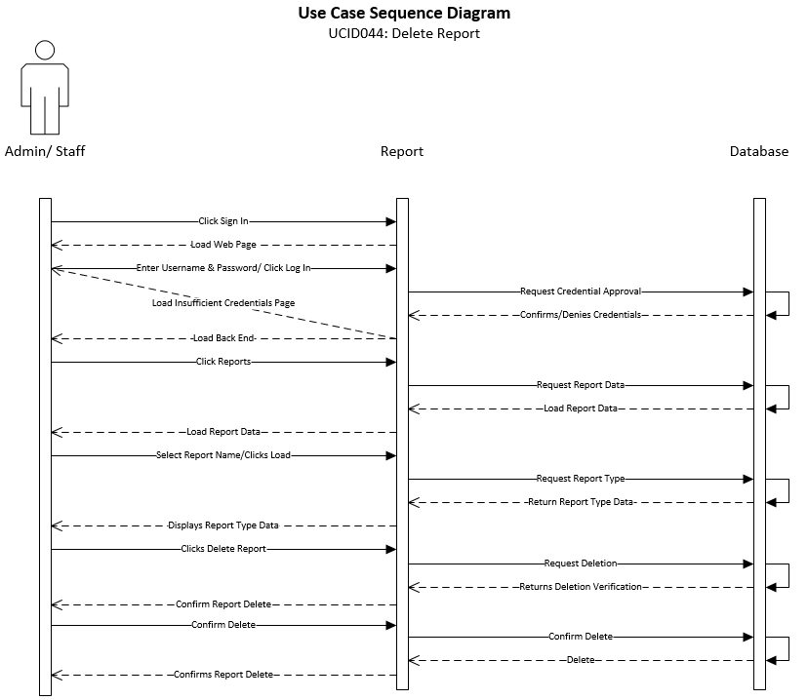

|  |
| --- |
| **Use Case:** Create Mail Directory – Admin/Staff View |
| **ID:** UCID045 |
| **Brief Description:** Describes how to instantiate a Mail Directory. |
| **Primary Actors:** Admin |
| **Secondary Actors:** Staff |
| **Preconditions:** System operational  Admin/Staff user must have rights to create new Mail Directory |
| **Main Flow:**   1. Admin/Staff user will click login on website 2. Admin/Staff user enters credentials 3. Admin/Staff user clicks Mail Directory 4. Admin/Staff user creates Mail Directory 5. Admin/Staff user clicks submit |
| **Postconditions:** Mail Directory is created |
| **Alternative flows:**  None |

The sequence diagram shows the necessary flow of interactions between the primary actor and the system. Based on interactions with the system, different steps can be taken to achieve the creation, deletion, reading, and modification of different aspects of the system. This shows the “happy day” scenario of how the system would run.

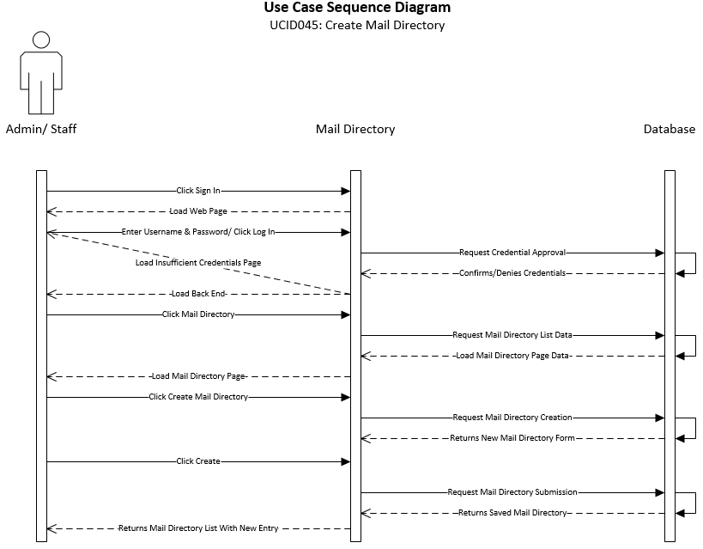

|  |
| --- |
| **Use Case:** Read Mail Directory – Admin/Staff View |
| **ID:** UCID046 |
| **Brief Description:**  Describes how the system will retrieve Mail Directory data. |
| **Primary Actors:** Admin |
| **Secondary Actors:** Staff |
| **Preconditions:** System operational  Admin/Staff user must have rights to read Mail Directory |
| **Main Flow:**   1. Admin/Staff user will click login on website 2. Admin/Staff user enters credentials 3. Admin/Staff user clicks Mail Directory 4. Admin/Staff user views Mail Directory |
| **Postconditions:** Mail Directory is read |
| **Alternative flows:**  None |

The sequence diagram shows the necessary flow of interactions between the primary actor and the system. Based on interactions with the system, different steps can be taken to achieve the creation, deletion, reading, and modification of different aspects of the system. This shows the “happy day” scenario of how the system would run.

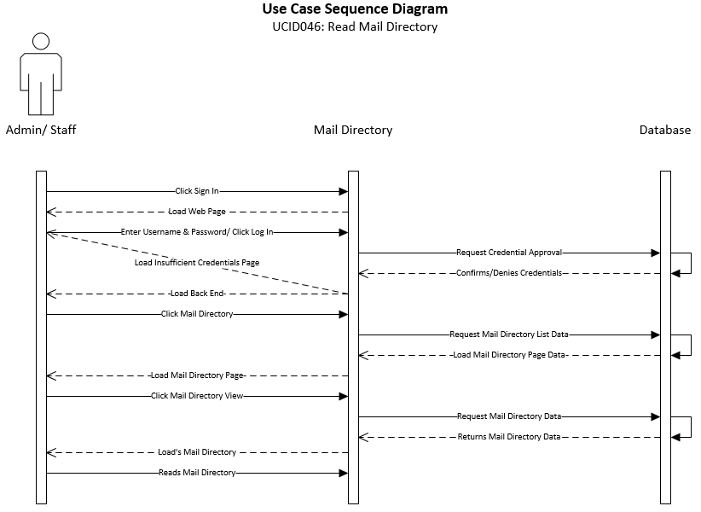

|  |
| --- |
| **Use Case:** Update Mail Directory – Admin/Staff View |
| **ID:** UCID047 |
| **Brief Description:**  Describes how the system will update Mail Directory data. |
| **Primary Actors:** Admin |
| **Secondary Actors:** Staff |
| **Preconditions:** System operational  Admin/Staff user must have rights to update Mail Directory  Prior Mail Directory creation |
| **Main Flow:**   1. Admin/Staff user will click login on website 2. Admin/Staff user enters credentials 3. Admin/Staff user clicks Mail Directory 4. Admin/Staff user views Mail Directory 5. Admin/Staff user clicks Update Mail Directory |
| **Postconditions:** Mail Directory is updated |
| **Alternative flows:**  None |

The sequence diagram shows the necessary flow of interactions between the primary actor and the system. Based on interactions with the system, different steps can be taken to achieve the creation, deletion, reading, and modification of different aspects of the system. This shows the “happy day” scenario of how the system would run.

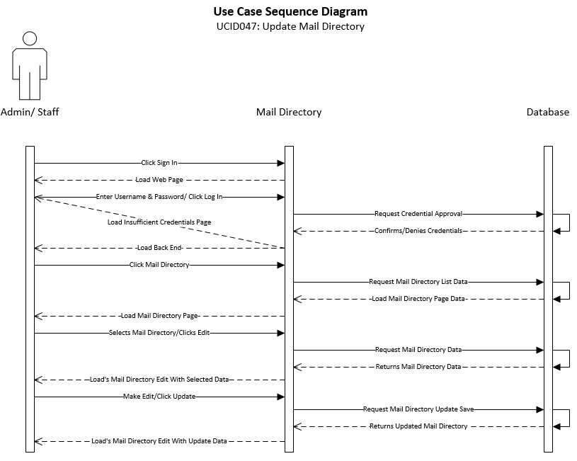

|  |
| --- |
| **Use Case:** Send Mail Directory – Admin/Staff/Student View |
| **ID:** UCID048 |
| **Brief Description:**  Describes how the system will implement automated emails. |
| **Primary Actors:** Admin |
| **Secondary Actors:** Staff/Student |
| **Preconditions:** System operational  Admin/Staff/Student must have rights to send Mail Directory |
| **Main Flow:**   1. Admin/Staff/Student user will click login on website 2. Admin/Staff/Student user enters credentials 3. Admin/Staff/Student user clicks Mail Directory 4. Admin/Staff/Student user sends Mail Directory desired |
| **Postconditions:** Mail Directory is sent |
| **Alternative flows:**  None |

The sequence diagram shows the necessary flow of interactions between the primary actor and the system. Based on interactions with the system, different steps can be taken to achieve the creation, deletion, reading, and modification of different aspects of the system. This shows the “happy day” scenario of how the system would run.

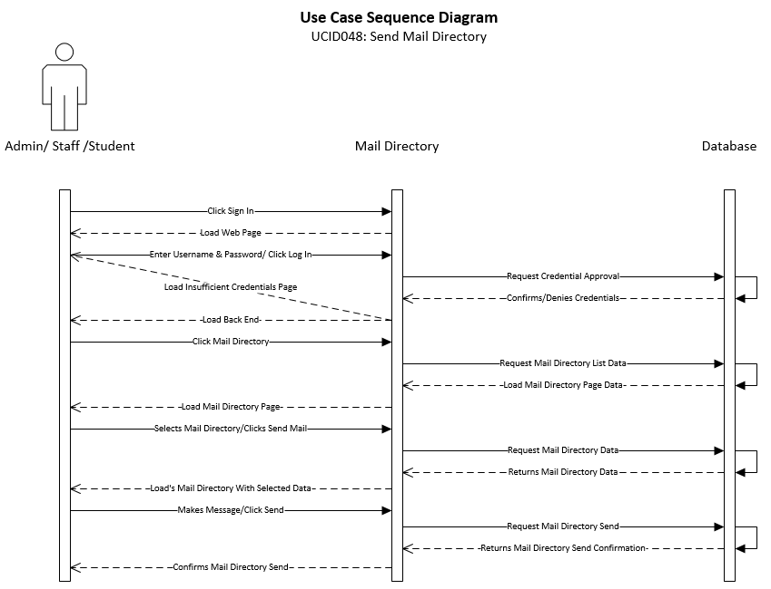

|  |
| --- |
| **Use Case:** Delete Mail Directory – Admin/Staff View |
| **ID:** UCID049 |
| **Brief Description:**  Describes how the system will delete a Mail Directory |
| **Primary Actors:** Admin |
| **Secondary Actors:** Admin/Staff |
| **Preconditions:**  System operational  Admin/Staff user must have rights to delete Mail Directory |
| **Main Flow:**   1. Admin/Staff user will click login on website 2. Admin/Staff user enters credentials 3. Admin/Staff user clicks Mailing List 4. Admin/Staff user views Mailing List 5. Admin/Staff user clicks Delete Mailing List |
| **Postconditions:** Mail Directory is deleted |
| **Alternative flows:**  None |

The sequence diagram shows the necessary flow of interactions between the primary actor and the system. Based on interactions with the system, different steps can be taken to achieve the creation, deletion, reading, and modification of different aspects of the system. This shows the “happy day” scenario of how the system would run.

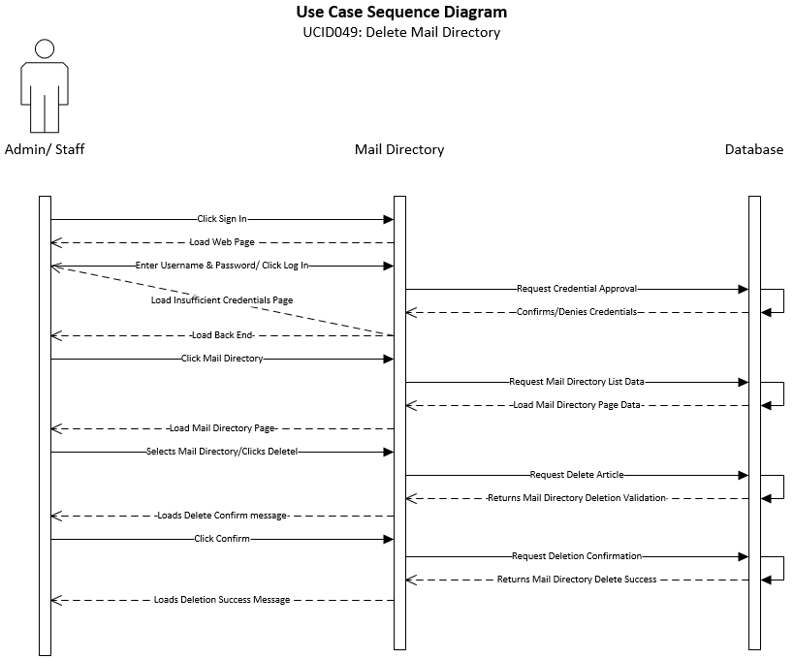

|  |
| --- |
| **Use Case:** Create Donor ID – Admin/Staff View |
| **ID:** UCID050 |
| **Brief Description:**  Describes how the system will create a Donor ID |
| **Primary Actors:** Admin |
| **Secondary Actors:** Admin/Staff |
| **Preconditions:**  System operational  Admin/Staff user must have rights to create a Donor ID |
| **Main Flow:**   1. Admin/Staff user will click login on website 2. Admin/Staff user enters credentials 3. Admin/Staff user clicks Donors 4. Admin/Staff user creates Donor ID 5. Admin/Staff user clicks Submit |
| **Postconditions:** Donor ID is created |
| **Alternative flows:**  None |

The sequence diagram shows the necessary flow of interactions between the primary actor and the system. Based on interactions with the system, different steps can be taken to achieve the creation, deletion, reading, and modification of different aspects of the system. This shows the “happy day” scenario of how the system would run.

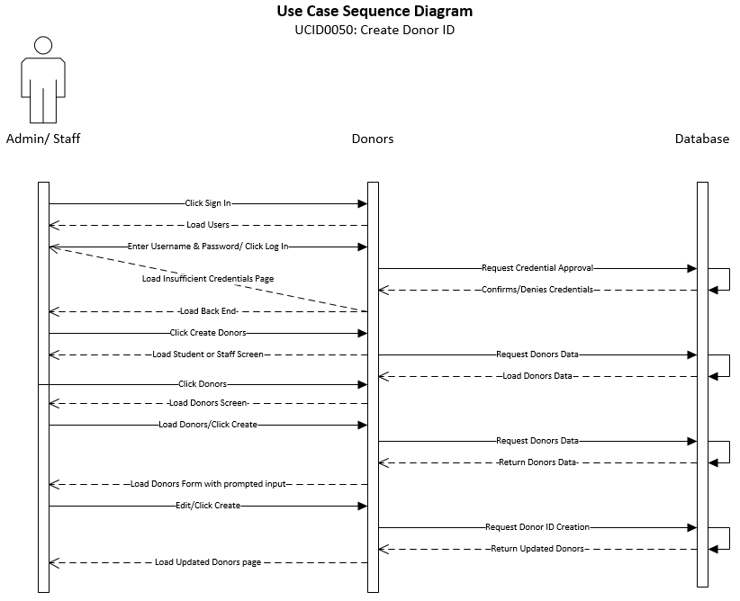

|  |
| --- |
| **Use Case:** Read Donor ID – Admin/Staff View |
| **ID:** UCID051 |
| **Brief Description:**  Describes how the system will view a Donor ID |
| **Primary Actors:** Admin |
| **Secondary Actors:** Admin/Staff |
| **Preconditions:**  System operational  Admin/Staff user must have rights to view a Donor ID |
| **Main Flow:**   1. Admin/Staff user will click login on website 2. Admin/Staff user enters credentials 3. Admin/Staff user clicks Donors 4. Admin/Staff user views Donor ID |
| **Postconditions:** Donor ID is read |
| **Alternative flows:**  None |

The sequence diagram shows the necessary flow of interactions between the primary actor and the system. Based on interactions with the system, different steps can be taken to achieve the creation, deletion, reading, and modification of different aspects of the system. This shows the “happy day” scenario of how the system would run.

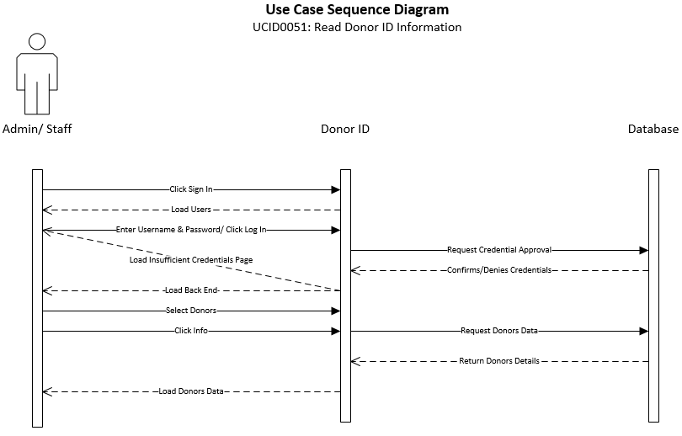

|  |
| --- |
| **Use Case:** Update Donor ID – Admin/Staff View |
| **ID:** UCID052 |
| **Brief Description:**  Describes how the system will update a Donor ID |
| **Primary Actors:** Admin |
| **Secondary Actors:** Admin/Staff |
| **Preconditions:**  System operational  Admin/Staff user must have rights to update a Donor ID |
| **Main Flow:**   1. Admin/Staff user will click login on website 2. Admin/Staff user enters credentials 3. Admin/Staff user clicks Donors 4. Admin/Staff user views Donors 5. Admin/Staff user clicks Update Donor ID |
| **Postconditions:** Donor ID is updated |
| **Alternative flows:**  None |

The sequence diagram shows the necessary flow of interactions between the primary actor and the system. Based on interactions with the system, different steps can be taken to achieve the creation, deletion, reading, and modification of different aspects of the system. This shows the “happy day” scenario of how the system would run.

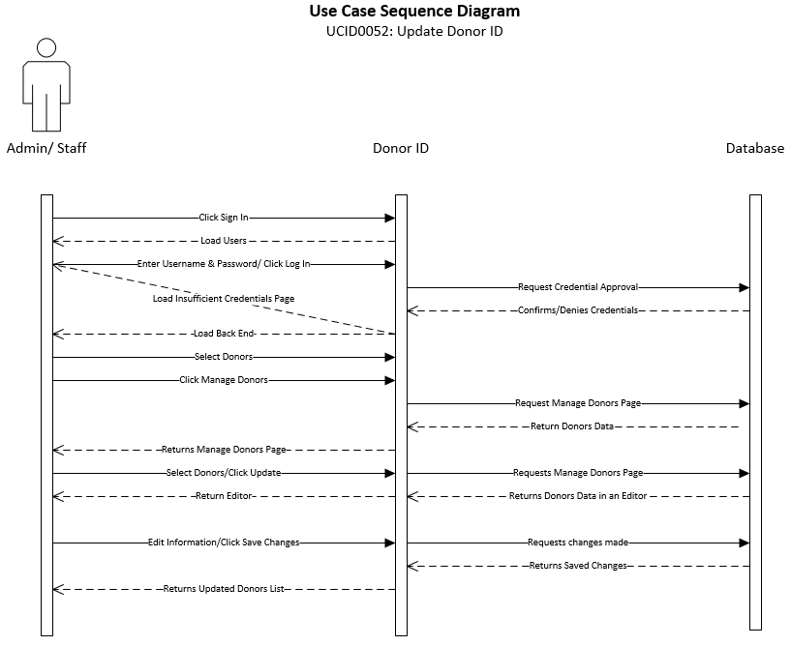

|  |
| --- |
| **Use Case:** Delete Donor ID – Admin/Staff View |
| **ID:** UCID053 |
| **Brief Description:**  Describes how the system will delete a Donor ID |
| **Primary Actors:** Admin |
| **Secondary Actors:** Admin/Staff |
| **Preconditions:**  System operational  Admin/Staff user must have rights to delete a Donor ID |
| **Main Flow:**   1. Admin/Staff user will click login on website 2. Admin/Staff user enters credentials 3. Admin/Staff user clicks Donors 4. Admin/Staff user views Donors 5. Admin/Staff user clicks Delete Donor ID |
| **Postconditions:** Donor ID is deleted |
| **Alternative flows:**  None |

The sequence diagram shows the necessary flow of interactions between the primary actor and the system. Based on interactions with the system, different steps can be taken to achieve the creation, deletion, reading, and modification of different aspects of the system. This shows the “happy day” scenario of how the system would run.

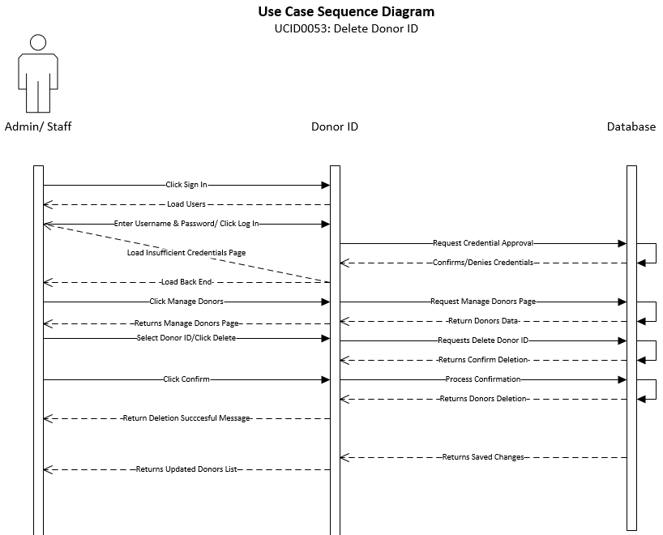

|  |
| --- |
| **Use Case:** Approve Donor ID – Admin/Staff View |
| **ID:** UCID054 |
| **Brief Description:**  Describes how the system will approve a Donor ID |
| **Primary Actors:** Admin |
| **Secondary Actors:** Admin/Staff |
| **Preconditions:**  System operational  Admin/Staff user must have rights to approve a Donor ID  Prior Donor ID created |
| **Main Flow:**   1. Admin/Staff user will click login on website 2. Admin/Staff user enters credentials 3. Admin/Staff user clicks Donors 4. Admin/Staff user views Donors 5. Admin/Staff user clicks Approve Donor ID |
| **Postconditions:** Donor ID is approved |
| **Alternative flows:**  None |

The sequence diagram shows the necessary flow of interactions between the primary actor and the system. Based on interactions with the system, different steps can be taken to achieve the creation, deletion, reading, and modification of different aspects of the system. This shows the “happy day” scenario of how the system would run.

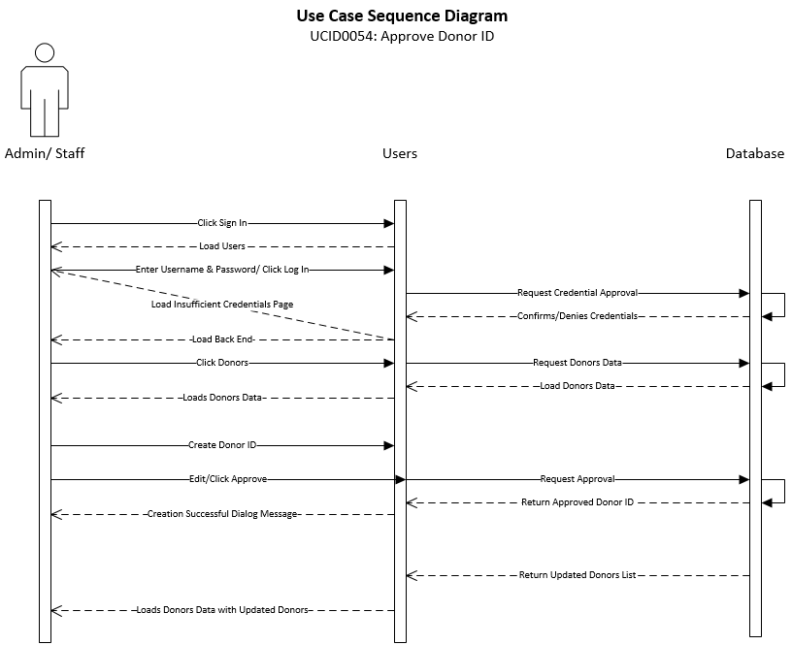

|  |
| --- |
| **Use Case:** Create Alumni – Admin/Staff View |
| **ID:** UCID055 |
| **Brief Description:**  Describes how the system will create an Alumni |
| **Primary Actors:** Admin |
| **Secondary Actors:** Admin/Staff |
| **Preconditions:**  System operational  Admin/Staff user must have rights to create an Alumni |
| **Main Flow:**   1. Admin/Staff user will click login on website 2. Admin/Staff user enters credentials 3. Admin/Staff user clicks Alumni 4. Admin/Staff user clicks Create Alumni 5. Admin/Staff user clicks Submit |
| **Postconditions:** Alumni is created |
| **Alternative flows:**  None |

The sequence diagram shows the necessary flow of interactions between the primary actor and the system. Based on interactions with the system, different steps can be taken to achieve the creation, deletion, reading, and modification of different aspects of the system. This shows the “happy day” scenario of how the system would run.

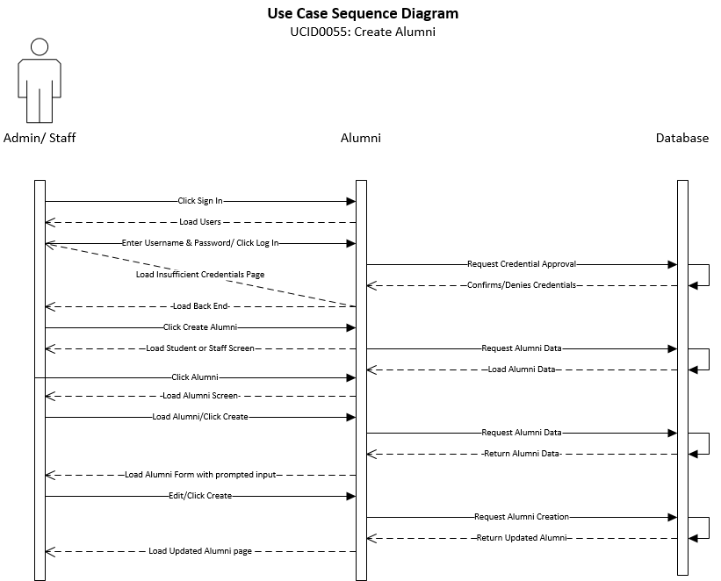

|  |
| --- |
| **Use Case:** Read Alumni – Admin/Staff View |
| **ID:** UCID056 |
| **Brief Description:**  Describes how the system will view an Alumni |
| **Primary Actors:** Admin |
| **Secondary Actors:** Admin/Staff |
| **Preconditions:**  System operational  Admin/Staff user must have rights to view Alumni |
| **Main Flow:**   1. Admin/Staff user will click login on website 2. Admin/Staff user enters credentials 3. Admin/Staff user clicks Alumni 4. Admin/Staff user views Alumni |
| **Postconditions:** Alumni is read |
| **Alternative flows:**  None |

The sequence diagram shows the necessary flow of interactions between the primary actor and the system. Based on interactions with the system, different steps can be taken to achieve the creation, deletion, reading, and modification of different aspects of the system. This shows the “happy day” scenario of how the system would run.

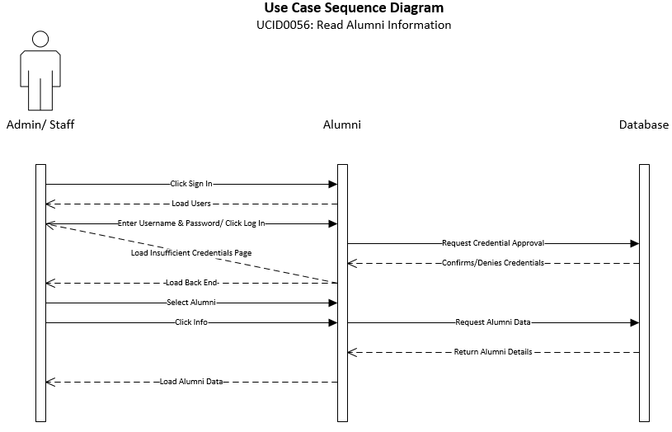

|  |
| --- |
| **Use Case:** Update Alumni – Admin/Staff View |
| **ID:** UCID057 |
| **Brief Description:**  Describes how the system will update an Alumni |
| **Primary Actors:** Admin |
| **Secondary Actors:** Admin/Staff |
| **Preconditions:**  System operational  Admin/Staff user must have rights to update an Alumni |
| **Main Flow:**   1. Admin/Staff user will click login on website 2. Admin/Staff user enters credentials 3. Admin/Staff user clicks Alumni 4. Admin/Staff user views Alumni 5. Admin/Staff user clicks Update Alumni |
| **Postconditions:** Alumni is updated |
| **Alternative flows:**  None |

The sequence diagram shows the necessary flow of interactions between the primary actor and the system. Based on interactions with the system, different steps can be taken to achieve the creation, deletion, reading, and modification of different aspects of the system. This shows the “happy day” scenario of how the system would run.

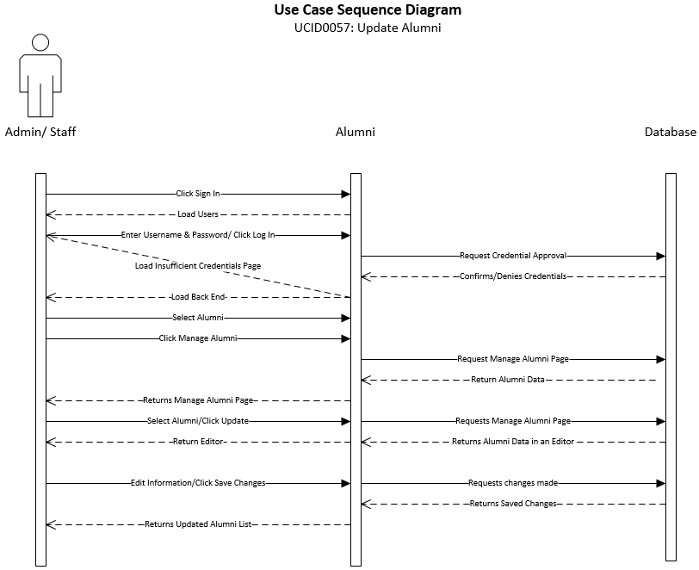

|  |
| --- |
| **Use Case:** Delete Alumni – Admin/Staff View |
| **ID:** UCID058 |
| **Brief Description:**  Describes how the system will delete an Alumni |
| **Primary Actors:** Admin |
| **Secondary Actors:** Admin/Staff |
| **Preconditions:**  System operational  Admin/Staff user must have rights to delete an Alumni |
| **Main Flow:**   1. Admin/Staff user will click login on website 2. Admin/Staff user enters credentials 3. Admin/Staff user clicks Alumni 4. Admin/Staff user views Alumni 5. Admin/Staff user clicks Delete Alumni |
| **Postconditions:** Alumni is deleted |
| **Alternative flows:**  None |

The sequence diagram shows the necessary flow of interactions between the primary actor and the system. Based on interactions with the system, different steps can be taken to achieve the creation, deletion, reading, and modification of different aspects of the system. This shows the “happy day” scenario of how the system would run.

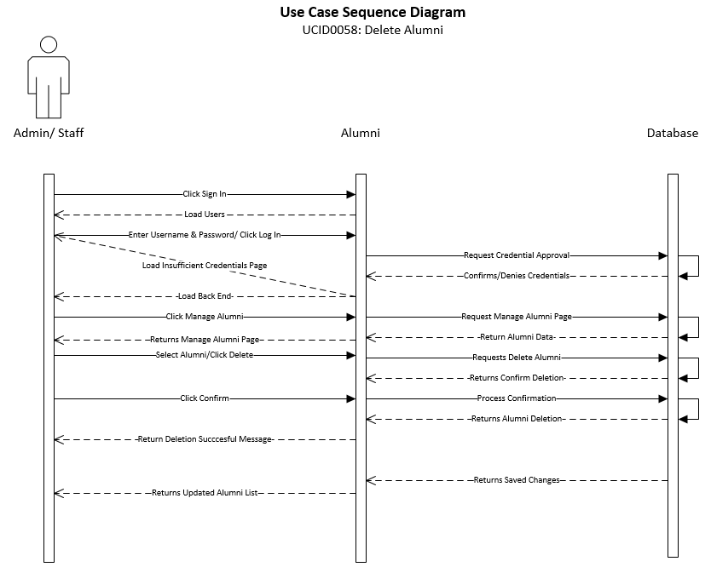

|  |
| --- |
| **Use Case:** Approve Alumni – Admin/Staff View |
| **ID:** UCID059 |
| **Brief Description:**  Describes how the system will Approve an Alumni |
| **Primary Actors:** Admin |
| **Secondary Actors:** Admin/Staff |
| **Preconditions:**  System operational  Admin/Staff user must have rights to approve Alumni |
| **Main Flow:**   1. Admin/Staff user will click login on website 2. Admin/Staff user enters credentials 3. Admin/Staff user clicks Alumni 4. Admin/Staff user views Alumni 5. Admin/Staff user clicks Approve Alumni |
| **Postconditions:** Alumni is approved |
| **Alternative flows:**  None |

The sequence diagram shows the necessary flow of interactions between the primary actor and the system. Based on interactions with the system, different steps can be taken to achieve the creation, deletion, reading, and modification of different aspects of the system. This shows the “happy day” scenario of how the system would run.

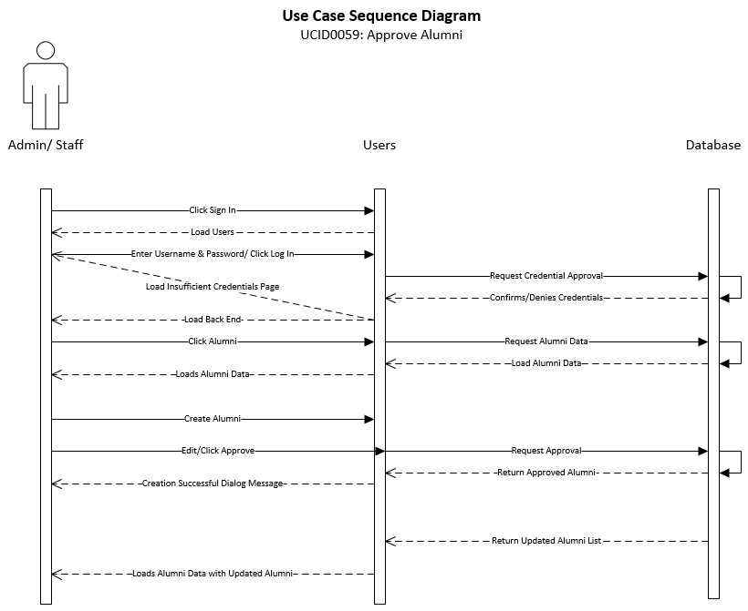

|  |
| --- |
| **Use Case:** Create Perspective Student – Admin/Staff View |
| **ID:** UCID060 |
| **Brief Description:**  Describes how the system will create a Perspective Student |
| **Primary Actors:** Admin |
| **Secondary Actors:** Admin/Staff |
| **Preconditions:**  System operational  Admin/Staff user must have rights to create a Perspective Student |
| **Main Flow:**   1. Admin/Staff user will click login on website 2. Admin/Staff user enters credentials 3. Admin/Staff user clicks Perspective Student 4. Admin/Staff user creates a Perspective Student 5. Admin/Staff user clicks Submit |
| **Postconditions:** Perspective Student is created |
| **Alternative flows:**  None |

The sequence diagram shows the necessary flow of interactions between the primary actor and the system. Based on interactions with the system, different steps can be taken to achieve the creation, deletion, reading, and modification of different aspects of the system. This shows the “happy day” scenario of how the system would run.

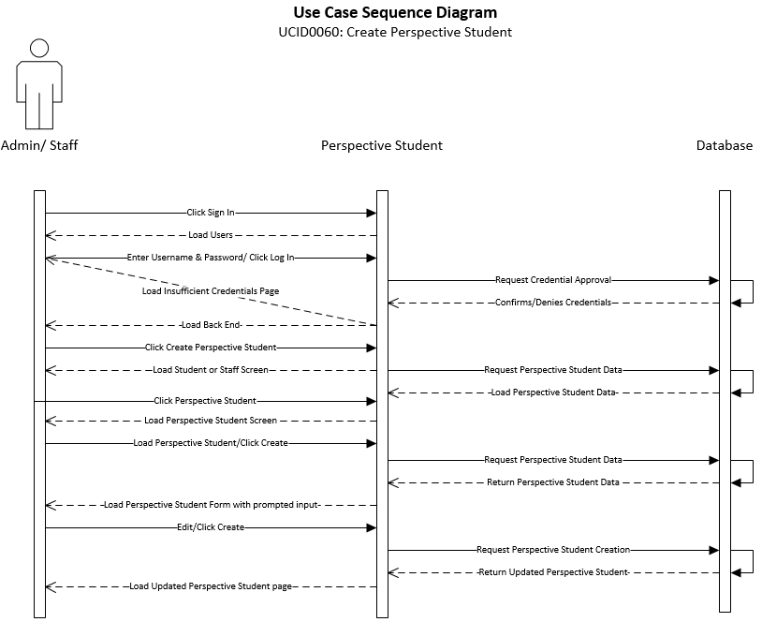

|  |
| --- |
| **Use Case:** Read Perspective Student – Admin/Staff View |
| **ID:** UCID061 |
| **Brief Description:**  Describes how the system will view a Perspective Student |
| **Primary Actors:** Admin |
| **Secondary Actors:** Admin/Staff |
| **Preconditions:**  System operational  Admin/Staff user must have rights to View a Perspective Student  Perspective Student must be created |
| **Main Flow:**   1. Admin/Staff user will click login on website 2. Admin/Staff user enters credentials 3. Admin/Staff user clicks Perspective Student 4. Admin/Staff user views Perspective Student |
| **Postconditions:** Perspective Student is read |
| **Alternative flows:**  None |

The sequence diagram shows the necessary flow of interactions between the primary actor and the system. Based on interactions with the system, different steps can be taken to achieve the creation, deletion, reading, and modification of different aspects of the system. This shows the “happy day” scenario of how the system would run.

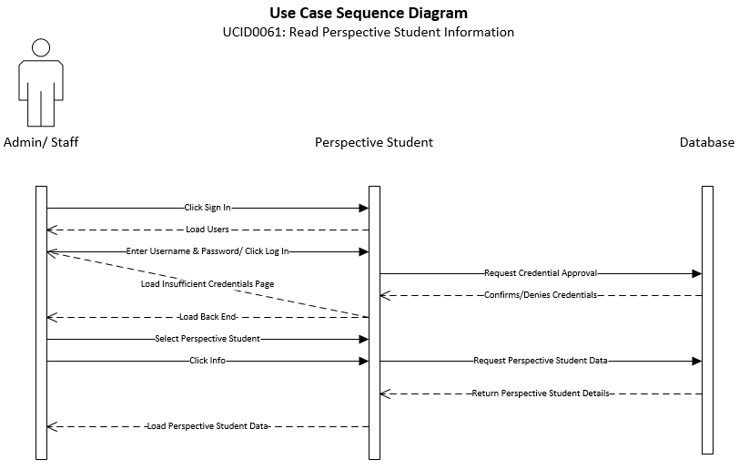

|  |
| --- |
| **Use Case:** Update Perspective Student – Admin/Staff View |
| **ID:** UCID062 |
| **Brief Description:**  Describes how the system will update a Perspective Student |
| **Primary Actors:** Admin |
| **Secondary Actors:** Admin/Staff |
| **Preconditions:**  System operational  Admin/Staff user must have rights to update a Perspective Student |
| **Main Flow:**   1. Admin/Staff user will click login on website 2. Admin/Staff user enters credentials 3. Admin/Staff user clicks Perspective Student 4. Admin/Staff user views Perspective Student 5. Admin/Staff user clicks Update Perspective Student |
| **Postconditions:** Perspective Student is updated |
| **Alternative flows:**  None |

The sequence diagram shows the necessary flow of interactions between the primary actor and the system. Based on interactions with the system, different steps can be taken to achieve the creation, deletion, reading, and modification of different aspects of the system. This shows the “happy day” scenario of how the system would run.

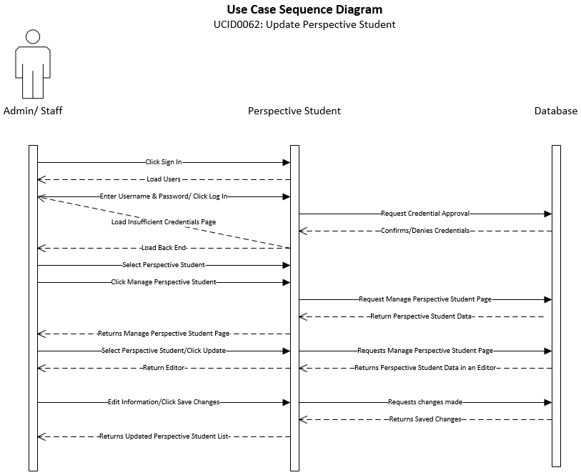

|  |
| --- |
| **Use Case:** Delete Perspective Student – Admin/Staff View |
| **ID:** UCID063 |
| **Brief Description:**  Describes how the system will delete a Perspective Student |
| **Primary Actors:** Admin |
| **Secondary Actors:** Admin/Staff |
| **Preconditions:**  System operational  Admin/Staff user must have rights to delete a Perspective Student |
| **Main Flow:**   1. Admin/Staff user will click login on website 2. Admin/Staff user enters credentials 3. Admin/Staff user clicks Perspective Student 4. Admin/Staff user views Perspective Student 5. Admin/Staff user clicks Delete Perspective Student |
| **Postconditions:** Perspective Student is deleted |
| **Alternative flows:**  None |

The sequence diagram shows the necessary flow of interactions between the primary actor and the system. Based on interactions with the system, different steps can be taken to achieve the creation, deletion, reading, and modification of different aspects of the system. This shows the “happy day” scenario of how the system would run.

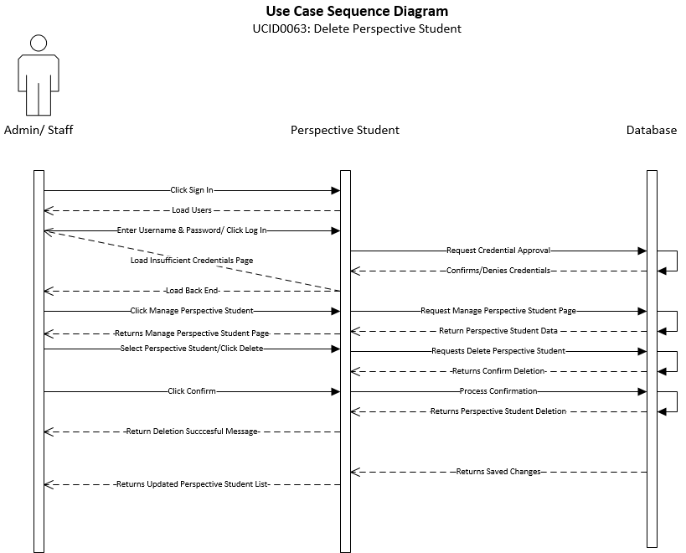

|  |
| --- |
| **Use Case:** Approve Perspective Student – Admin/Staff View |
| **ID:** UCID064 |
| **Brief Description:**  Describes how the system will approve a Perspective Student |
| **Primary Actors:** Admin |
| **Secondary Actors:** Admin/Staff |
| **Preconditions:**  System operational  Admin/Staff user must have rights to approve a Perspective Student  Perspective Student must be created |
| **Main Flow:**   1. Admin/Staff user will click login on website 2. Admin/Staff user enters credentials 3. Admin/Staff user clicks Perspective Student 4. Admin/Staff user views Perspective Student 5. Admin/Staff user clicks Approve Perspective Student |
| **Postconditions:** Perspective Student is approved |
| **Alternative flows:**  None |

The sequence diagram shows the necessary flow of interactions between the primary actor and the system. Based on interactions with the system, different steps can be taken to achieve the creation, deletion, reading, and modification of different aspects of the system. This shows the “happy day” scenario of how the system would run.

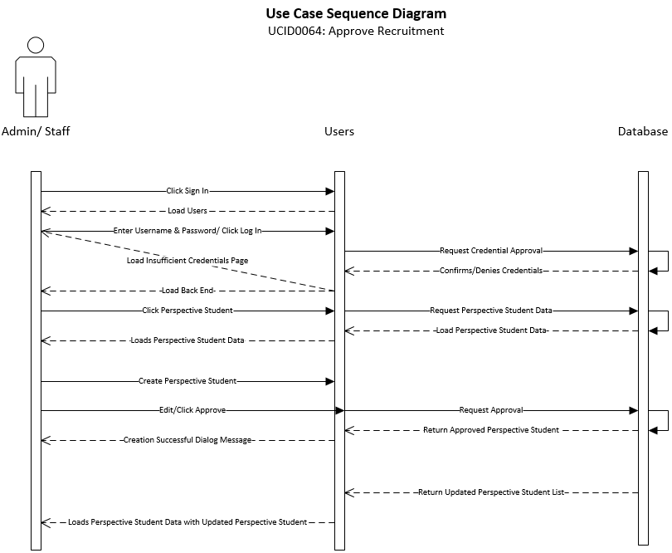

|  |
| --- |
| **Use Case:** Create Recruitment – Admin/Staff View |
| **ID:** UCID065 |
| **Brief Description:**  Describes how the system will create a Recruitment |
| **Primary Actors:** Admin |
| **Secondary Actors:** Admin/Staff |
| **Preconditions:**  System operational  Admin/Staff user must have rights to create a Recruitment |
| **Main Flow:**   1. Admin/Staff user will click login on website 2. Admin/Staff user enters credentials 3. Admin/Staff user clicks Recruitment 4. Admin/Staff user creates Recruitment 5. Admin/Staff user clicks Submit |
| **Postconditions:** Recruitment is created |
| **Alternative flows:**  None |

The sequence diagram shows the necessary flow of interactions between the primary actor and the system. Based on interactions with the system, different steps can be taken to achieve the creation, deletion, reading, and modification of different aspects of the system. This shows the “happy day” scenario of how the system would run.

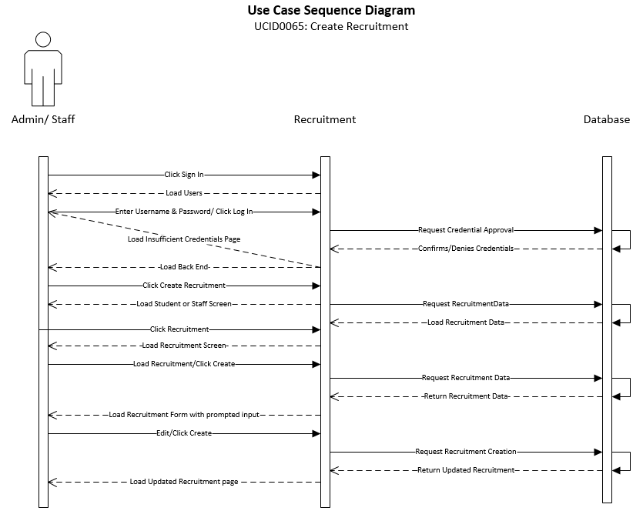

|  |
| --- |
| **Use Case:** Read Recruitment – Admin/Staff View |
| **ID:** UCID066 |
| **Brief Description:**  Describes how the system will view a Recruitment |
| **Primary Actors:** Admin |
| **Secondary Actors:** Admin/Staff |
| **Preconditions:**  System operational  Admin/Staff user must have rights to view a Recruitment |
| **Main Flow:**   1. Admin/Staff user will click login on website 2. Admin/Staff user enters credentials 3. Admin/Staff user clicks Recruitment 4. Admin/Staff user views Recruitment |
| **Postconditions:** Recruitment is read |
| **Alternative flows:**  None |

The sequence diagram shows the necessary flow of interactions between the primary actor and the system. Based on interactions with the system, different steps can be taken to achieve the creation, deletion, reading, and modification of different aspects of the system. This shows the “happy day” scenario of how the system would run.

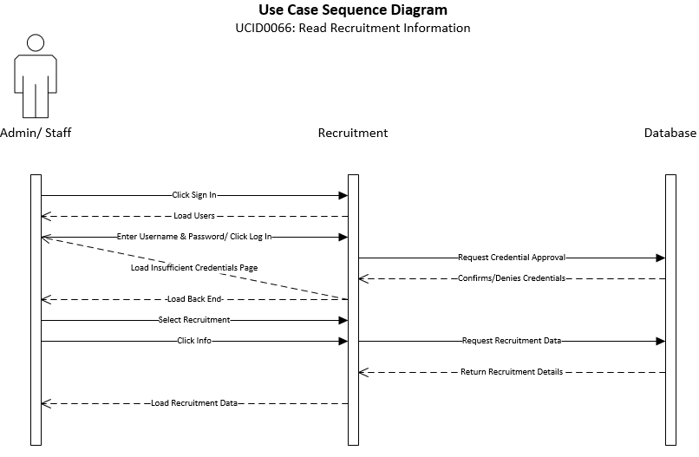

|  |
| --- |
| **Use Case:** Update Recruitment – Admin/Staff View |
| **ID:** UCID067 |
| **Brief Description:**  Describes how the system will update a Recruitment |
| **Primary Actors:** Admin |
| **Secondary Actors:** Admin/Staff |
| **Preconditions:**  System operational  Admin/Staff user must have rights to update a Recruitment |
| **Main Flow:**   1. Admin/Staff user will click login on website 2. Admin/Staff user enters credentials 3. Admin/Staff user clicks Recruitment 4. Admin/Staff user views Recruitment 5. Admin/Staff user clicks Update Recruitment |
| **Postconditions:** Recruitment is updated |
| **Alternative flows:**  None |

The sequence diagram shows the necessary flow of interactions between the primary actor and the system. Based on interactions with the system, different steps can be taken to achieve the creation, deletion, reading, and modification of different aspects of the system. This shows the “happy day” scenario of how the system would run.

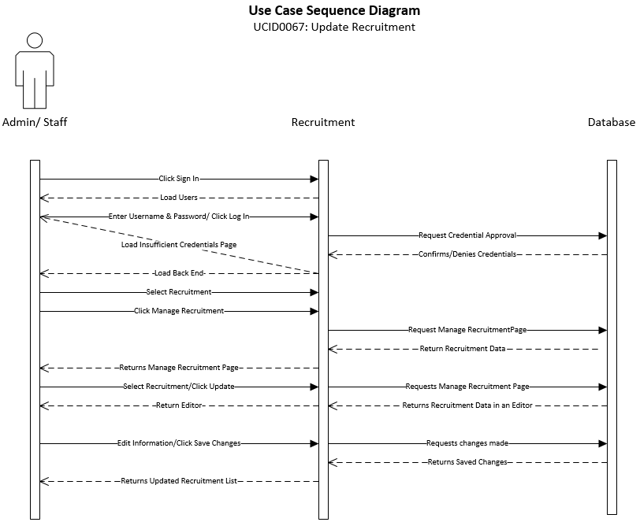

|  |
| --- |
| **Use Case:** Delete Recruitment – Admin/Staff View |
| **ID:** UCID068 |
| **Brief Description:**  Describes how the system will delete a Recruitment |
| **Primary Actors:** Admin |
| **Secondary Actors:** Admin/Staff |
| **Preconditions:**  System operational  Admin/Staff user must have rights to delete a Recruitment |
| **Main Flow:**   1. Admin/Staff user will click login on website 2. Admin/Staff user enters credentials 3. Admin/Staff user clicks Recruitment 4. Admin/Staff user views Recruitment 5. Admin/Staff user clicks Delete Recruitment |
| **Postconditions:** Recruitment is deleted |
| **Alternative flows:**  None |

The sequence diagram shows the necessary flow of interactions between the primary actor and the system. Based on interactions with the system, different steps can be taken to achieve the creation, deletion, reading, and modification of different aspects of the system. This shows the “happy day” scenario of how the system would run.

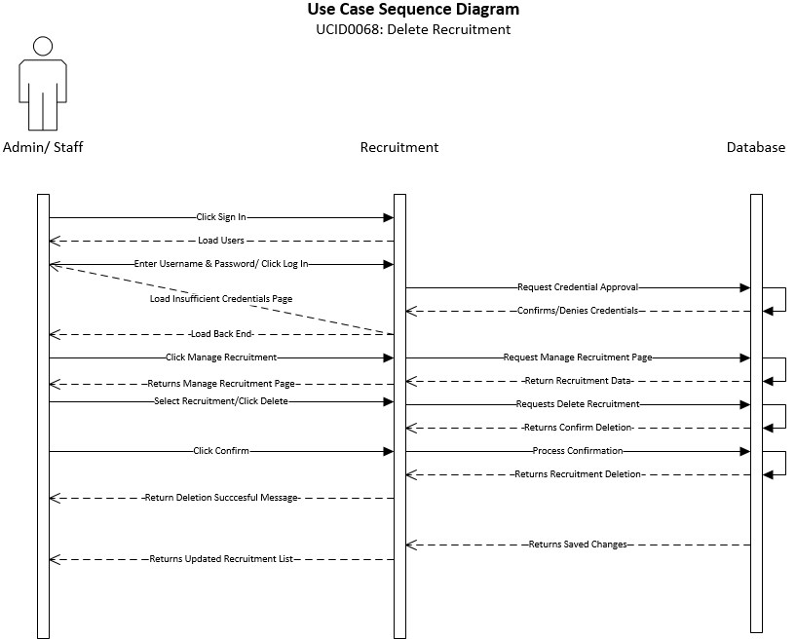

|  |
| --- |
| **Use Case:** Approve Recruitment – Admin/Staff View |
| **ID:** UCID069 |
| **Brief Description:**  Describes how the system will approve a Recruitment |
| **Primary Actors:** Admin |
| **Secondary Actors:** Admin/Staff |
| **Preconditions:**  System operational  Admin/Staff user must have rights to approve a Recruitment  Recruitment must be created |
| **Main Flow:**   1. Admin/Staff user will click login on website 2. Admin/Staff user enters credentials 3. Admin/Staff user clicks Recruitment 4. Admin/Staff user views Recruitment 5. Admin/Staff user clicks Approve Recruitment |
| **Postconditions:** Recruitment is approved |
| **Alternative flows:**  None |

The sequence diagram shows the necessary flow of interactions between the primary actor and the system. Based on interactions with the system, different steps can be taken to achieve the creation, deletion, reading, and modification of different aspects of the system. This shows the “happy day” scenario of how the system would run.

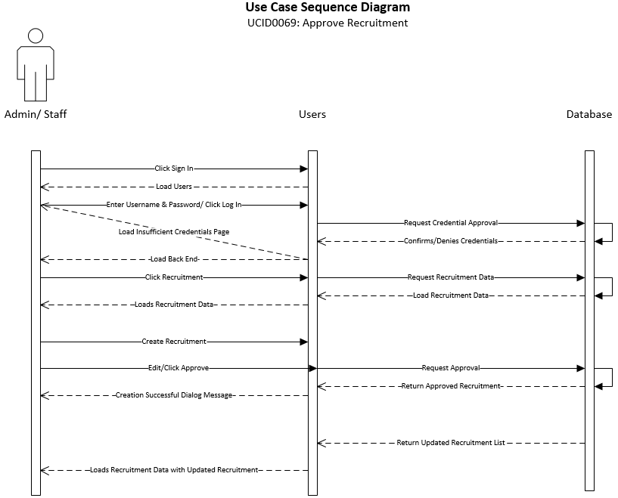

|  |
| --- |
| **Use Case:** Approve Clinicals – Admin/Staff View |
| **ID:** UCID070 |
| **Brief Description:**  Describes how the system will approve a Clinical |
| **Primary Actors:** Admin |
| **Secondary Actors:** Admin/Staff |
| **Preconditions:**  System operational  Admin/Staff user must have rights to approve a Clinical  Recruitment must be created |
| **Main Flow:**   1. Admin/Staff user will click login on website 2. Admin/Staff user enters credentials 3. Admin/Staff user clicks Clinicals 4. Admin/Staff user views Clinicals 5. Admin/Staff user clicks Approve Clinicals |
| **Postconditions:** Clinicals is approved |
| **Alternative flows:**  None |

The sequence diagram shows the necessary flow of interactions between the primary actor and the system. Based on interactions with the system, different steps can be taken to achieve the creation, deletion, reading, and modification of different aspects of the system. This shows the “happy day” scenario of how the system would run.

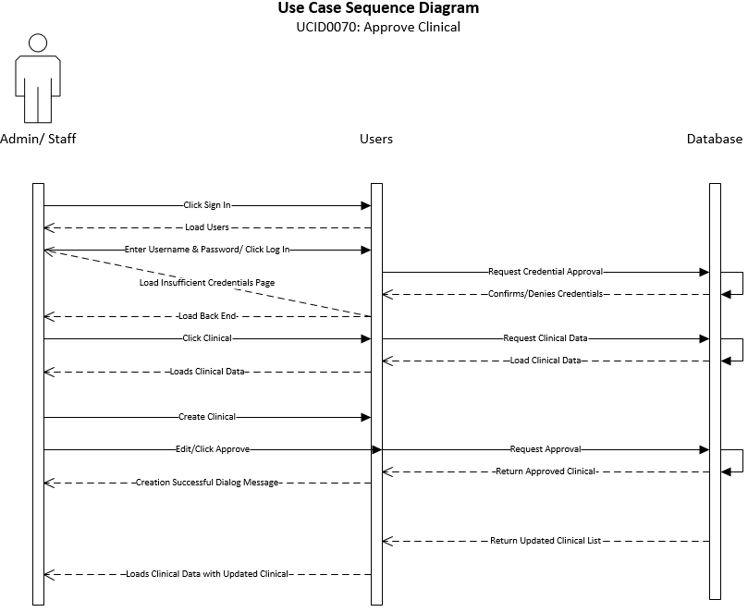

|  |
| --- |
| **Use Case:** Create Graduate Student – Admin/Staff View |
| **ID:** UCID071 |
| **Brief Description:**  Describes how the system will create a Graduate Student |
| **Primary Actors:** Admin |
| **Secondary Actors:** Admin/Staff |
| **Preconditions:**  System operational  Admin/Staff user must have rights to create a student |
| **Main Flow:**   1. Admin/Staff user will click login on website 2. Admin/Staff user enters credentials 3. Admin/Staff user clicks Manage Student Users 4. Admin/Staff user creates Graduate Student 5. Admin/Staff user clicks Submit |
| **Postconditions:** Graduate Student is created |
| **Alternative flows:**  None |

The sequence diagram shows the necessary flow of interactions between the primary actor and the system. Based on interactions with the system, different steps can be taken to achieve the creation, deletion, reading, and modification of different aspects of the system. This shows the “happy day” scenario of how the system would run.

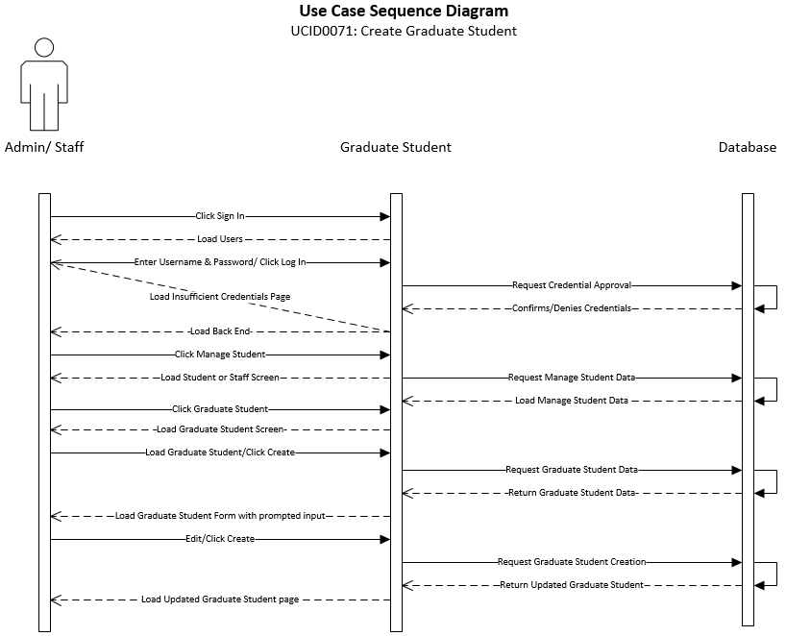

|  |
| --- |
| **Use Case:** Read Graduate Student – Admin/Staff View |
| **ID:** UCID072 |
| **Brief Description:**  Describes how the system will view a Graduate Student |
| **Primary Actors:** Admin |
| **Secondary Actors:** Admin/Staff |
| **Preconditions:**  System operational  Admin/Staff user must have rights to view a Graduate Student |
| **Main Flow:**   1. Admin/Staff user will click login on website 2. Admin/Staff user enters credentials 3. Admin/Staff user clicks Manage Student Users 4. Admin/Staff user views Graduate Students |
| **Postconditions:** Graduate Student is read |
| **Alternative flows:**  None |

The sequence diagram shows the necessary flow of interactions between the primary actor and the system. Based on interactions with the system, different steps can be taken to achieve the creation, deletion, reading, and modification of different aspects of the system. This shows the “happy day” scenario of how the system would run.

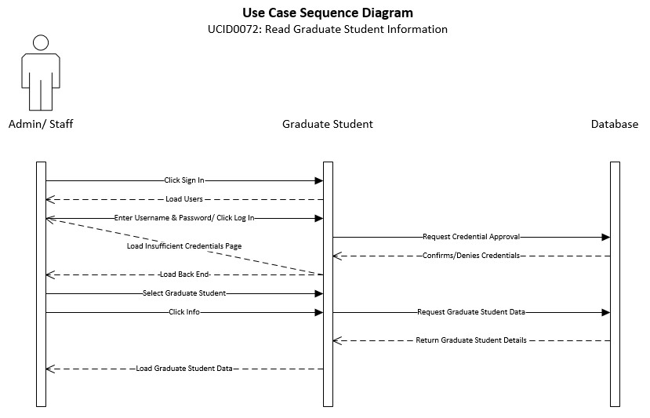

|  |
| --- |
| **Use Case:** Update Graduate Student – Admin/Staff View |
| **ID:** UCID073 |
| **Brief Description:**  Describes how the system will update a Graduate Student |
| **Primary Actors:** Admin |
| **Secondary Actors:** Admin/Staff |
| **Preconditions:**  System operational  Admin/Staff user must have rights to update a Graduate Student |
| **Main Flow:**   1. Admin/Staff user will click login on website 2. Admin/Staff user enters credentials 3. Admin/Staff user clicks Manage Student Users 4. Admin/Staff user views Graduate Student 5. Admin/Staff user clicks Update Graduate Student |
| **Postconditions:** Graduate Student is updated |
| **Alternative flows:**  None |

The sequence diagram shows the necessary flow of interactions between the primary actor and the system. Based on interactions with the system, different steps can be taken to achieve the creation, deletion, reading, and modification of different aspects of the system. This shows the “happy day” scenario of how the system would run.

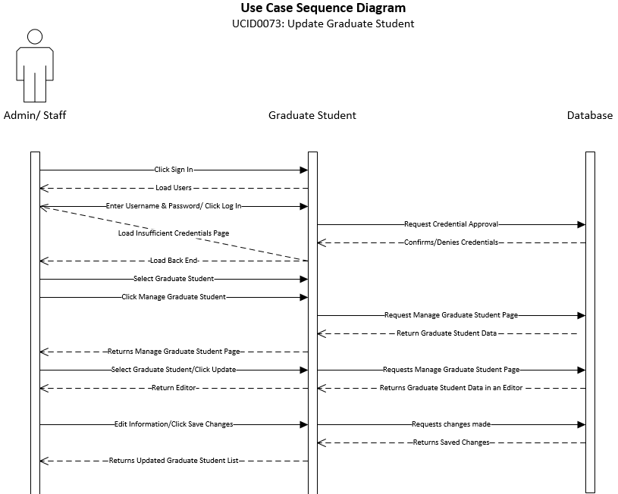

|  |
| --- |
| **Use Case:** Delete Graduate Student – Admin/Staff View |
| **ID:** UCID074 |
| **Brief Description:**  Describes how the system will delete a Recruitment |
| **Primary Actors:** Admin |
| **Secondary Actors:** Admin/Staff |
| **Preconditions:**  System operational  Admin/Staff user must have rights to delete a Recruitment |
| **Main Flow:**   1. Admin/Staff user will click login on website 2. Admin/Staff user enters credentials 3. Admin/Staff user clicks Recruitment 4. Admin/Staff user views Recruitment 5. Admin/Staff user clicks Delete Recruitment |
| **Postconditions:** Recruitment is deleted |
| **Alternative flows:**  None |

The sequence diagram shows the necessary flow of interactions between the primary actor and the system. Based on interactions with the system, different steps can be taken to achieve the creation, deletion, reading, and modification of different aspects of the system. This shows the “happy day” scenario of how the system would run.

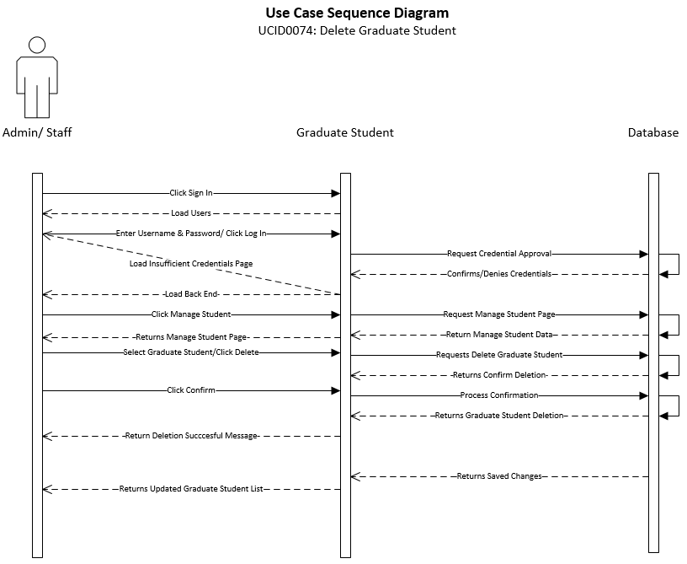

|  |
| --- |
| **Use Case:** Approve Graduate Student – Admin/Staff View |
| **ID:** UCID075 |
| **Brief Description:**  Describes how the system will approve a Graduate Student |
| **Primary Actors:** Admin |
| **Secondary Actors:** Admin/Staff |
| **Preconditions:**  System operational  Admin/Staff user must have rights to approve Graduate Student  Graduate Student must be created |
| **Main Flow:**   1. Admin/Staff user will click login on website 2. Admin/Staff user enters credentials 3. Admin/Staff user clicks Manage Students 4. Admin/Staff user views Graduate Student 5. Admin/Staff user clicks Approve Graduate Student |
| **Postconditions:** Graduate Student is approved |
| **Alternative flows:**  None |

The sequence diagram shows the necessary flow of interactions between the primary actor and the system. Based on interactions with the system, different steps can be taken to achieve the creation, deletion, reading, and modification of different aspects of the system. This shows the “happy day” scenario of how the system would run.

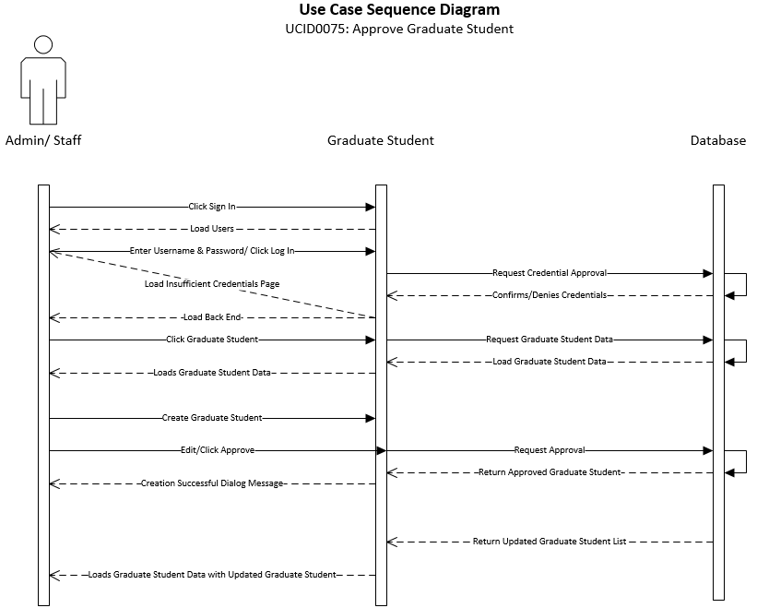

|  |
| --- |
| **Use Case:** Create Donation Information – Admin/Staff View |
| **ID:** UCID076 |
| **Brief Description:**  Describes how the system will create Donation Information |
| **Primary Actors:** Admin |
| **Secondary Actors:** Admin/Staff |
| **Preconditions:**  System operational  Admin/Staff user must have rights to create a Donor |
| **Main Flow:**   1. Admin/Staff user will click login on website 2. Admin/Staff user enters credentials 3. Admin/Staff user clicks Donors 4. Admin/Staff user creates Donation Information 5. Admin/Staff user clicks Submit |
| **Postconditions:** Donor Information is created |
| **Alternative flows:**  None |

The sequence diagram shows the necessary flow of interactions between the primary actor and the system. Based on interactions with the system, different steps can be taken to achieve the creation, deletion, reading, and modification of different aspects of the system. This shows the “happy day” scenario of how the system would run.

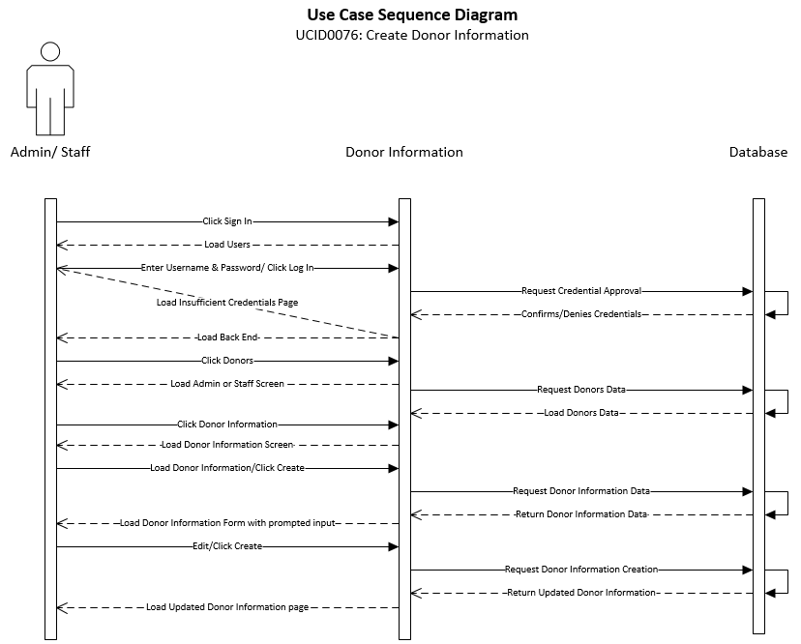

|  |
| --- |
| **Use Case:** Read Donation Information – Admin/Staff View |
| **ID:** UCID077 |
| **Brief Description:**  Describes how the system will view a Donation Information |
| **Primary Actors:** Admin |
| **Secondary Actors:** Admin/Staff |
| **Preconditions:**  System operational  Admin/Staff user must have rights to view a Donation Information |
| **Main Flow:**   1. Admin/Staff user will click login on website 2. Admin/Staff user enters credentials 3. Admin/Staff user clicks Donors 4. Admin/Staff user views Donation Information |
| **Postconditions:**  Donation Information is read |
| **Alternative flows:**  None |

The sequence diagram shows the necessary flow of interactions between the primary actor and the system. Based on interactions with the system, different steps can be taken to achieve the creation, deletion, reading, and modification of different aspects of the system. This shows the “happy day” scenario of how the system would run.

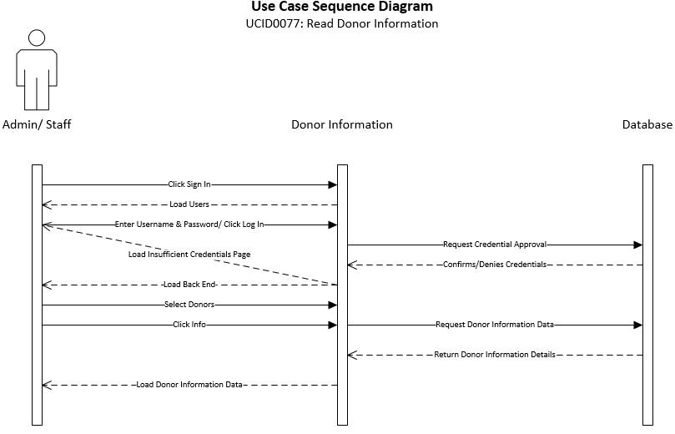

|  |
| --- |
| **Use Case:** Update Donation Information– Admin/Staff View |
| **ID:** UCID078 |
| **Brief Description:**  Describes how the system will update a Donation Information |
| **Primary Actors:** Admin |
| **Secondary Actors:** Admin/Staff |
| **Preconditions:**  System operational  Admin/Staff user must have rights to update a Donation Information |
| **Main Flow:**   1. Admin/Staff user will click login on website 2. Admin/Staff user enters credentials 3. Admin/Staff user clicks Donors 4. Admin/Staff user views Donation Information 5. Admin/Staff user clicks Update Donation Information |
| **Postconditions:** Donation Information is updated |
| **Alternative flows:**  None |

The sequence diagram shows the necessary flow of interactions between the primary actor and the system. Based on interactions with the system, different steps can be taken to achieve the creation, deletion, reading, and modification of different aspects of the system. This shows the “happy day” scenario of how the system would run.

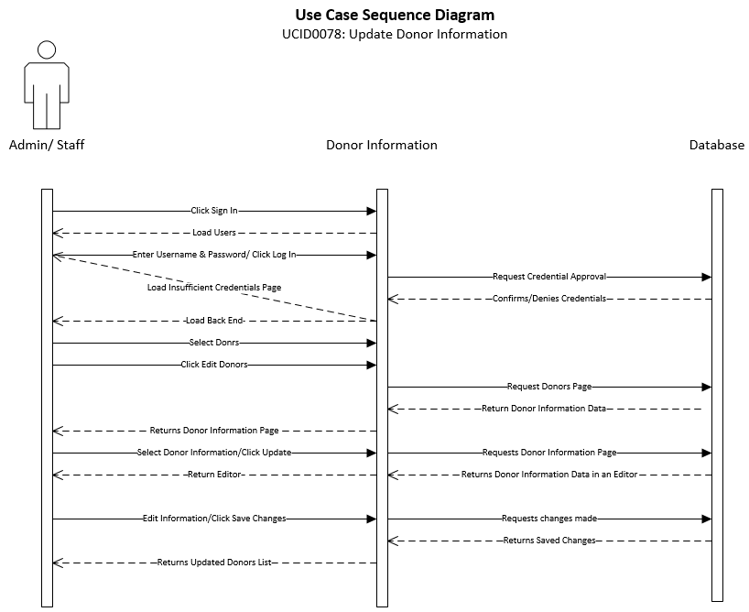

|  |
| --- |
| **Use Case:** Delete Donation Information – Admin/Staff View |
| **ID:** UCID079 |
| **Brief Description:**  Describes how the system will delete a Donation Information |
| **Primary Actors:** Admin |
| **Secondary Actors:** Admin/Staff |
| **Preconditions:**  System operational  Admin/Staff user must have rights to delete a Donation Information |
| **Main Flow:**   1. Admin/Staff user will click login on website 2. Admin/Staff user enters credentials 3. Admin/Staff user clicks Donors 4. Admin/Staff user views Donation Information 5. Admin/Staff user clicks Delete Donation Information |
| **Postconditions:** Donation Information is deleted |
| **Alternative flows:**  None |

The sequence diagram shows the necessary flow of interactions between the primary actor and the system. Based on interactions with the system, different steps can be taken to achieve the creation, deletion, reading, and modification of different aspects of the system. This shows the “happy day” scenario of how the system would run.

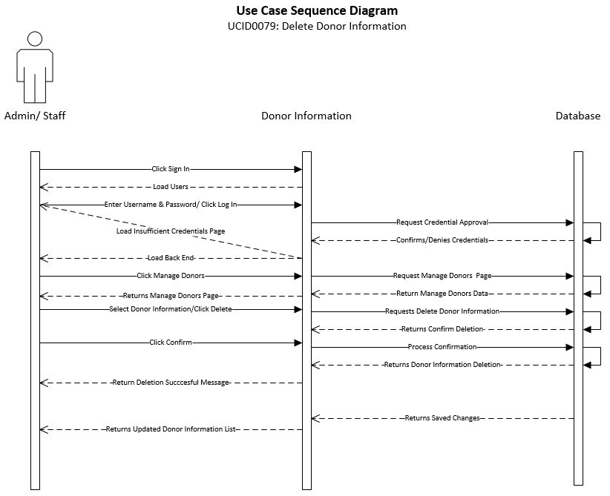

|  |
| --- |
| **Use Case:** Approve Donation Information – Admin/Staff View |
| **ID:** UCID080 |
| **Brief Description:**  Describes how the system will approve a Donation Information |
| **Primary Actors:** Admin |
| **Secondary Actors:** Admin/Staff |
| **Preconditions:**  System operational  Admin/Staff user must have rights to approve Donation Information  Donation Information must be created |
| **Main Flow:**   1. Admin/Staff user will click login on website 2. Admin/Staff user enters credentials 3. Admin/Staff user clicks Donors 4. Admin/Staff user views Donation Information 5. Admin/Staff user clicks Approve Donation Information |
| **Postconditions:** Donation Information is approved |
| **Alternative flows:**  None |

The sequence diagram shows the necessary flow of interactions between the primary actor and the system. Based on interactions with the system, different steps can be taken to achieve the creation, deletion, reading, and modification of different aspects of the system. This shows the “happy day” scenario of how the system would run.

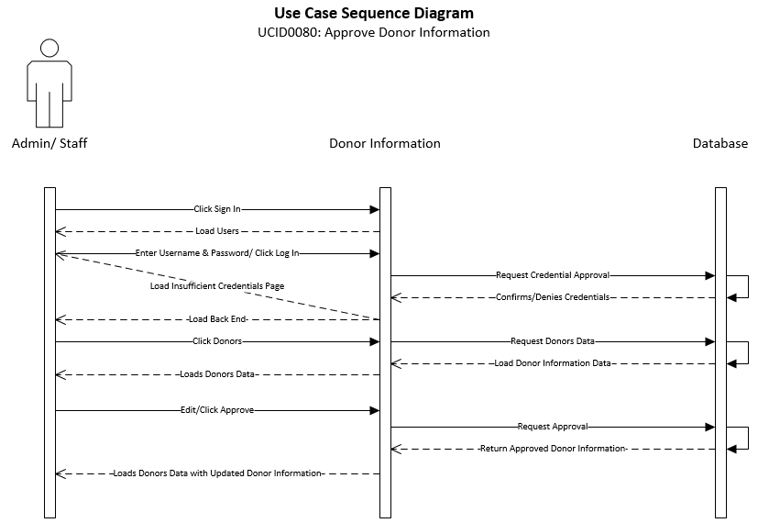

**Class Diagram**

The following demonstrative aid is a class diagram, a model that shows all the classes and their relationships among each other. The class diagram depicts classes that contain both behaviors and states, as well as the relationships between the classes. We use the noun-verb analysis to set up these classes, attributes, and methods with nouns to map up with the classes, objects, or attributes while having verbs describe the methods. In this type of analysis, different versions of nouns and verbs are used to describe different entities within a system.

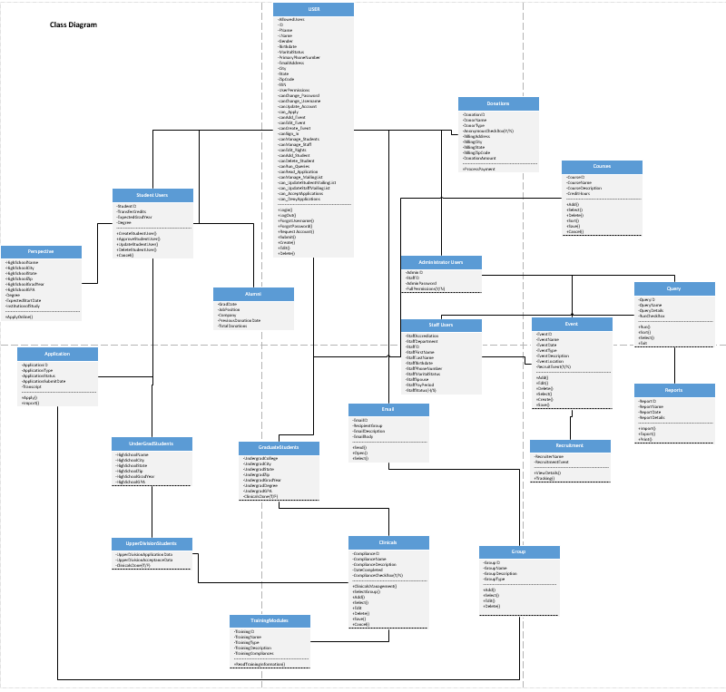

**Entity Relationship Diagram (ERD)**

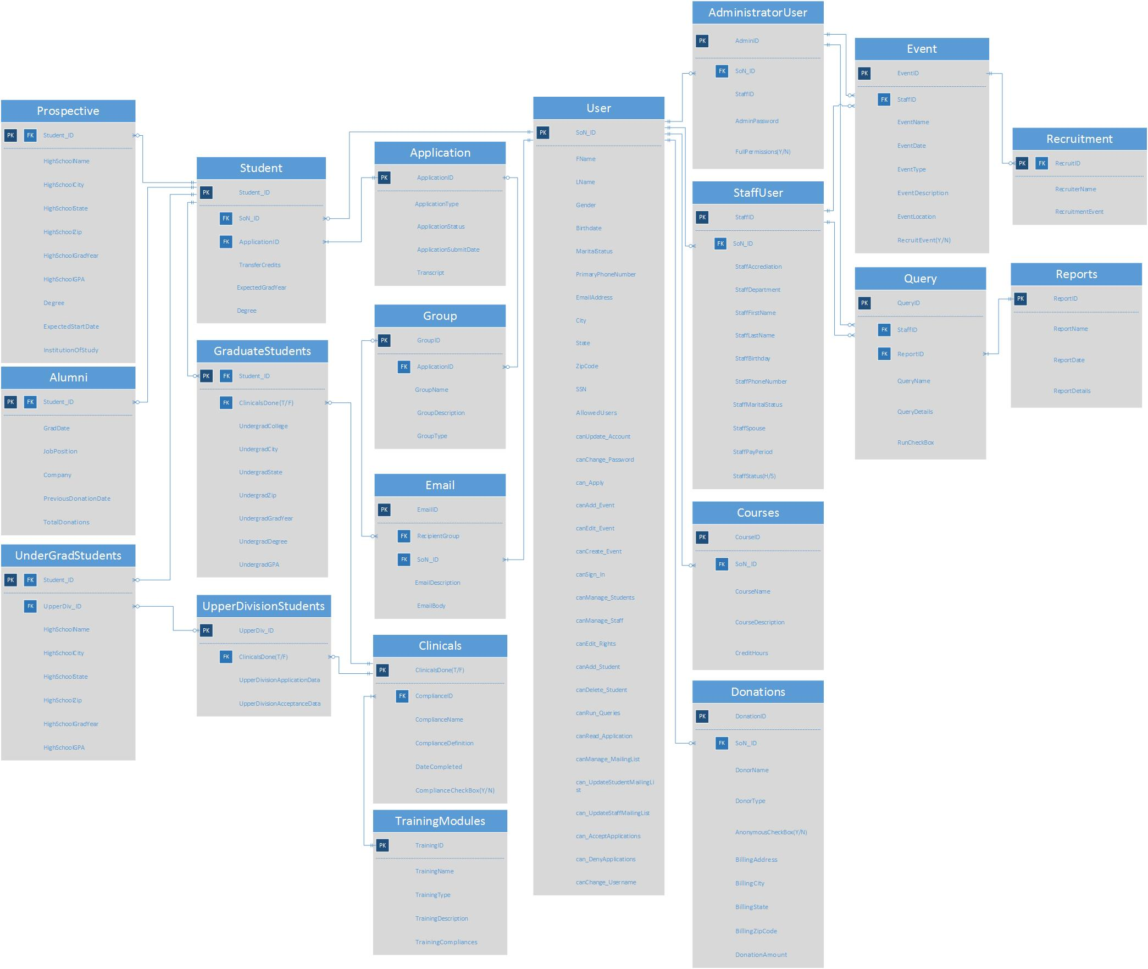The following ERD is a graphical representation of the proposed database system for the School of Nursing. It illustrates the entites of the database as tables filled with their affiliated attributes (i.e. Student User, Staff User, Clinicals, and Classes). Lines are drawn to represent the relationships between one table and another, their end points consisting of symbols which depict the cardinality of each relationship (one-to-one, one-to-many, zero-to-many, etc.).

**Data Dictionary**

The Data Dictionary consists of the following tables, with each table representative of an object within the School of Nursing’s potential database system. The tables provide detailed information about the data elements affiliated with each entity (i.e. Users, Reports, Events, etc.). The name of each attribute is listed along with a short definition, as well as each attribute’s data type and size. The attribute’s designated as Primary Keys and Foreign Keys are notated to the far left of the table.

|  |  |  |  |  |  |  |
| --- | --- | --- | --- | --- | --- | --- |
| **Table Name:** | **AdministratorUsers** | | |  |  |  |
|  |  |  |  |  |  |  |
|  |  | **PK/FK** | **Attributes** | **Definition** | **Type** | **Size (Bytes)** |
|  |  | PK | AdminID | Administrator User Identification Number | CHAR(8) | 8 |
|  |  | FK | SoN_ID | The User's ID Number | CHAR(8) | 8 |
|  |  |  | StaffID | Staff User Identification Number | CHAR(8) | 8 |
|  |  |  | AdminPassword | Unique password for Administrator Users | VCHAR(15) | 17 |
|  |  |  | FullPermissions(Y/N) | User is given clearance for all Permissions - checkbox (Y/N) | BIN | 1 |

|  |  |  |  |  |  |  |
| --- | --- | --- | --- | --- | --- | --- |
| **Table Name:** | **Alumni** |  |  |  |  |  |
|  |  |  |  |  |  |  |
|  |  | **PK/FK** | **Attributes** | **Definition** | **Type** | **Size(Bytes)** |
|  |  | PK/FK | Student_ID | Student User's Identification Number | CHAR(8) | 8 |
|  |  |  | GradDate | User's Graduation Date | DATE | 3 |
|  |  |  | JobPosition | User's Current Job title | VCHAR(30) | 32 |
|  |  |  | Company | Calendar with dates | DATE | 3 |
|  |  |  | PreviousDonationDate | Dates of previous donations | DATE | 3 |
|  |  |  | TotalDonations | Total amount of donations | DECIMAL(10,2) | 10 |

|  |  |  |  |  |  |  |
| --- | --- | --- | --- | --- | --- | --- |
| **Table Name:** | **Applications** | |  |  |  |  |
|  |  |  |  |  |  |  |
|  |  | **PK/FK** | **Attributes** | **Definition** | **Type** | **Size(Bytes)** |
|  |  | PK | ApplicationID | Unique code for every item | CHAR(8) | 8 |
|  |  |  | ApplicationType | Type of Application being submitted | VCHAR(30) | 31 |
|  |  |  | ApplicationStatus | Approval Status of Application | VCHAR(10) | 10 |
|  |  |  | ApplicationSubmitDate | Calendar with dates | DATETIME | 8 |
|  |  |  | Transcript | Transcript Attached - checkbox (Y/N) | BIN | 1 |
|  |  |  | Apply | Button to submit Application | BIN | 1 |
|  |  |  | Import | Button to import a transcript | BIN | 1 |

|  |  |  |  |  |  |  |
| --- | --- | --- | --- | --- | --- | --- |
| **Table Name:** | **Clinicals** |  |  |  |  |  |
|  |  |  |  |  |  |  |
|  |  | **PK/FK** | **Attributes** | **Definition** | **Type** | **Size(Bytes)** |
|  |  | PK | ComplianceCheckBox(Y/N) | Compliance completion - checkbox (Y/N) | BIN | 1 |
|  |  | FK | ComplianceID | Unique code for every Clinical | CHAR(8) | 8 |
|  |  |  | ComplianceName | TItle of the Compliance | VCHAR(30) | 32 |
|  |  |  | ComplianceDescription | Description of the Compliance | VCHAR(255) | 257 |
|  |  |  | DateCompleted | Completion date of the Compliance | DATE | 3 |
|  |  |  | ClinicalsManagement | Button to edit Clinical details | BIN | 1 |
|  |  |  | SelectGroup | Button to select multiple compliances | BIN | 1 |
|  |  |  | Add | Button to create a Compliance | BIN | 1 |
|  |  |  | Select | Button to select a single Compliance | BIN | 1 |
|  |  |  | Edit | Button to edit Compliance details | BIN | 1 |
|  |  |  | Delete | Button to delete a Compliance | BIN | 1 |
|  |  |  | Save | Button to save a Compliance | BIN | 1 |
|  |  |  | Cancel | Button to Cancel an action | BIN | 1 |

|  |  |  |  |  |  |  |
| --- | --- | --- | --- | --- | --- | --- |
| **Table Name:** | **Courses** | |  |  |  |  |
|  |  |  |  |  |  |  |
|  |  | **PK/FK** | **Attributes** | **Definition** | **Type** | **Size (Bytes)** |
|  |  | PK | CourseID | Course Identification Number | CHAR(8) | 8 |
|  |  | FK | SoN_ID | The User's ID Number | CHAR(8) | 8 |
|  |  |  | CourseName | Name of Course | VCHAR(20) | 22 |
|  |  |  | CourseDescription | Description of Course | VCHAR(255) | 257 |
|  |  |  | CreditHours | Amount of credit hours awarded for completion of course | DECIMAL(1,1) | 5 |
|  |  |  | Add | Button to add the Course | BIN | 1 |
|  |  |  | Select | Button to select the Course | BIN | 1 |
|  |  |  | Delete | Button to delete Course | BIN | 1 |
|  |  |  | Sort | Button to sort courses (ascending/decending) | BIN | 1 |
|  |  |  | Save | Button to save Course details | BIN | 1 |
|  |  |  | Cancel | Button to cancel action | BIN | 1 |

|  |  |  |  |  |  |  |
| --- | --- | --- | --- | --- | --- | --- |
| **Table Name:** | **Donations** | |  |  |  |  |
|  |  |  |  |  |  |  |
|  |  | **PK/FK** | **Attributes** | **Definition** | **Type** | **Size (Bytes)** |
|  |  | PK | DonationID | Donation Identification Number | CHAR(8) | 8 |
|  |  | FK | SoN_ID | The User's ID Number | CHAR(8) | 8 |
|  |  |  | DonorName | Name of Donor | VCHAR(40) | 42 |
|  |  |  | DonorType | Type of Donation | VCHAR(20) | 22 |
|  |  |  | AnonymousCheckBox(Y/N) | Donor wishes to remain anonymous - checkbox (Y/N) | BIN | 1 |
|  |  |  | BillingAddress | Address to be used for billing | VCHAR(50) | 52 |
|  |  |  | BillingCity | City to be used for billing | VCHAR(20) | 22 |
|  |  |  | BillingState | State to be used for billing | VCHAR(2) | 4 |
|  |  |  | BillingZipCode | Zipcode to be used for billing | CHAR(10) | 10 |
|  |  |  | DonationAmount | Amount to be donated | DECIMAL(10,2) | 5 |
|  |  |  | ProcessPayment | Button to initiate donation payment | BIN | 1 |

|  |  |  |  |  |  |  |
| --- | --- | --- | --- | --- | --- | --- |
| **Table Name:** | **Email** |  |  |  |  |  |
|  |  |  |  |  |  |  |
|  |  | **PK/FK** | **Attributes** | **Definition** | **Type** | **Size (Bytes)** |
|  |  | PK | EmailID | Email Identification Number | CHAR(8) | 8 |
|  |  | FK | SoN_ID | The User's ID Number | CHAR(8) | 8 |
|  |  | FK | RecipientGroup | Email group ID | CHAR(8) | 8 |
|  |  |  | EmailDescription | Description of email | VCHAR(30) | 32 |
|  |  |  | EmailBody | Email contents/message | VCHAR(255) | 257 |
|  |  |  | Send | Button to send an Email | BIN | 1 |
|  |  |  | Open | Button to open an Email | BIN | 1 |
|  |  |  | Select | Button to select an Email | BIN | 1 |

|  |  |  |  |  |  |  |
| --- | --- | --- | --- | --- | --- | --- |
| **Table Name:** | **Event** |  |  |  |  |  |
|  |  |  |  |  |  |  |
|  |  | **PK/FK** | **Attributes** | **Definition** | **Type** | **Size (Bytes)** |
|  |  | PK | EventID | Event Identification Number | CHAR(8) | 8 |
|  |  | FK | StaffID | Staff User Identification Number | CHAR(8) | 8 |
|  |  |  | EventName | Name of event | VCHAR(20) | 22 |
|  |  |  | EventDate | Date & Time of event | DATETIME | 8 |
|  |  |  | EventType | Type of event | VCHAR(20) | 22 |
|  |  |  | EventDescription | Description of event | VCHAR(255) | 257 |
|  |  |  | EventLocation | Location of event | VCHAR(50) | 52 |
|  |  |  | RecruitEvent(Y/N) | Event is a recruitment event - checkbox (Y/N) | BIN | 1 |
|  |  |  | Add | Button to add the Course | BIN | 1 |
|  |  |  | Edit | Button to edit course details | BIN | 1 |
|  |  |  | Delete | Button to delete Course | BIN | 1 |
|  |  |  | Select | Button to select the Course | BIN | 1 |
|  |  |  | Create | Button to create a Course | BIN | 1 |
|  |  |  | Save | Button to save Course details | BIN | 1 |
|  |  |  | Cancel | Button to cancel action | BIN | 1 |

|  |  |  |  |  |  |  |
| --- | --- | --- | --- | --- | --- | --- |
| **Table Name:** | **GraduateStudents** | | |  |  |  |
|  |  |  |  |  |  |  |
|  |  | **PK/FK** | **Attributes** | **Definition** | **Type** | **Size(Bytes)** |
|  |  | PK/FK | StudentID | Student User's Identification Number | CHAR(8) | 8 |
|  |  | FK | ClinicalsDone(T/F) | Clinicals completed - checkbox (Y/N) | BIN | 1 |
|  |  |  | UndergradCollege | Name of User's graduating college | VCHAR(50) | 52 |
|  |  |  | UndergradCity | City of User's graduating college | VCHAR(30) | 32 |
|  |  |  | UndergradState | State of User's graduating college | VCHAR(2) | 4 |
|  |  |  | UndergradZip | Zipcode of User's graduating college | VCHAR(10) | 12 |
|  |  |  | UndergradGradYear | User's graduating year | DATE | 3 |
|  |  |  | UndergradDegree | User's applicable degree | VCHAR(30) | 32 |
|  |  |  | UndergradGPA | User's standing GPA | DECIMAL(1,4) | 5 |

|  |  |  |  |  |  |  |
| --- | --- | --- | --- | --- | --- | --- |
| **Table Name:** | **Group** |  |  |  |  |  |
|  |  |  |  |  |  |  |
|  |  | **PK/FK** | **Attributes** | **Definition** | **Type** | **Size (Bytes)** |
|  |  | PK | GroupID | Group Identification Number | CHAR(8) | 8 |
|  |  | FK | ApplicationID | Unique code for Applications | CHAR(8) | 8 |
|  |  |  | GroupName | Name of group | VCHAR(20) | 22 |
|  |  |  | GroupDescription | Description of group | VCHAR(255) | 257 |
|  |  |  | GroupType | Type of group | VCHAR(20) | 22 |
|  |  |  | Add | Button to add a Group | BIN | 1 |
|  |  |  | Select | Button to select Groups | BIN | 1 |
|  |  |  | Edit | Button to edit Group | BIN | 1 |
|  |  |  | Delete | Button to delete Group | BIN | 1 |

|  |  |  |  |  |  |  |
| --- | --- | --- | --- | --- | --- | --- |
| **Table Name:** | **Prospective** | |  |  |  |  |
|  |  |  |  |  |  |  |
|  |  | **PK/FK** | **Attributes** | **Definition** | **Type** | **Size (Bytes)** |
|  |  | PK/FK | Student_ID | Student User's Identification Number | CHAR(8) | 8 |
|  |  |  | HighSchoolName | Name of High School attended | VCHAR(20) | 22 |
|  |  |  | HighSchoolCity | Name of High School location (City) | VCHAR(20) | 22 |
|  |  |  | HighSchoolState | Name of High School location (State) | VCHAR(20) | 22 |
|  |  |  | HighSchoolZip | Zipcode of High School location | CHAR(10) | 10 |
|  |  |  | HighSchoolGradYear | Date & Time of event on calendar | DATE | 3 |
|  |  |  | HighSchoolGPA | Standing (current) GPA of attended High School | Decimal(1,4) | 5 |
|  |  |  | Degree | User has an applicable degree - checkbox (Y/N) | BIN | 1 |
|  |  |  | ExpectedStartDate | Date User intends to begin program | DATE | 3 |
|  |  |  | InstitutionOfStudy | Name of User's previous educational institute | VCHAR(255) | 257 |
|  |  |  | ApplyOnline | Button to open Application window | BIN | 1 |

|  |  |  |  |  |  |  |
| --- | --- | --- | --- | --- | --- | --- |
| **Table Name:** | **Query** |  |  |  |  |  |
|  |  |  |  |  |  |  |
|  |  | **PK/FK** | **Attributes** | **Definition** | **Type** | **Size (Bytes)** |
|  |  | PK | QueryID | Query Identification Number | CHAR(8) | 8 |
|  |  | FK | StaffID | Staff User Identification Number | CHAR(8) | 8 |
|  |  | FK | ReportID | Report Identification Number | CHAR(8) | 8 |
|  |  |  | QueryName | Name of Query | VCHAR(20) | 22 |
|  |  |  | QueryDetails | Details of Query | VCHAR(255) | 257 |
|  |  |  | RunCheckBox | Query has been executed - checkbox (Y/N) | BIN | 1 |
|  |  |  | Run | Button to execute query | BIN | 1 |
|  |  |  | Sort | Button to sort queries (ascending/descending) | BIN | 1 |
|  |  |  | Select | Button to select queries | BIN | 1 |
|  |  |  | Exit | Button to exit Query window | BIN | 1 |

|  |  |  |  |  |  |  |
| --- | --- | --- | --- | --- | --- | --- |
| **Table Name:** | **Recruitment** | |  |  |  |  |
|  |  |  |  |  |  |  |
|  |  | **PK/FK** | **Attributes** | **Definition** | **Type** | **Size (Bytes)** |
|  |  | PK/FK | RecruitID | Unique identifier for Recruitment Events | CHAR(8) | 8 |
|  |  |  | RecruiterName | Name of recruiter | VCHAR(20) | 22 |
|  |  |  | RecruitmentEvent | Description of recruitment event | VCHAR(255) | 257 |
|  |  |  | ViewDetails | Button to view attached recruitment event details | BIN | 1 |
|  |  |  | Tracking | Button to track recruitment event | BIN | 1 |

|  |  |  |  |  |  |  |
| --- | --- | --- | --- | --- | --- | --- |
| **Table Name:** | **Report** |  |  |  |  |  |
|  |  |  |  |  |  |  |
|  |  | **PK/FK** | **Attributes** | **Definition** | **Type** | **Size (Bytes)** |
|  |  | PK | ReportID | Report Identification Number | CHAR(8) | 8 |
|  |  |  | ReportName | Name of report | VCHAR(20) | 22 |
|  |  |  | ReportDate | Date report was executed | DATETIME | 8 |
|  |  |  | ReportDetails | Details of report | VCHAR(255) | 257 |
|  |  |  | Import | Button to upload a document | BIN | 1 |
|  |  |  | Export | Button to export a report | BIN | 1 |
|  |  |  | Print | Button to initiate the printing process for a report | BIN | 1 |

|  |  |  |  |  |  |  |
| --- | --- | --- | --- | --- | --- | --- |
| **Table Name:** | **StaffUsers** | |  |  |  |  |
|  |  |  |  |  |  |  |
|  |  | **PK/FK** | **Attributes** | **Definition** | **Type** | **Size (Bytes)** |
|  |  | PK | StaffID | Staff User Identification Number | CHAR(8) | 8 |
|  |  | FK | SoN_ID | The User's ID Number | CHAR(8) | 8 |
|  |  |  | StaffAccreditation | Accreditation of Staff User | VCHAR(20) | 22 |
|  |  |  | StaffDepartment | Department of Staff User | VCHAR(20) | 22 |
|  |  |  | StaffFirstName | Staff User's First Name | VCHAR(20) | 22 |
|  |  |  | StaffLastName | Staff User's Last Name | VCHAR(20) | 22 |
|  |  |  | StaffBirthdate | Staff User's Date of Birth | DATE | 3 |
|  |  |  | StaffPhoneNumber | Staff User's Phone Number | CHAR(10) | 10 |
|  |  |  | StaffMaritalStatus | Staff User's Marital Status - checkbox (Y/N) | BIN | 1 |
|  |  |  | StaffSpouse | Staff User's Spouse name | VCHAR(20) | 22 |
|  |  |  | StaffPayPeriod | Staff User's Pay Period | DATE | 3 |
|  |  |  | StaffStatus(H/S) | Staff User's status - checkbox (H/S) | BIN | 1 |

|  |  |  |  |  |  |  |
| --- | --- | --- | --- | --- | --- | --- |
| **Table Name:** | **StudentUsers** | |  |  |  |  |
|  |  |  |  |  |  |  |
|  |  | **PK/FK** | **Attributes** | **Definition** | **Type** | **Size(Bytes)** |
|  |  | PK | StudentID | Student User's Identification Number | CHAR(8) | 8 |
|  |  | FK | SoN_ID | The User's ID Number | CHAR(8) | 8 |
|  |  |  | TransferCredits | The User's applicable transfer credits | VCHAR(3) | 5 |
|  |  |  | ExpectedGradYear | The User's expected year of graduation | DATE | 3 |
|  |  |  | Degree | The User's applicable degree | VCHAR(30) | 32 |
|  |  |  | CreateStudentUser | Create Student User Button | BIN | 1 |
|  |  |  | ApproveStudentUser | Approve Student User Button | BIN | 1 |
|  |  |  | UpdateStudentUser | Update Student User Button | BIN | 1 |
|  |  |  | DeleteStudentUser | Delete Student User Button | BIN | 1 |
|  |  |  | Cancel | Cancel Button Pressed | BIN | 1 |

|  |  |  |  |  |  |  |
| --- | --- | --- | --- | --- | --- | --- |
| **Table Name:** | **TrainingModules** | | |  |  |  |
|  |  |  |  |  |  |  |
|  |  | **PK/FK** | **Attributes** | **Definition** | **Type** | **Size (Bytes)** |
|  |  | PK | TrainingID | Training Identification Number | CHAR(8) | 8 |
|  |  |  | TrainingName | Name of training | VCHAR(20) | 22 |
|  |  |  | TrainingType | Type of training | VCHAR(20) | 22 |
|  |  |  | TrainingDescription | Description of training | VCHAR(255) | 257 |
|  |  |  | TrainingCompliances | Affiliated Compliances | CHAR(8) | 8 |
|  |  |  | ReadTrainingInformation | Button to read attached training information | BIN | 1 |

|  |  |  |  |  |  |  |
| --- | --- | --- | --- | --- | --- | --- |
| **Table Name:** | **UnderGradStudents** | | |  |  |  |
|  |  |  |  |  |  |  |
|  |  | **PK/FK** | **Attributes** | **Definition** | **Type** | **Size(Bytes)** |
|  |  | PK/FK | Student_ID | Student User's Identification Number | CHAR(8) | 8 |
|  |  | FK | UpperDiv_ID | Upper Division Student User Identifier | CHAR(8) | 8 |
|  |  |  | HighSchoolName | User's High School Name | VCHAR(30) | 32 |
|  |  |  | HighSchoolCity | User's High School City | VCHAR(30) | 32 |
|  |  |  | HighSchoolState | User's High School State | VCHAR(2) | 4 |
|  |  |  | HighSchoolZip | User's High School Zip | VCHAR(10) | 12 |
|  |  |  | HighSchoolGradYear | User's High School Graduation Year | DATE | 3 |
|  |  |  | HighSchoolGPA | User's High School GPA | DECIMAL(1,4) | 5 |

|  |  |  |  |  |  |  |
| --- | --- | --- | --- | --- | --- | --- |
| **Table Name:** | **UpperDivisionStudents** | | |  |  |  |
|  |  |  |  |  |  |  |
|  |  | **PK/FK** | **Attributes** | **Definition** | **Type** | **Size** |
|  |  | PK | UpperDiv_ID | Upper Division Student User Identifier | CHAR(8) | 8 |
|  |  | FK | ClinicalsDone(T/F) | Clinicals completed - checkbox (Y/N) | BIN | 1 |
|  |  |  | UpperDivisionApplicationData | Upper Division Student Application Data | VCHAR(255) | 256 |
|  |  |  | UpperDivisionAcceptanceData | Upper Division Student Acceptance Data | VCHAR(255) | 256 |

|  |  |  |  |  |  |  |  |
| --- | --- | --- | --- | --- | --- | --- | --- |
|  |  |  |  |  |  |  |  |
|  | **Table Name:** | **User** |  |  |  |  |  |
|  |  |  |  |  |  |  |  |
|  |  |  | **PK/FK** | **Attributes** | **Definition** | **Type** | **Size(Bytes)** |
|  |  |  | PK | SoN_ID | The User's ID Number | CHAR(8) | 8 |
|  |  |  |  | FName | The User's First Name | VCHAR(30) | 32 |
|  |  |  |  | LName | The User's Last Name | VCHAR(50) | 52 |
|  |  |  |  | Gender | The User's Gender | CHAR(1) | 1 |
|  |  |  |  | Birthdate | D:M:Y of birth | DATE | 3 |
|  |  |  |  | MaritalStatus | The User's marital status | VCHAR(40) | 42 |
|  |  |  |  | PrimaryPhoneNumber | The User's phone number | CHAR(10) | 10 |
|  |  |  |  | EmailAddress | The User's email | VCHAR(80) | 82 |
|  |  |  |  | City | The User's City | VCHAR(30) | 32 |
|  |  |  |  | State | The User's State | CHAR(2) | 2 |
|  |  |  |  | ZipCode | The User's Zip Code | CHAR(10) | 10 |
|  |  |  |  | SSN | The User's SSN | CHAR(9) | 9 |
|  |  |  |  | Login | Login Button | BIN | 1 |
|  |  |  |  | LogOut | Log Out Button | BIN | 1 |
|  |  |  |  | ForgotUsername | Forgot Username Button | BIN | 1 |
|  |  |  |  | ForgotPassword | Forgot Password Button | BIN | 1 |
|  |  |  |  | RequestAccount | Request Account information Button | BIN | 1 |
|  |  |  |  | Submit | Submit Button | BIN | 1 |
|  |  |  |  | Edit | Edit Button | BIN | 1 |
|  |  |  |  | Delete | Delete Button | BIN | 1 |
|  |  |  |  | AllowedUsers | User is allowed access to the Website | BIN | 1 |
|  |  |  |  | canChange_Password | User can edit User Passwords - checkbox Yes/No | BIN | 1 |
|  |  |  |  | canChange_UserName | User can edit User UserNames - checkbox Yes/No | BIN | 1 |
|  |  |  |  | canUpdate_Account | User can edit User Account details - checkbox Yes/No | BIN | 1 |
|  |  |  |  | can_Apply | User can access Apply function - checkbox Yes/No | BIN | 1 |
|  |  |  |  | canAdd_Event | User can add an Event to Events - checkbox Yes/No | BIN | 1 |
|  |  |  |  | canEdit_Event | User can edit existing Events - checkbox Yes/No | BIN | 1 |
|  |  |  |  | canCreate_Event | User can create an Event - checkbox Yes/No | BIN | 1 |
|  |  |  |  | canSign_In | User is allowed access the Website - checkbox Yes/No | BIN | 1 |
|  |  |  |  | canManage_Students | User can edit Student data - checkbox Yes/No | BIN | 1 |
|  |  |  |  | canManage_Staff | User can edit Staff data - checkbox Yes/No | BIN | 1 |
|  |  |  |  | canEdit_Rights | User can edit User Rights - checkbox Yes/No | BIN | 1 |
|  |  |  |  | canAdd_Student | User can add Users to Student Users - checkbox Yes/No | BIN | 1 |
|  |  |  |  | canDelete_Student | User can delete Student Users - checkbox Yes/No | BIN | 1 |
|  |  |  |  | canRun_Queries | User can create/run Queries - checkbox Yes/No | BIN | 1 |
|  |  |  |  | canRead_Application | User can view Student Application details - checkbox Yes/No | BIN | 1 |
|  |  |  |  | canManage_MailingList | User can edit Mail List data - checkbox Yes/No | BIN | 1 |
|  |  |  |  | can_UpdateStudentMailingList | User can edit Student Mail List details - checkbox Yes/No | BIN | 1 |
|  |  |  |  | can_UpdateStaffMailingList | User can edit Staff Mail List details - checkbox Yes/No | BIN | 1 |
|  |  |  |  | can_AcceptApplications | User has permission to Approve Student Application - checkbox Yes/No | BIN | 1 |
|  |  |  |  | can_DenyApplications | User has permission to Deny Student Application - checkbox Yes/No | BIN | 1 |

**User Interface Navigation**

The following navigation diagram represents the flow between the prototypes. When using the application, the user begins at the top of the diagram at the “Login” prototype, and continues down through the prototypes until reaching the feature they desire. Each page that can be accessed from a user’s current page is connected by an arrow.

The prototypes in light blue represent public web pages that all users have access to before logging in. After logging in, the user is routed to the dashboard that matches their specific account type – either Admin, Staff, Student, or Prospective Student. Admin users have access to the prototypes shown in dark red (as well as any prototypes accessible by a Staff user). Staff users can access the prototypes with a light red color. Student users can access the prototypes in dark orange, and Prospective Students have access to the light orange prototypes.

While not all the system features and use cases have prototype screens, many system features utilize a very similar layout. For example, nearly all objects in the “Admin” section (below “Admin Dashboard”) comprise of the same layout - first a select screen, then a create, edit, and delete screen based on which option the user clicked. Because of this, the navigation diagram only has a few instances of the multiple objects that the user can navigate to from the “Admin” section. However, each use case has a prototype screen that matches the general layout that would be required by that use case.

**User Interface Navigation Diagram**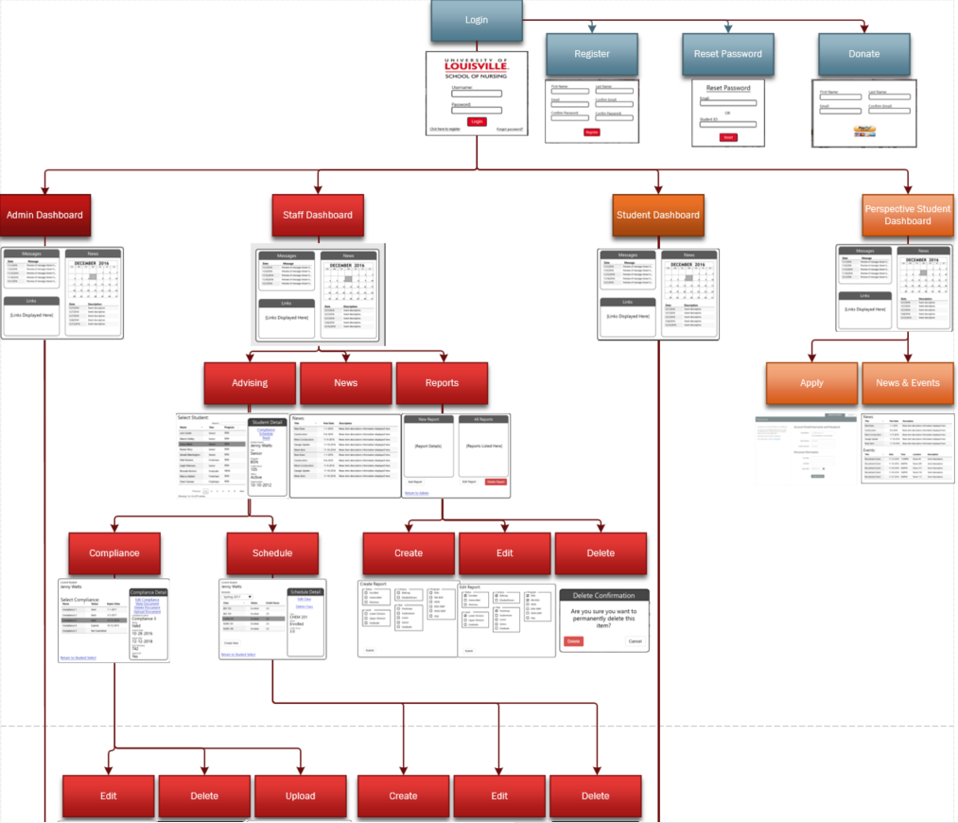 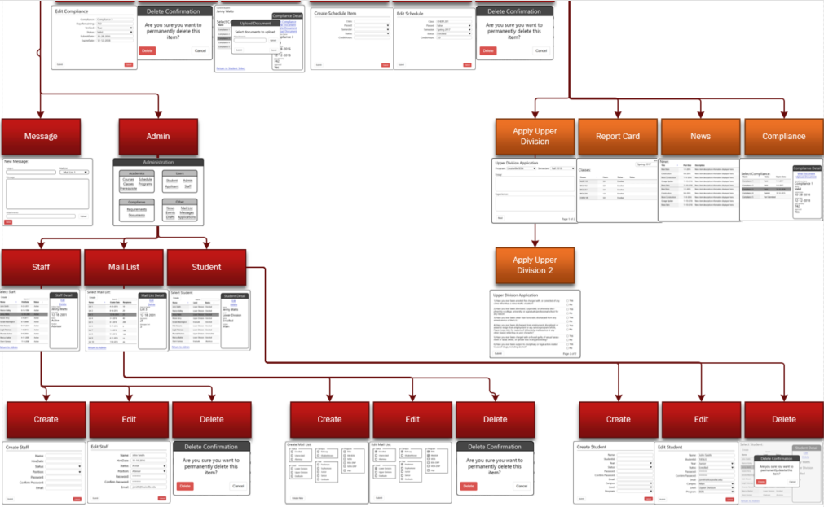

**Physical Architecture Design**

The deployment diagram shown here is the physical architecture design of the proposed system for the School of Nursing. Shown are different tiers representing the different components needed for the system to work including the Client Tier, the Web Tier, the Application Tier, and the Data Tier.

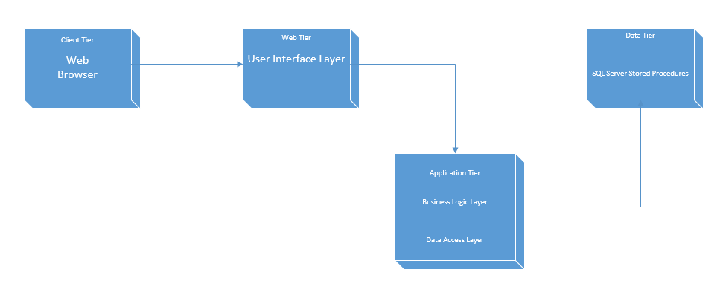

**Design Procedures for Security Concerns and Non-Functional Requirements**

The following document examines non-functional requirements and the security procedures

that can be utilized to optimize a secure environment.

**Environments**:

Through the use of four separate environments, the promotion of data security, specifically

confidentiality, integrity, and access will be maximized while minimizing data concerns such as

disclosure, alteration, and destruction. The four environments are listed as follows:

* Development – Critical environment to prevent security issues. Use of the following in the development environment can prevent concerns raised in the above paragraph.
  + Code Integrity and Handling – Promotes integrity, prevents alteration/destruction
  + Threat Analysis – Attempt to mitigate potential security threats before they can occur.
  + Documentation – Confidential documentation of work prevents unauthorized altercation and/or destruction.
* Test – Environment which serves as the test area for new applications/updates created in the development environment.
  + Code inspection
  + Documentation – As in the Development environment, prevents unauthorized altercation.
* Production – Live environment continually being updated from Test and/or Development environments. While not directly worked on, the production environment still requires extremely important security considerations.
  + Separate from Development/Test Environment.
  + Encryption – Secure Sockets Layer (SSL) software.
  + Access Control – Permissions for who can access what.
  + Authentication – Users logging in require authentication.
  + Virus control – Files/documents being uploaded require scanning.
* Backup – Final environment designed to protect against potential catastrophic events. Backup for the School of Nursing will occur through the GoDaddy service, either as an automatic feature, or through Snapshots occurring every couple of days.

**Gantt Chart**

The individual assignments of the different group members to sections of the use cases allowed us to spread out the task and finish the use cases more quickly. Having a lot of compilation to begin working on and last minute additions and revisions, it is necessary to break work up into individual assignments to finish by the allotted date. The Gantt chart shows what time frame we were working in for the final three iterations and shows each parts dependency and group member assignment.

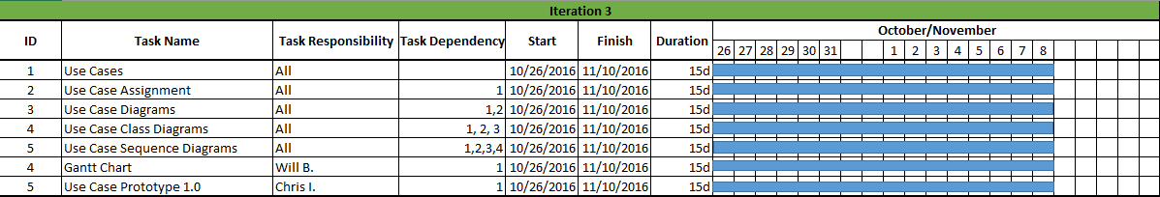

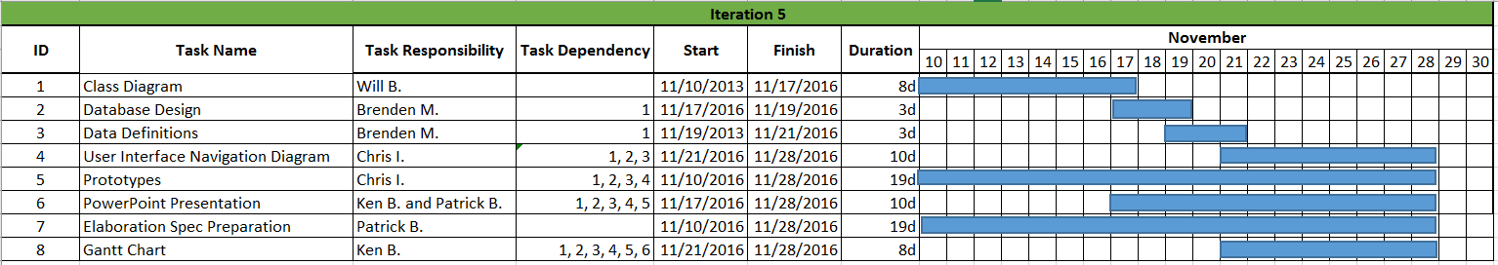

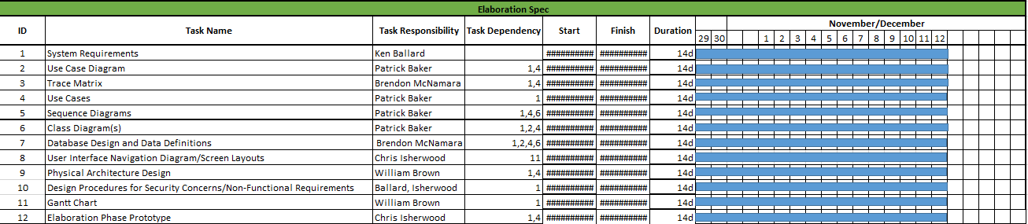

**Prototypes**

1 - Login Page

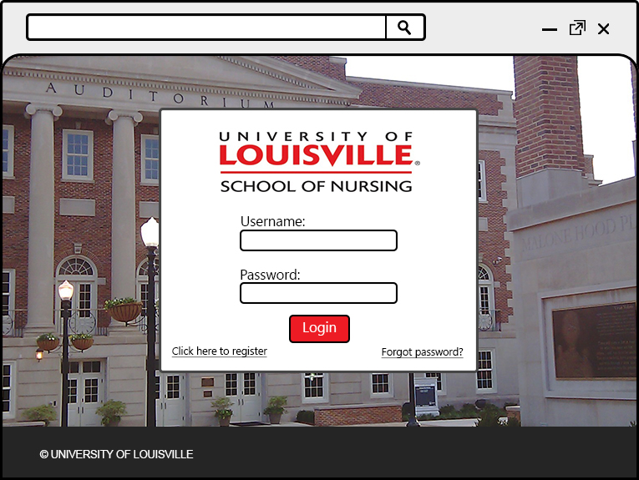

The page the user would be redirected to from the School of Nursing homepage (<http://louisville.edu/nursing>). This page could include both client and server side input verification, and will auto detect what user type the user is (admin, staff, student, or prospective student) and route them to the correct dashboard.

2 – User Registration

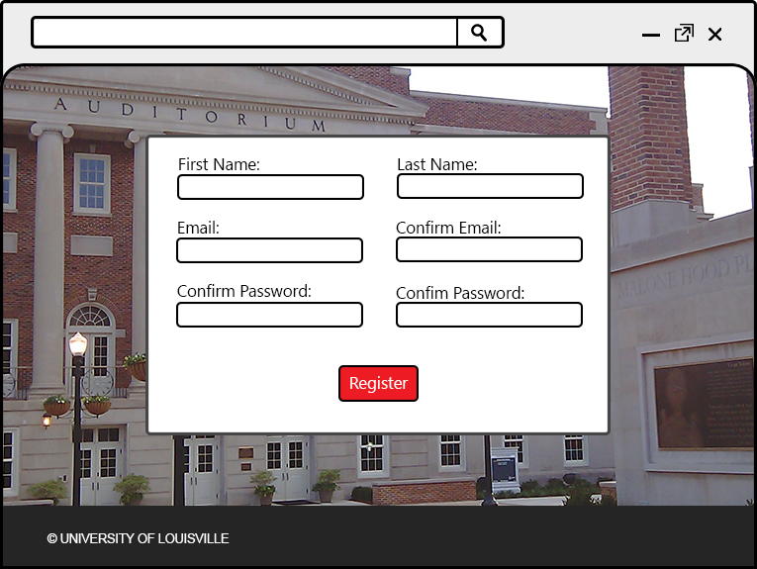

This page would be accessible through a link on the login page. On this page, users will fill out all important account information. After submission, an admin user must verify the account for the new account to be able to login.

3 – Password Reset

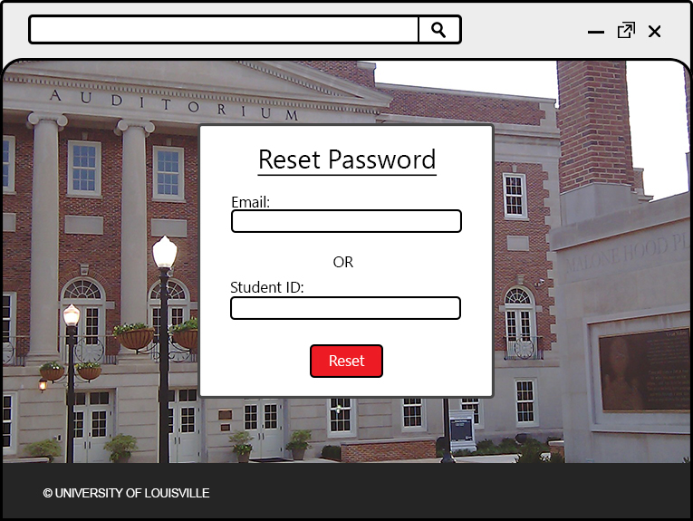

This page would be used if a student forgets their password. From this page, a student can enter in either their U of L email address or Student ID. Once submitted, the user will receive an email that enables them to set up a new password for their account.

4 – Donate

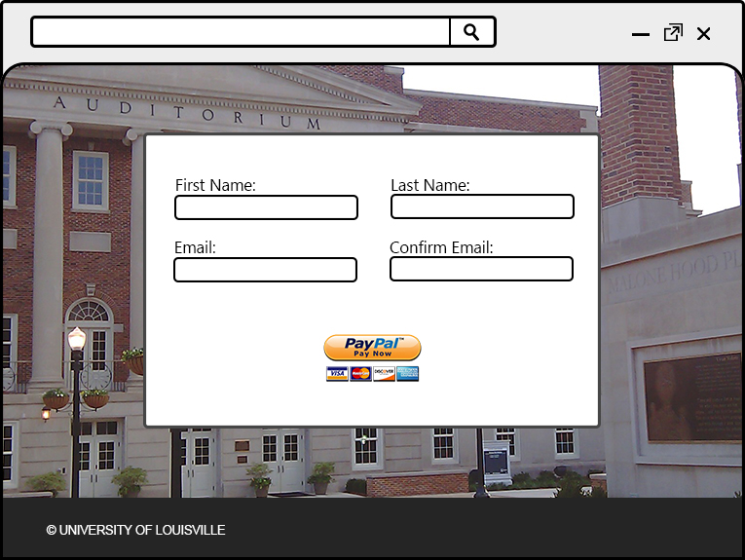

The donate page is a publicly available page that anyone can access without having created an account. From here, visitors would be able to submit a donation to the University of Louisville School of Nursing. Once the donor fills out their information, they can click a button to be taken to the webpage that processes the transaction (such as PayPal).

5 – Admin Dashboard

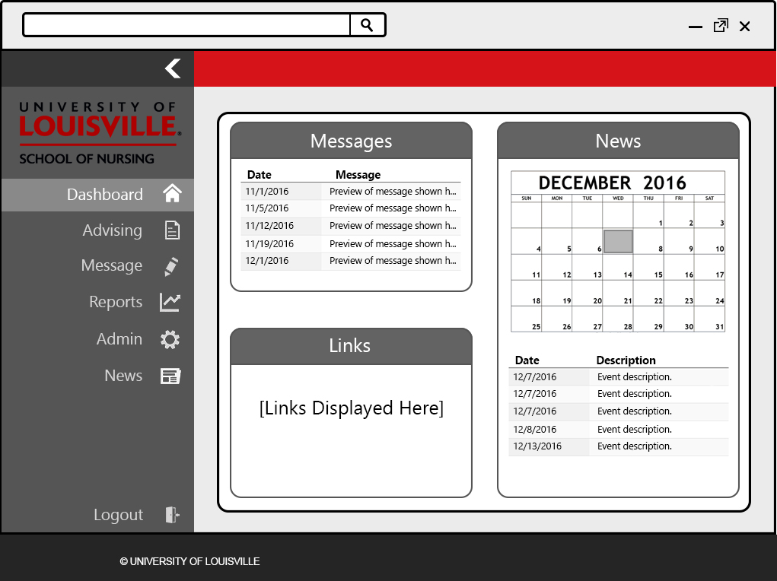

The admin dashboard is shown to the admin user after logging in. All different user types (admin, staff, student, and prospective student) have the same dashboard items: messages, news, and links. In the message section, any message sent out by an admin will be displayed. In the news section, all upcoming events are displayed, along with a calendar for the user to select a certain date and view any news items that would occur on that day. Finally, links contain useful and most accessed links to pages in the application, as well as external links.

6 – Message

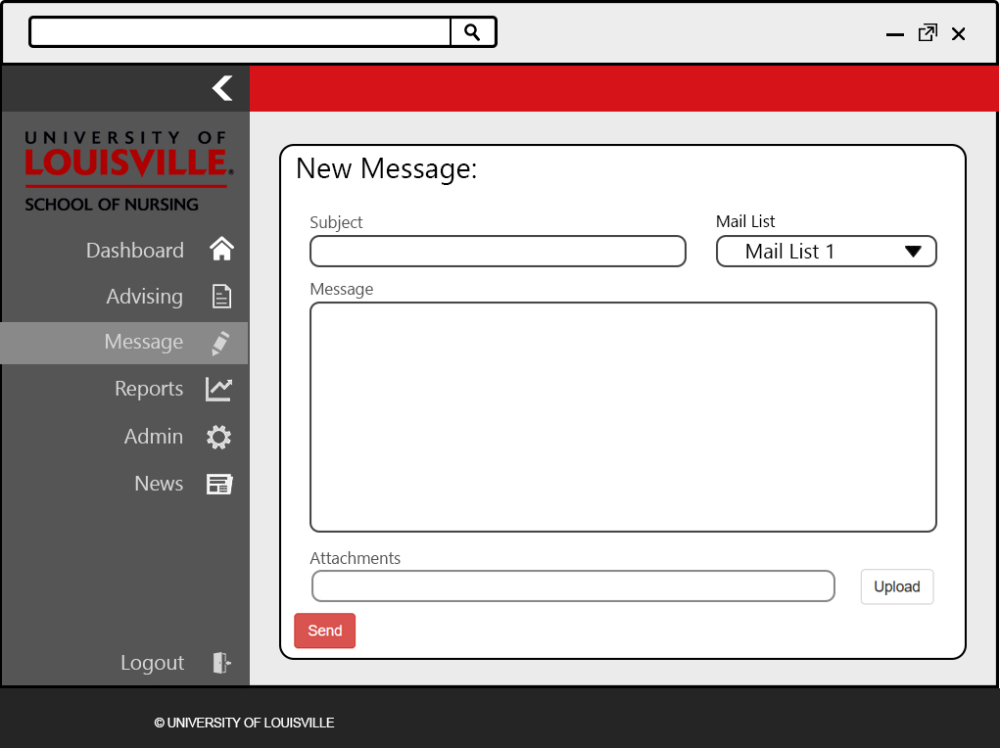

The message page allows an admin user to create and send out message to other users. The admin user will enter in the subject and message of the email, as well as upload any attachments. Also, the admin user must select from the list of pre-created mail lists to set the recipients of the message.

7 - Admin

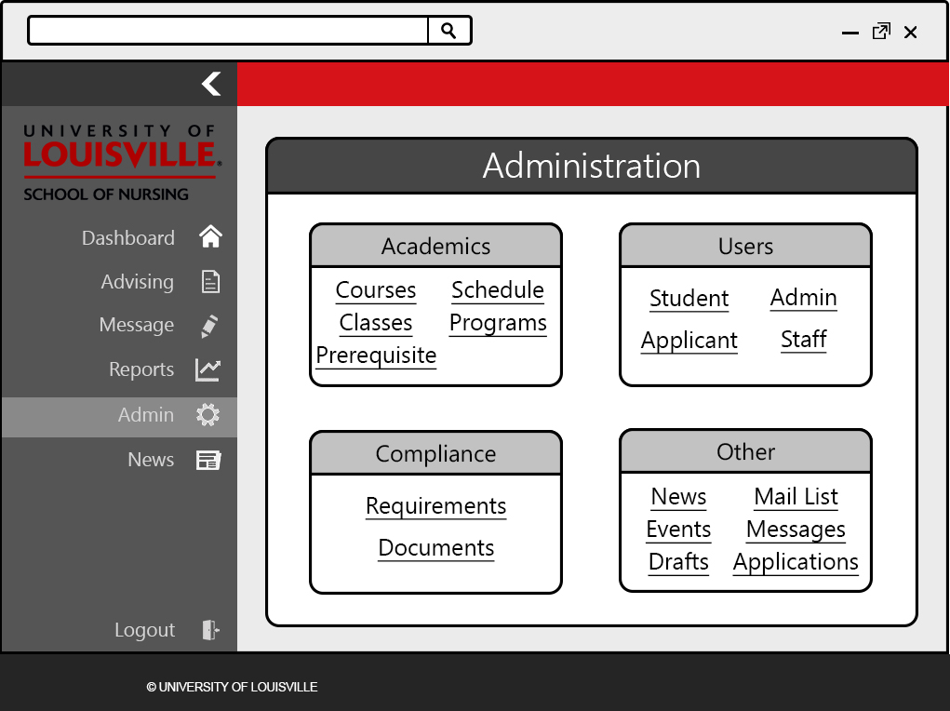

This page represents the admin section, only accessible by admin users. From here, the admin can select a certain object that they wish to modify. After clicking on an object, the user has option to view, create, edit, and delete other objects of that same type.

8 – Staff Select

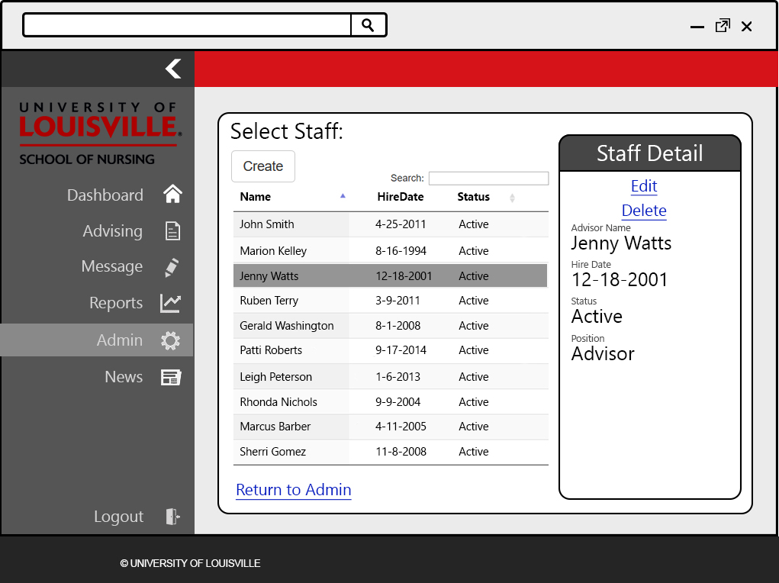

The staff select page shows a list of staff members. Upon clicking on a staff user, that user’s information is displayed on the panel on the right side of the page. From within this panel, the user can choose to edit or delete the selected staff user.

9 – Staff Create

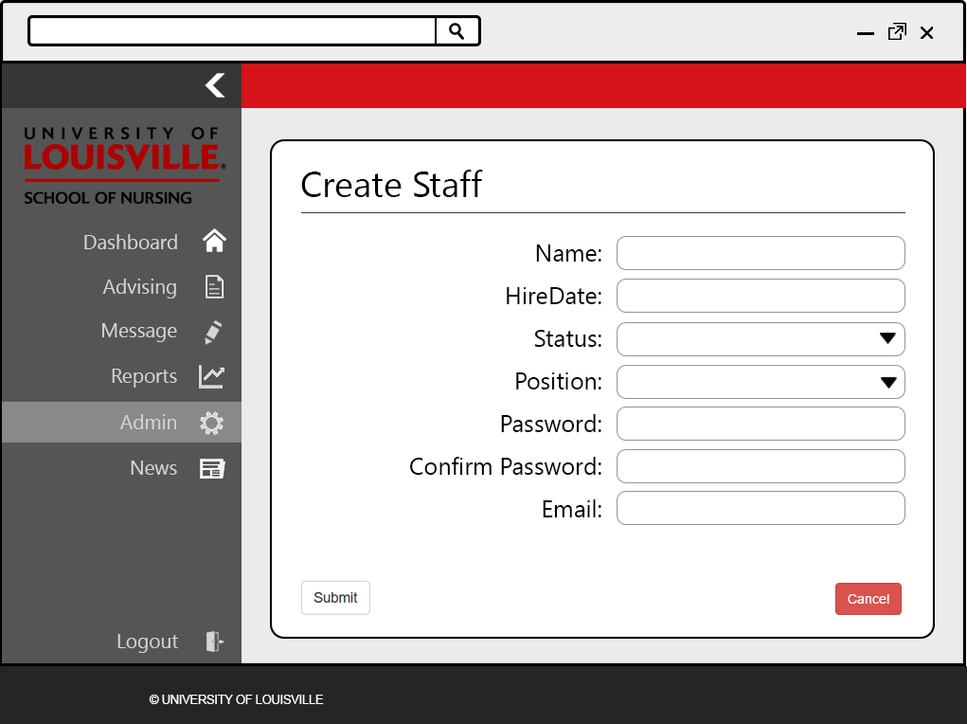

This page is used by an admin user to create a new staff user. This page contains text boxes for the admin to fill in the information about the new staff user, as well as drop down boxes to set the attribute of the staff user to a predefined list of options.

10 – Staff Edit

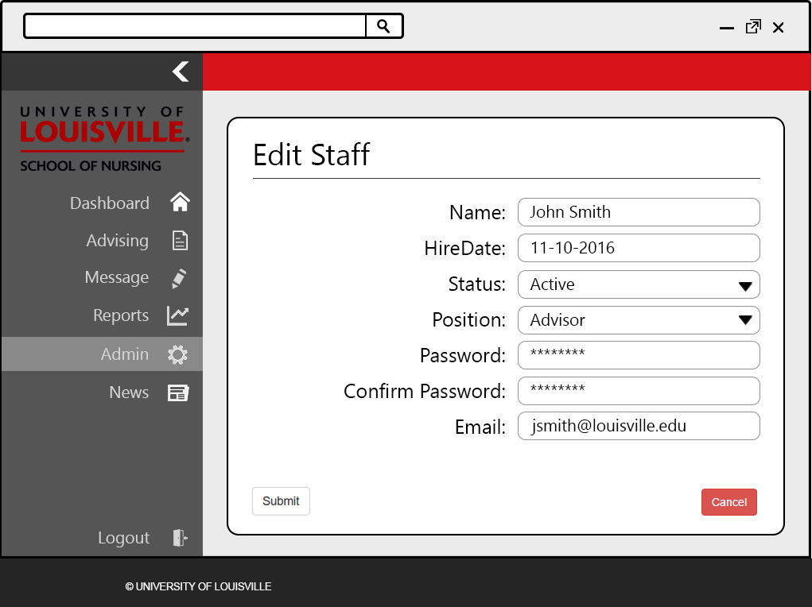

The edit page is the same layout as the create staff page, although it autofills the selected staff user’s information into the text boxes and dropdown boxes. The admin user can alter the staff user’s information through this interface.

11 – Mail List Select

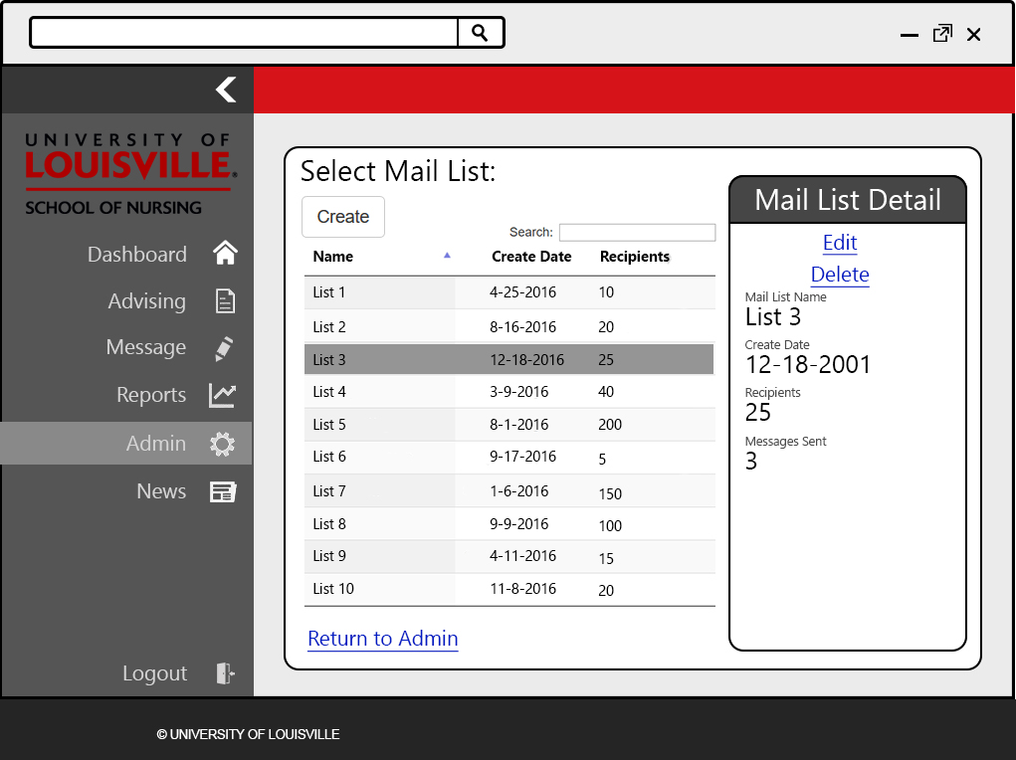

The mail list select page gives the admin user the ability to view all previously created mail lists, as well as select a specific mail list to either view, edit, or delete that mail list. These created mail lists are used in the message page to set the recipients of the message.

12 – Mail List Create

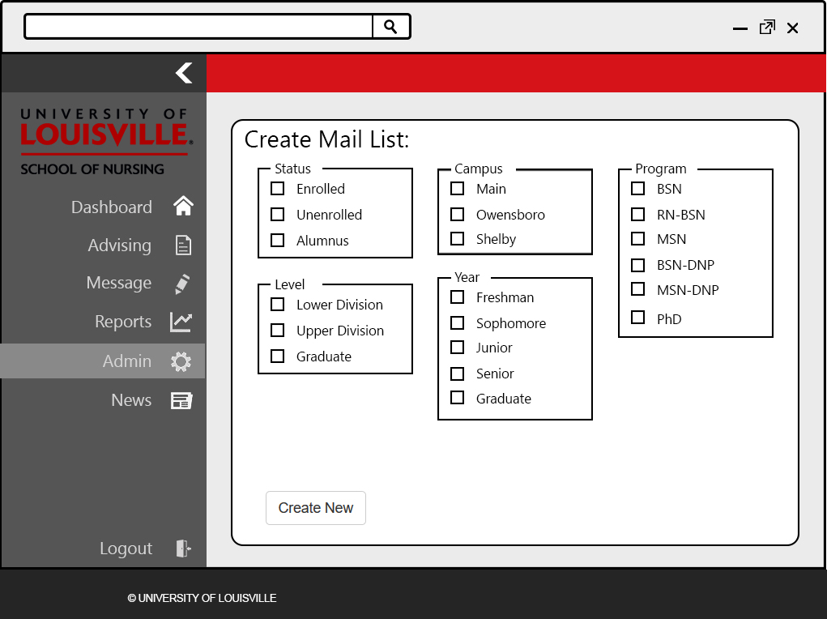

The mail list create page is an interface for an admin user to make a new mail list by filtering all students by certain categories, such as status, campus, and year. Each category contains checkboxes that allow the admin user to define which student types they wish to add to the mail list.

13 – Mail List Edit

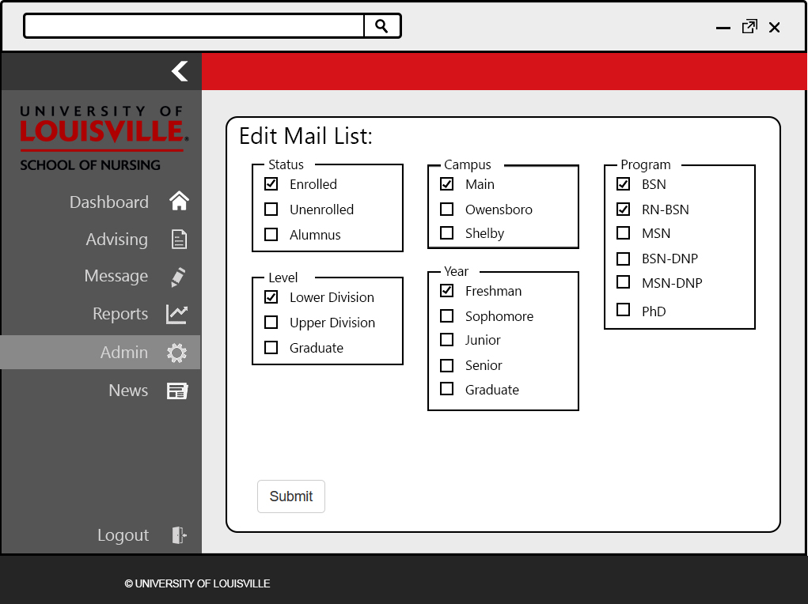

The mail list edit page has the same layout as the create mail list page; however, this page shows all previously selected options for the specified mail list. From here, the admin can edit the options to alter which students are present on the mail list.

14 – Student Select

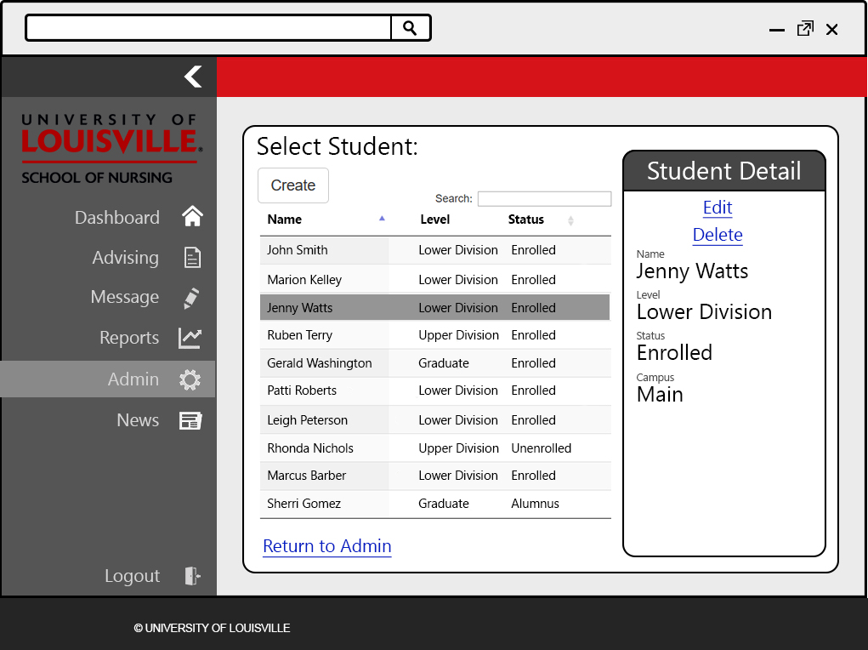

The student select page shows a list of student users. Upon clicking on a student user, that user’s information is displayed on the panel on the right side of the page. From within this panel, the user can choose to edit or delete the selected student user.

15 – Student Create

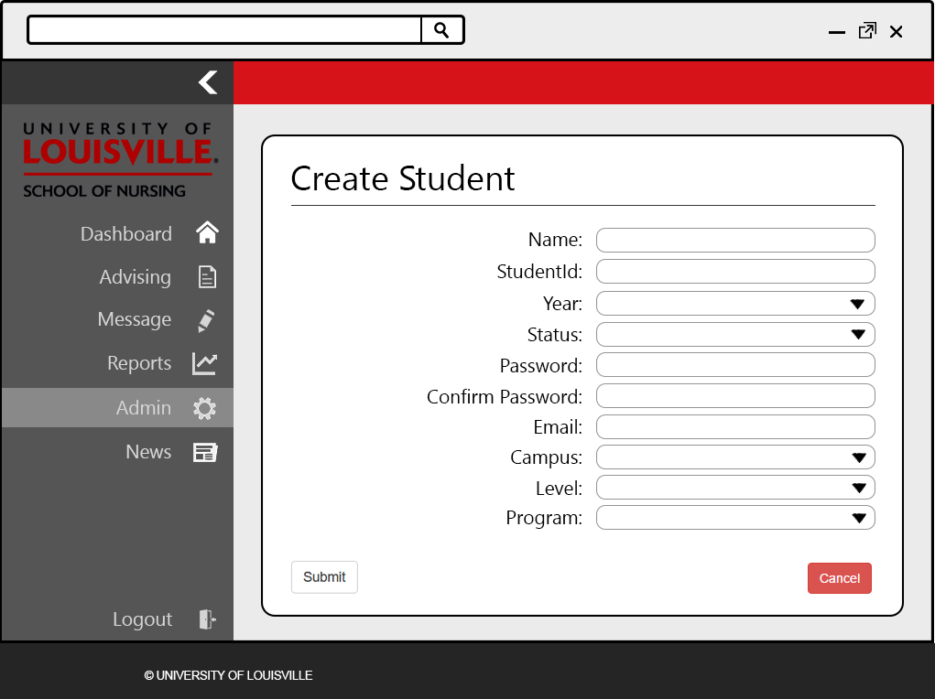

This page is used by an admin user to create a new student user. This page contains text boxes for the admin to fill in the information about the new student user, as well as drop down boxes to set the attributes of the student user to a predefined list of options.

16 – Student Edit

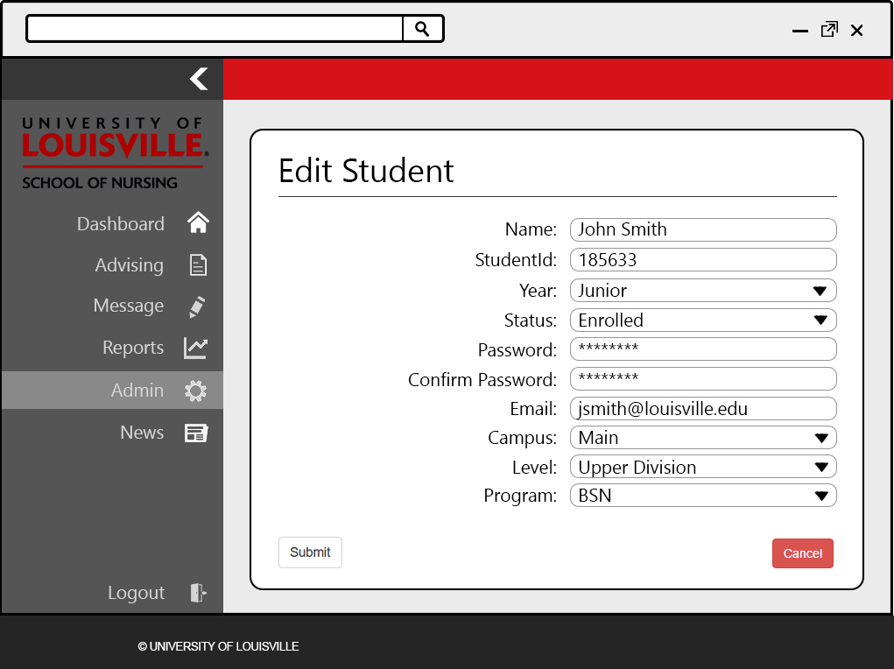

The edit page is the same layout as the create student page, although it autofills the selected student user’s information into the text boxes and dropdown boxes. The admin user can alter the student user’s information through this interface.

17 – Student Delete

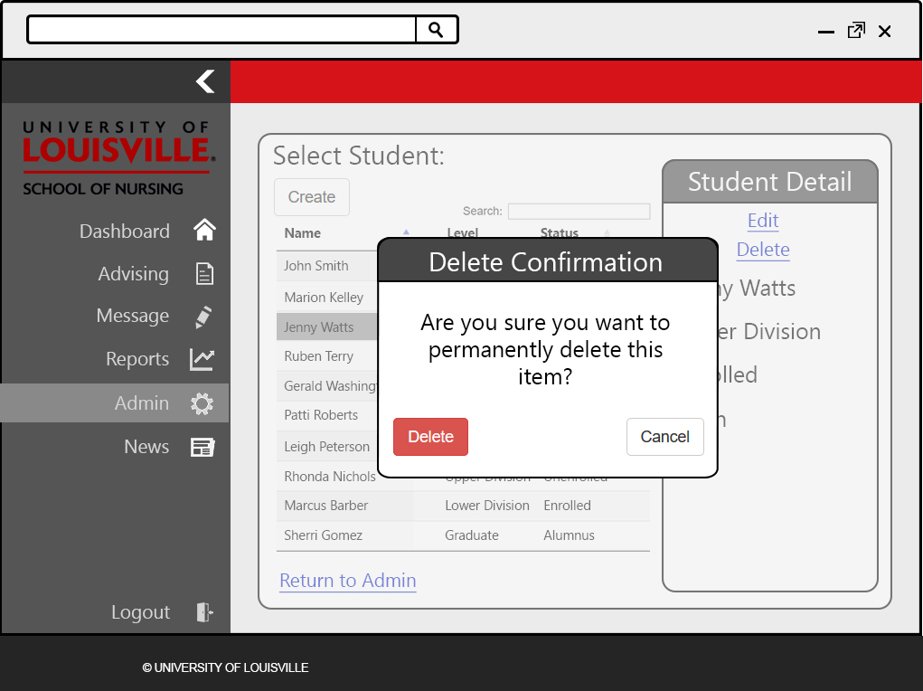

Once the user clicks “delete” from the panel on the select student page, the user is shown a dialog box asking them to confirm the deletion. If the user confirms to delete the student, that student will be removed from the database.

18 – Staff Dashboard

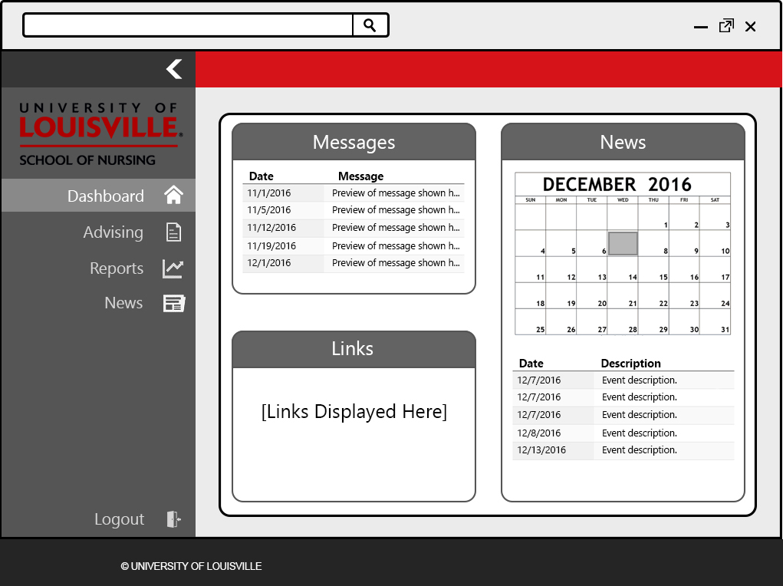

The homepage of staff users after logging in to the application. One difference between the staff dashboard and other dashboards are the navigation options available for that user. These navigation options are located on the left side of the page. Unlike an admin user, the staff user does not have access to the admin or message sections of the website.

19 – Advising Select Student

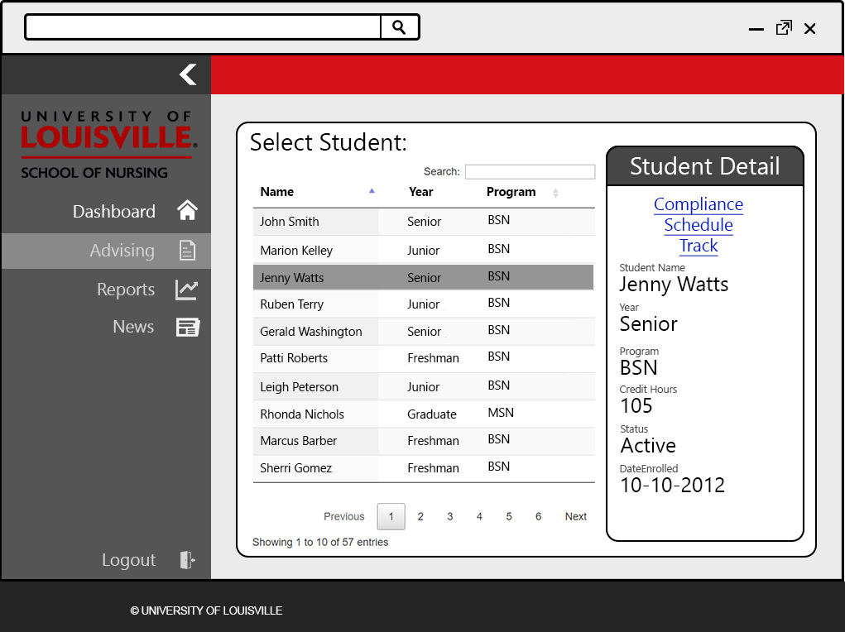

This page is the first page the staff or admin user is shown after selecting the advising link in the navigation menu. From here, the user will browse through all students and select the student they want to advise. After selecting the student, the user can view that student’s general information, as well as view that student’s compliances and schedule.

20 – Compliance Select

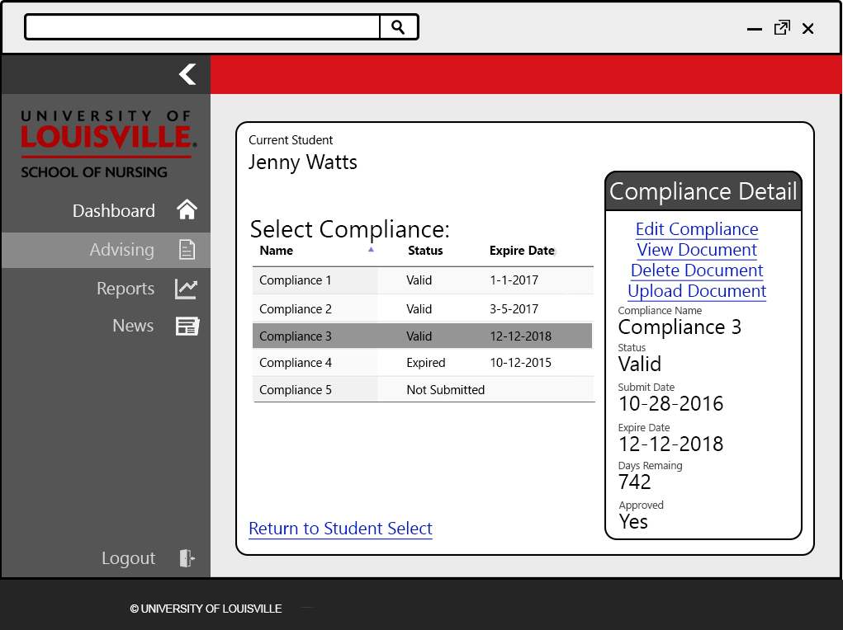

After selecting a student and clicking the “Compliance” link, the admin or staff user will be shown this page. From here, that user can view that status and information of all compliances required by a specific student. Also, the user can choose to edit, view, delete, or upload compliance information and documents for each compliance.

21 – Compliance Edit

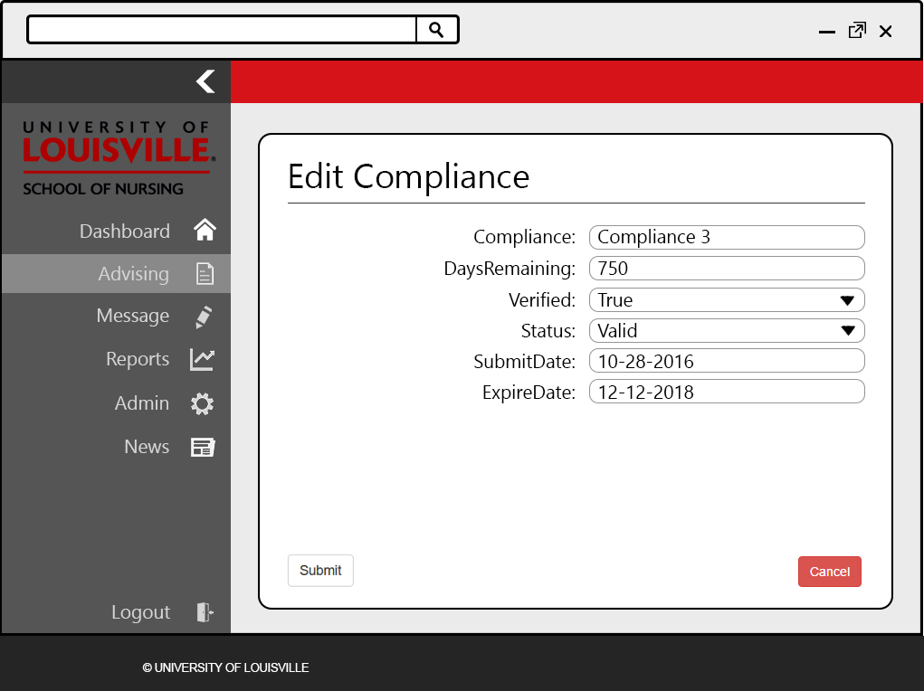

After selecting a compliance and choosing the “Edit Compliance” link, the user is shown this page. All information and attributes about that specific compliance are shown in text boxes and drop down boxes, where the user can alter this information.

22 – Compliance Upload

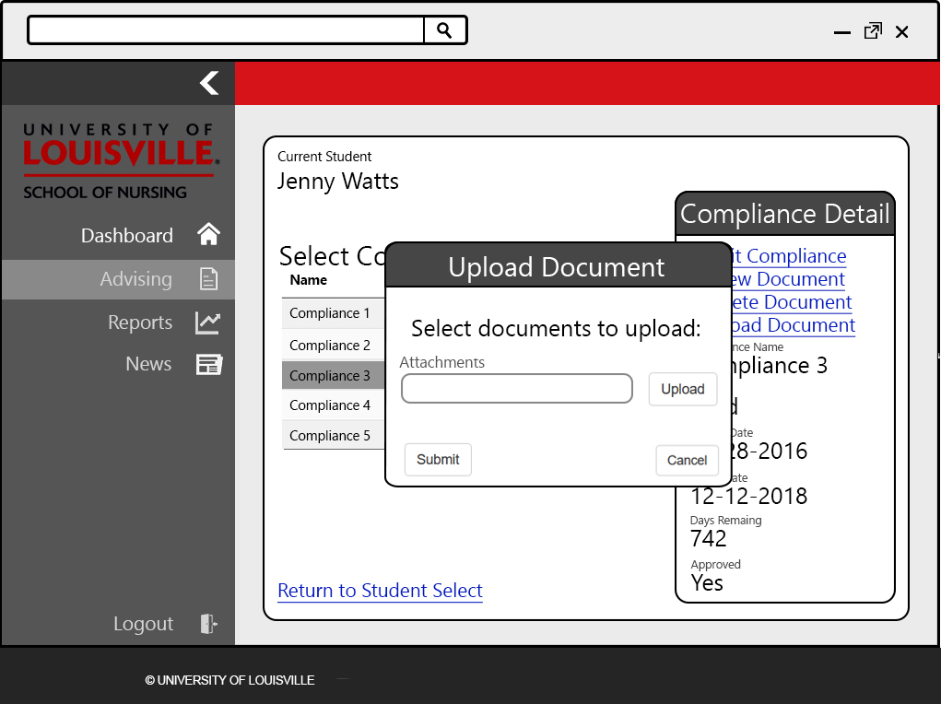

If the user clicks the “Upload Document” link after selecting a compliance, they are shown a dialog box. In this pop up, the user can click the upload button to browse their computer for the compliance document and upload it into the system.

23 – Schedule Select

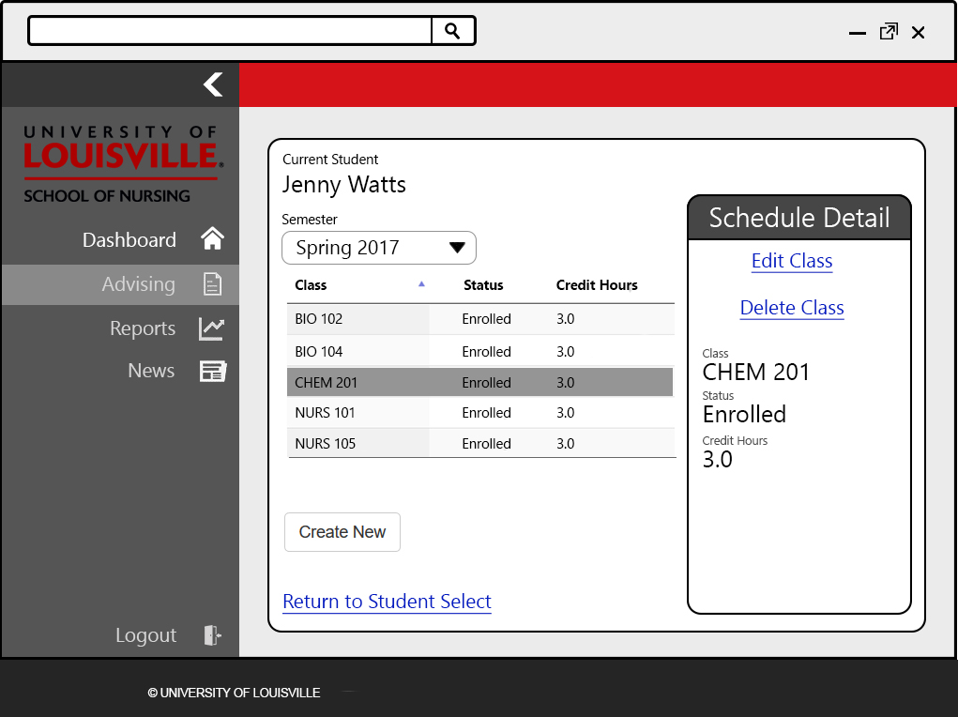

When the staff or admin user clicks on the “Schedule” link after selecting a student in the advising section, they can view the schedule for that student. This will show all previously taken classes, organized by semester. The semester being viewed can be changed by selecting a different semester from the drop down box. From here, the user can choose to edit or delete classes that the student has taken, or add classes for an upcoming or previous semester.

24 – Schedule Create

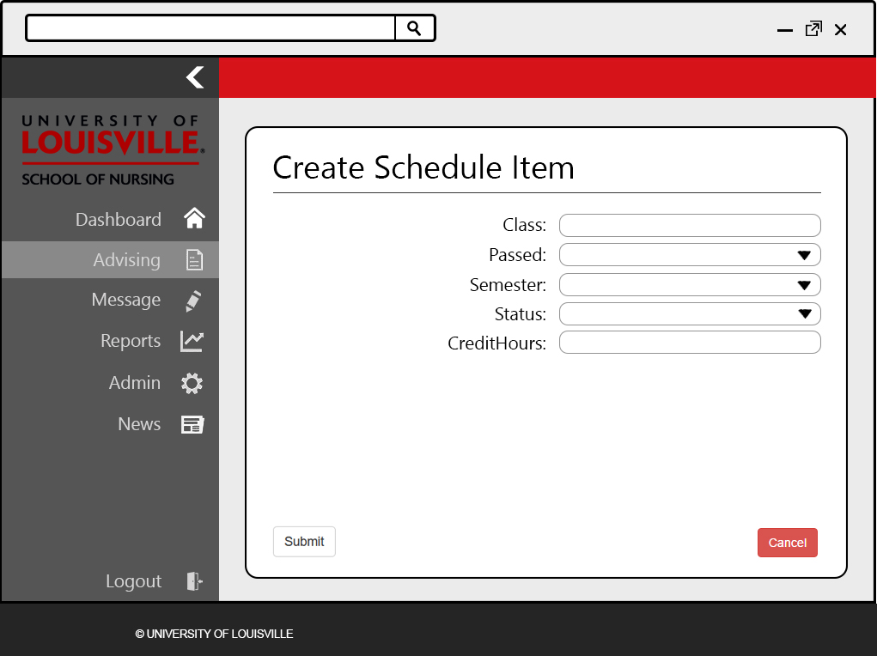

This page is shown after a user clicks the “Create New” button from the previous page. This page allows the user to input class information in textboxes and select class information from drop down boxes. Submitting this page will add the class to the student’s schedule.

25 – Schedule Edit

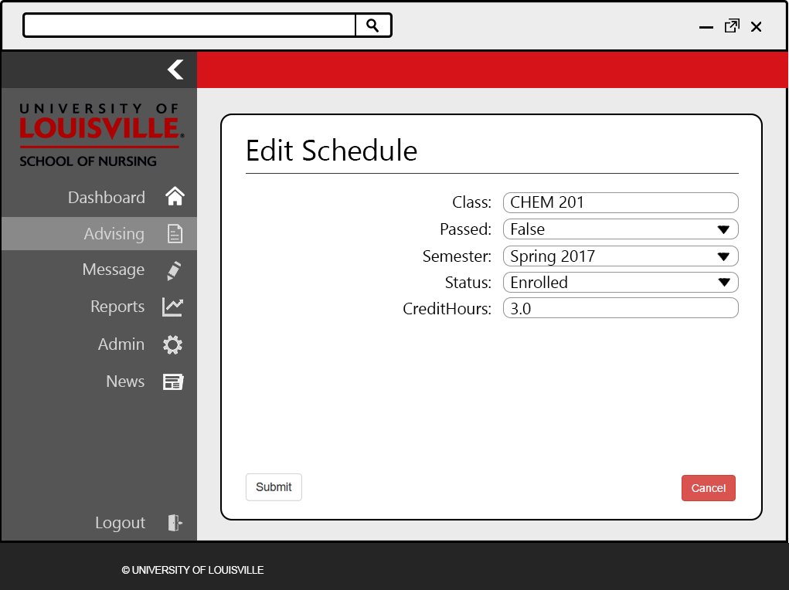

This page has the same layout as the “Create Schedule Item” page. However, this page autofills the information about the selected class into the textboxes and dropdown boxes. The staff or admin user can alter any previously entered information regarding a student’s classes.

26 – Report Select

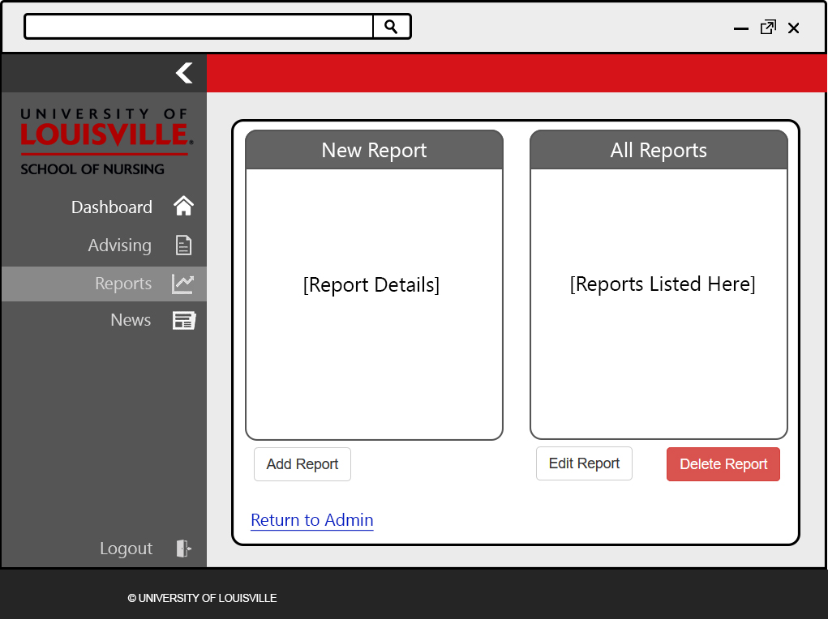

This is the main page shown after a staff or admin user select the “Reports” option from the navigation menu. This page would display all previously created reports, as well as the results from these reports. Also, the user will be able to edit or delete any previously created reports.

27 – Report Create

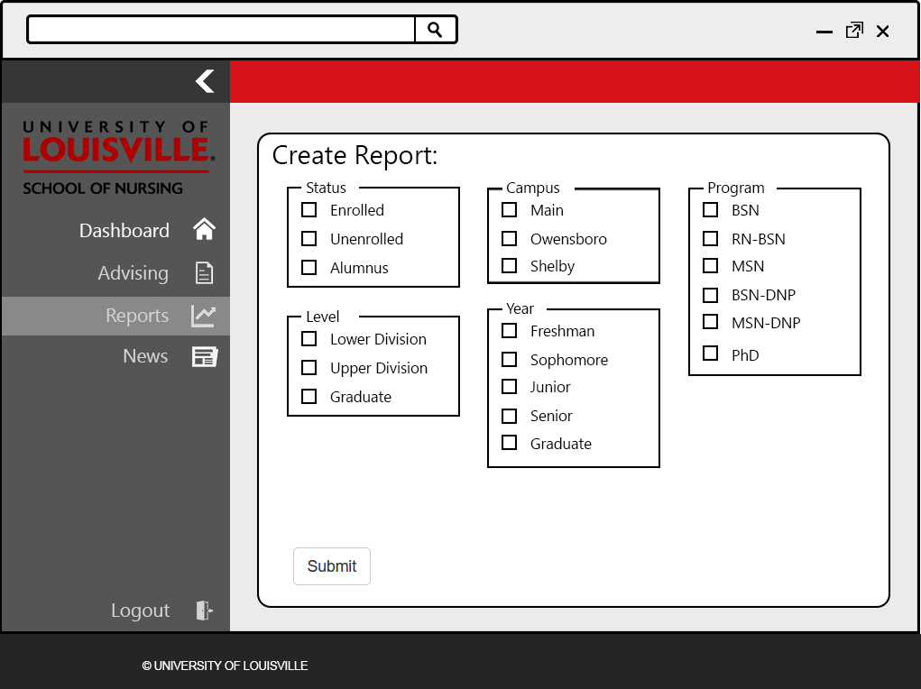

The create report page is used for generating reports about a specific group of students. The user will be able to select the types of student they would like to create a report about. Each group of attributes represents a specific data point about a student.

28 – Report Edit

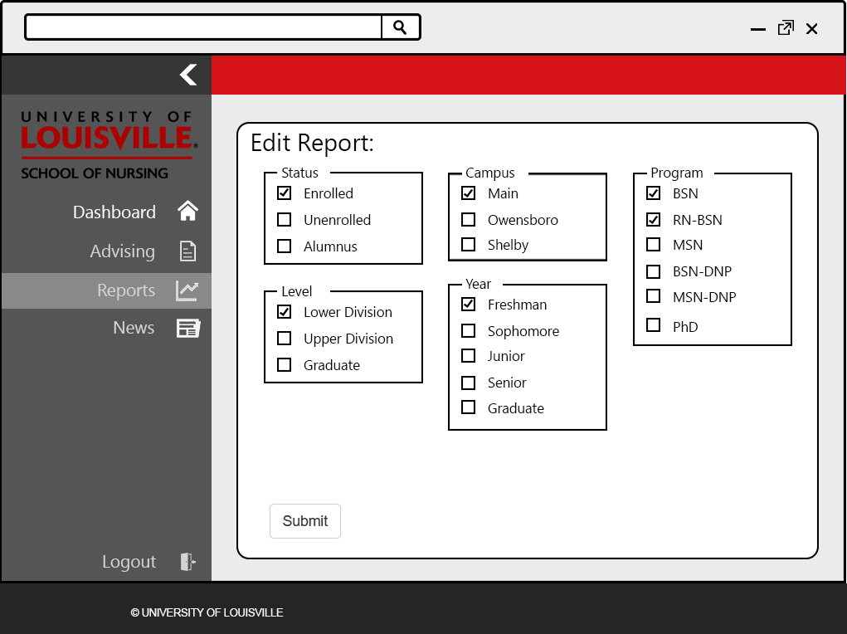

This page has the same layout as the report create page. However, the previously created report selections are shown and can be altered by the user.

29 – Student Dashboard

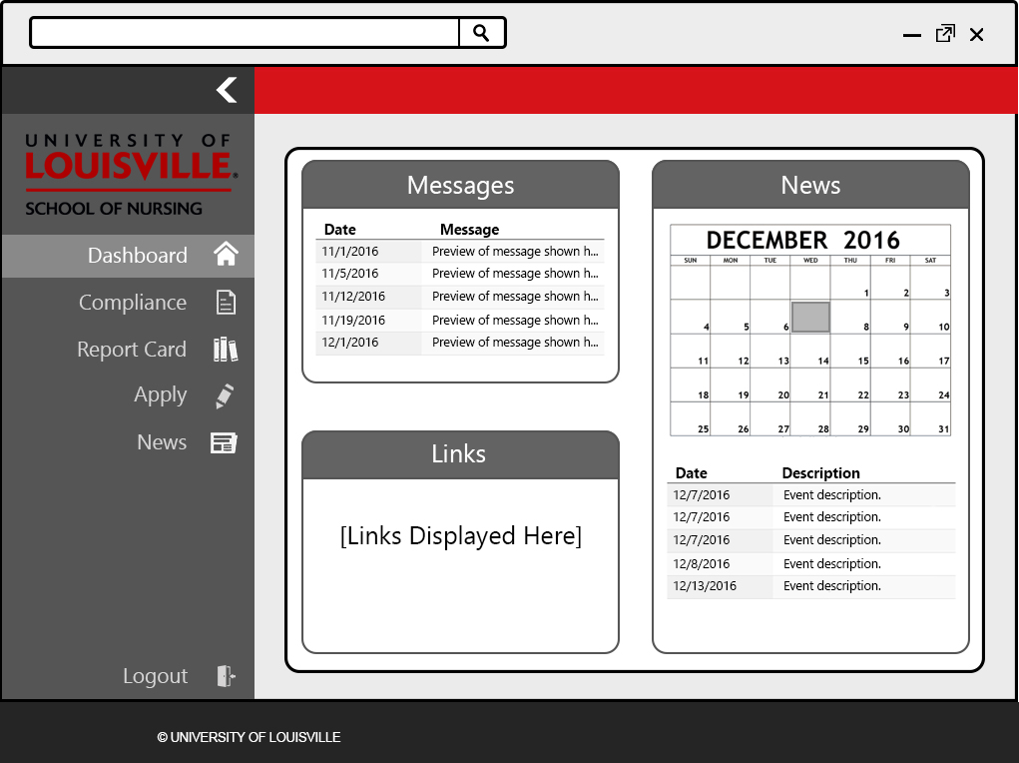

The homepage of student users after logging in to the application. One difference between the student dashboard and other dashboards are the navigation options available for that user. These navigation options are located on the left side of the page. Unlike a staff user, the student user does not have access to the advising section or the reports section.

30 – Upper Division Apply

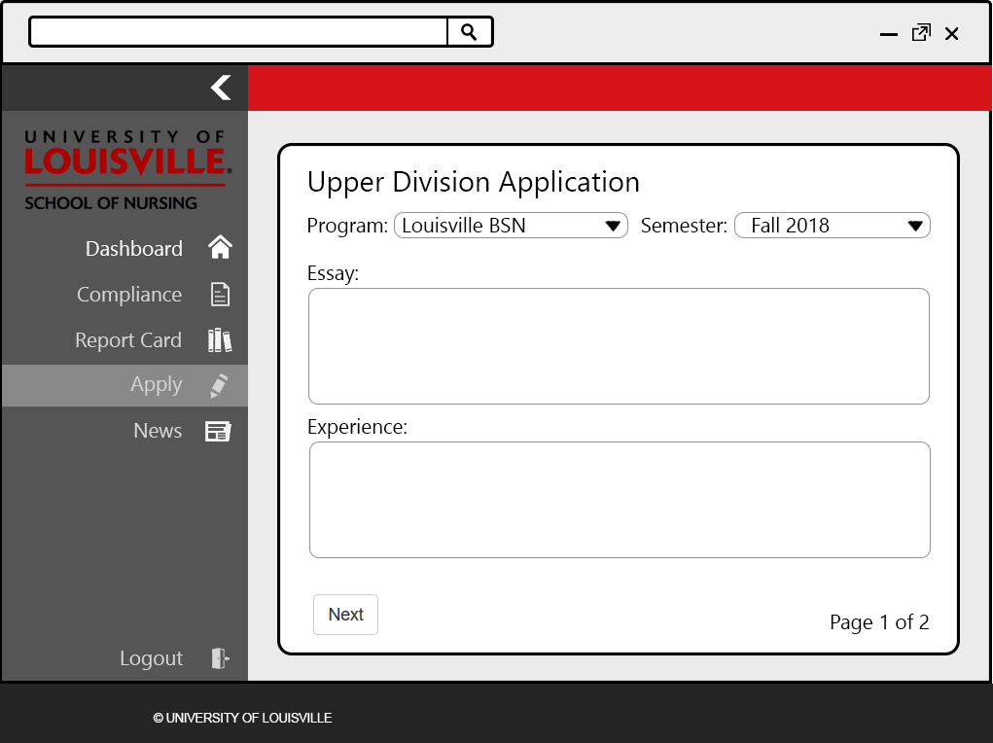

This is the first page shown after an eligible lower division student clicks the “Apply” navigation item. The fields for this page were taken from the current Upper Division application page on the School of Nursing’s website. The student will select the program they are interested in, and the semester for which they are applying. They are then given an essay prompt and will enter their response in the first textbox. Next, the student will fill out any previous experience they have had in the second textbox.

31 – Upper Division Apply 2

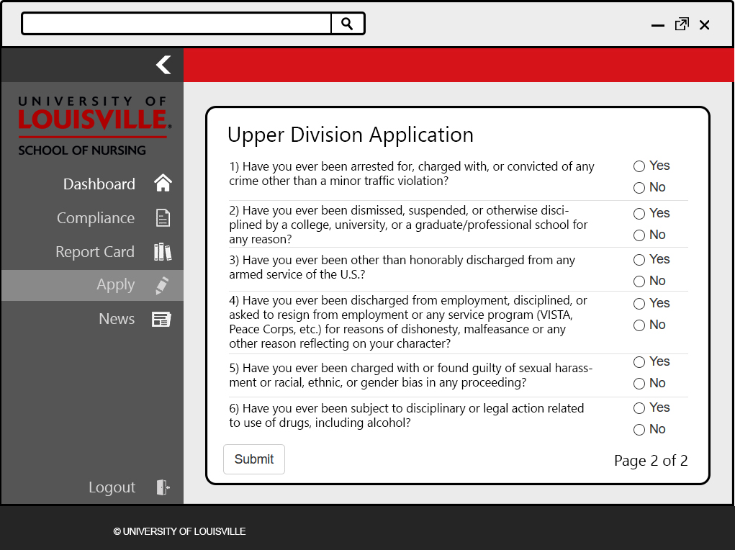

This is the second Upper Division application page, in which the student will answer a small series of questions. These questions were taken from the current Upper Division application on the School of Nursing’s website.

32 – Report Card

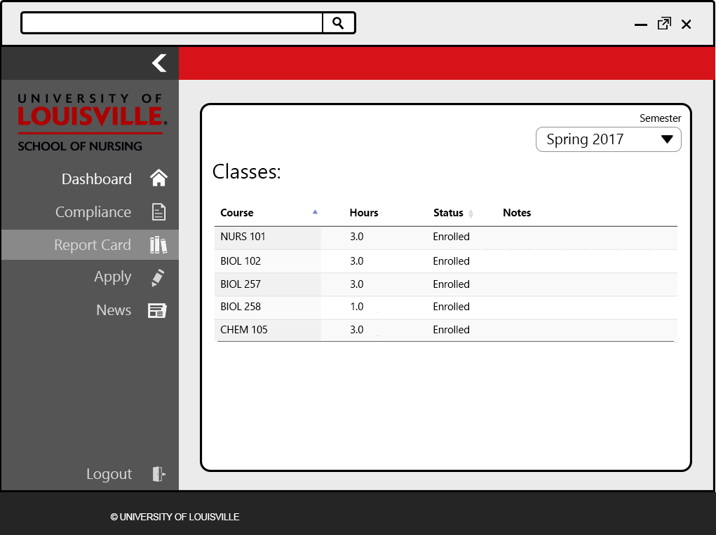

This page is like the “Schedule” page that staff and admin user have access to, without the ability to delete or edit previously taken classes. Students can view classes they have taken in past semesters, as well as classes that have enrolled in for upcoming semesters.

33 – News

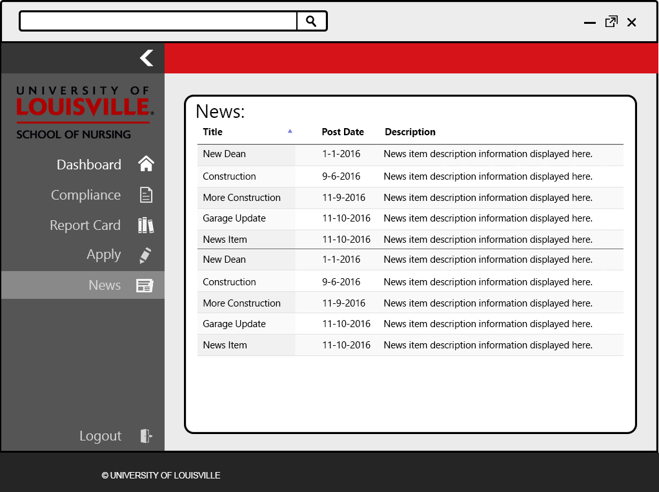

This page shows a complete list of all upcoming news. The student can select a certain news item to view the details about the item.

34 – Compliance Select

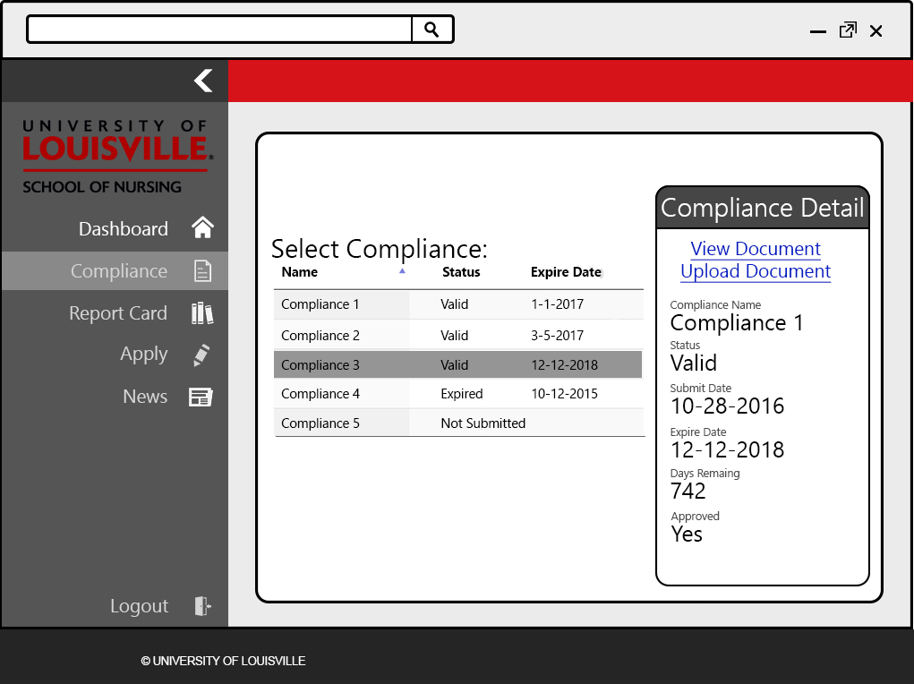

This page is like the “Compliance” page that staff and admin user have access to, without the ability to delete or edit compliance information or documents. Students can view the status of their compliances, and whether they have fulfilled their compliance requirements.

35 – Prospective Student Dashboard

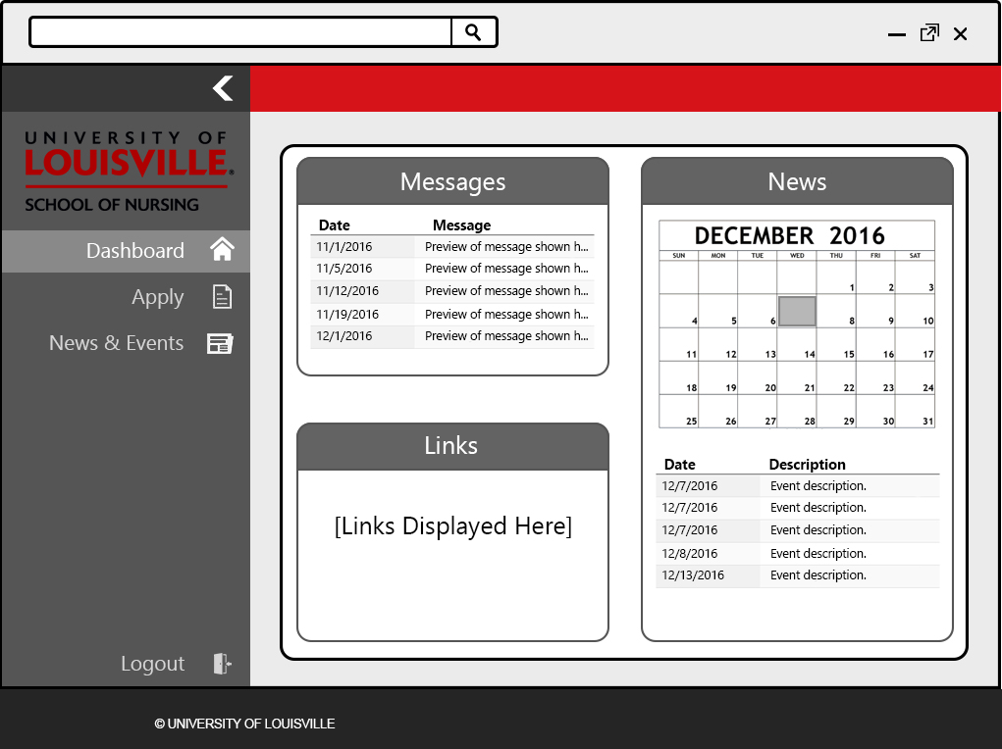

The homepage of prospective student users after logging in to the application. One difference between the prospective student dashboard and other dashboards are the navigation options available for that user. Unlike a student user, the prospective student user does not have access to the report card or compliance areas.

4

36 – Prospective Student News & Events

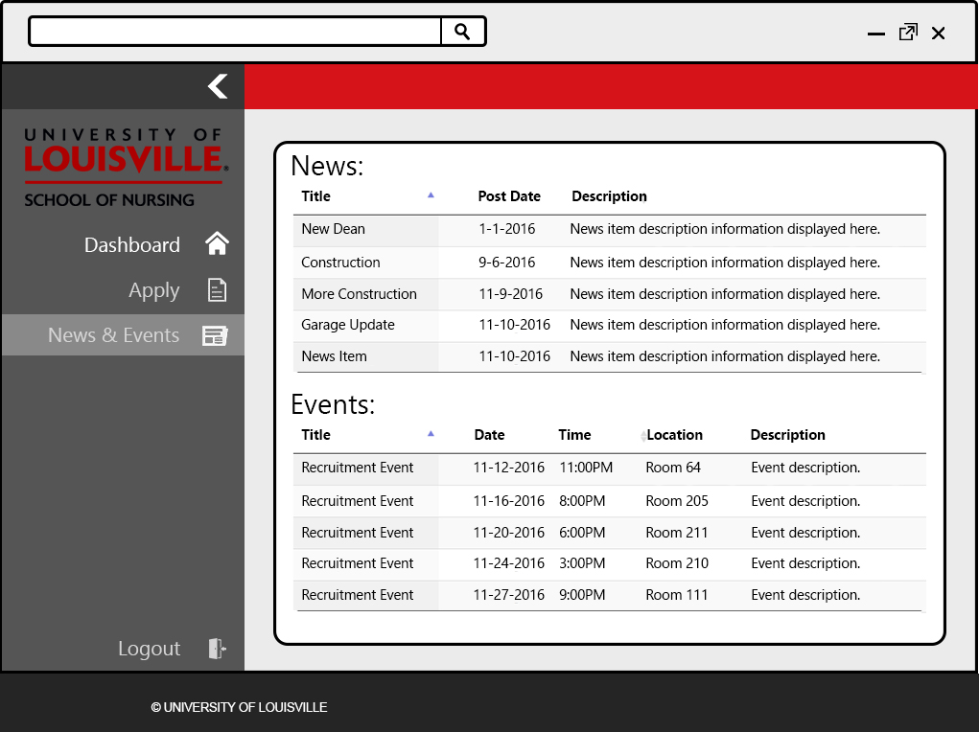

The news & events page is used by prospective student users to view any upcoming news items or recruitment events. This page displays a similar layout to the news page, with an additional section for recruitment evens. Only perspective students can view recruitment events.